EM401 Individual Project

Final Report

|  |
| --- |
| Talking HAM Linear Amplifier  (High Frequency High Power RF Amplifier) |
| Lewis Russell |
| 201721501 |
| 05 April 2021 |
| Supervisor: James Irvine |

Contents

1 Abstract 1

2 Termonology 2

3 Introduction 4

4 Background 5

4.1 What is an Amplifier? 5

4.2 What is an Amplifiers Class? 5

4.3 What is a Linear Amplifier? 6

4.4 Why are Linear Amplifiers Needed? 7

4.5 Behaviour of Waves 7

4.5.1 What is Propagation? 7

4.5.2 What is a normal? 7

4.5.3 What is Reflection? 8

4.5.4 What is Refraction? 10

4.5.5 What is Diffraction? 13

4.6 What are RF Propagation losses? 14

4.6.1 Free space Path Losses 15

4.6.2 Ground Wave Propagation 17

4.6.3 Ionospheric propagation 19

4.6.4 Tropospheric Propagation 20

4.7 Antenna Tunning Units 22

4.7.1 What is an ATU? 22

4.7.2 What is SWR? 22

4.7.3 How do ATUs work? 24

4.8 Thermionic Emmsion Valves 25

4.8.1 What is Thermionic emission? 25

4.8.2 What is a Thermionic Emission Valve? 26

4.8.3 How do Thermionic Emission Valve work? 27

4.8.4 What are Valves Made of? 27

4.8.5 Why is Valve Matching impotant? 29

4.8.6 How are Valves Matched? 30

4.8.7 Who still makes valves? 30

4.9 Why are valves being used over semiconductors? 31

4.10 What are the requirements for a HAM radio transmit? 32

4.11 What in the design is new? 34

5 What was the Design process used? 35

6 Amplifier Design 39

6.1 System Concept 39

6.2 System Architectre 40

6.3 Initial Overall System architecture 42

6.4 Initial Schematic Design 49

6.4.1 Initial Design 49

6.4.2 Part Selection 65

6.4.3 PDR 78

6.5 Modular Schematic Design 79

6.5.1 RF-ARCH-001 80

6.5.2 RF-PWR-001 84

6.5.3 RF-INP-001 91

6.5.4 RF-OUT-001 93

6.5.5 RF-VAL-001 95

6.5.6 Component Selection Changes 97

6.5.7 Modular Schematic Design PDR 100

6.6 Modular Layout Design 100

6.6.1 Trace Width and Clearances 100

6.6.2 RF-PWR-001 103

6.6.3 RF-INP-001 105

6.6.4 RF-VAL-001 109

6.6.5 RF-OUT-001 110

6.7 BOM Review 113

6.7.1 RF-PWR-001 BOM 113

6.7.2 RF-INP-001 BOM 115

6.7.3 RF-VAL-001 BOM 116

6.7.4 RF-OUT-001 BOM 116

6.7.5 RF-EXTRN-001 BOM 118

6.7.6 Total 119

6.7.7 Are the boards easy enough to build? 119

6.8 CDR 119

7 Operation 120

7.1 Receiving Mode 120

7.2 Transmitting Mode 120

7.3 Filter Switch Mode 121

7.3.1 Filter Switching (Receiving) 121

7.3.2 Filter Switching (Transmitting) 121

7.4 Fault Mode 121

7.5 Web UI 122

7.6 Arduino Pseudo Code 122

8 RF Propagation in a Forested Environment 125

8.1 Density of a forest 125

8.2 Equipment used 126

8.3 Set up 126

8.4 Hedge Information 129

8.5 Results 129

8.6 Propagation Conclusion 133

9 Future Work 134

10 Changes 135

11 COVID-19 136

12 Conclusion 136

13 References 138

14 Appendix 151

# Abstract

A modular 100 W valve Radio Frequency (RF) linear amplifier platform was researched and designed. This design was based on the KW1000 Amplifier, modernising and modularised its design, creating a test platform. This platform allows topologies to be changed so a range of different valves and MOSFET amplifiers can be tested. The initial option offers inbuilt SWR measurement, safety monitoring and cut off circuitry with live monitoring of the RF input and output signals. The amplifier design is a cost-effective solution (£791.09) per device, like the Gemini HF-1K solid State 1kW HF amplifier costing £2,165.83. The amplifier designed is scalable, allowing it to be scaled up to the Gemini power still at a cost-effective price. The amplifier can be built by experienced home builders. Additionally, an investigation into RF propagation losses in forested environments was carried out using a hedge. This found the propagation loss for 1.8410 MHz initial loss was 11 dBm which faded with distance. However, 27.405 MHz had a negligible difference, within the margin of error. The project demonstrates a scalable HF amplifier design, which despite COVID-19 restrictions, achieved the main goals of creating the overall architecture and design being completed, however, the restrictions did leave future work.

# Termonology

|  |  |
| --- | --- |
| Acronym | Long Form |
| AC | Alternating Current |
| AC/DC | Alternating Current to Direct Current |
| ADC | Analogue to Digital Converter |
| ATU | Antenna Tuning Unit |
| BOM | Bill of Materials |
| CDR | Critical Design Review |
| DC | Direct Current |
| HF | High Frequency (3 to 30 MHz) |
| DNF | Do Not Fit |
| EHF | Extremely High Frequency (30 to 300 GHz) |
| ELF | Extremely Low Frequency (3 to 30 Hz) |
| FRR | Flight Readiness Review |
| HV | High Voltage |
| ISWR | Current Standing Wave Ratio |
| MCR | Mission Concept Review |
| MDR | Mission Definition Review |
| MF | Medium Frequency (300 kHz to 3 MHz) |
| NASA | National Aeronautics and Space Administration |
| LF | Low Frequency (30 to 300 kHz) |
| ORR | Operational Readiness Review |
| PCB | Printed Circuit Board |
| PDR | Preliminary Design Review |
| RF | Radio Frequency |
| PRR | Production Readiness Review |
| PTT | Push To Talk |
| QA | Quality Assurance |
| RTRR | Radio Transmission Readiness Review |
| SAR | System Acceptance Review |
| SDR | Software Defined Ratio |
| SHF | Super High Frequency (3 to 30 GHz) |
| SLF | Super Low Frequency (30 to 300 Hz) |
| SPI | Serial Peripheral Interface |
| SMD | Surface Mounted Device |
| SNR | Signal to Noise Ratio |
| SRR | System Requirement Review |
| SWR | Standing Wave Ratio |
| SYDR[1] | SYstem Design Review |
| THF | TeraHertz Radiation (300 GHz to 3 THz) |
| TRR | Test Readiness Review |
| UHF | Ultra-High Frequency (300 MHz to 3 GHz) |
| ULF | Ultra-Low Frequency (300 Hz to 3 kHz) |
| VNA | Vector Network Analyser |
| VHF | Very High Frequency (30 to 300 MHz) |
| VLF | Very Low Frequency (3 to 30 kHz) |
| VSWR | Voltage Standing Wave Ratio |

# Introduction

The goal of this project is to research, design and build a cost-effective modular high-power Radio Frequency (RF) Amplifier with signal analysis and built-in safety monitoring and control system, which would be able to be built by an experienced home constructor. The platform’s modularity allows individual sections to be swapped out allowing different topologies to be tested. This ability allows different amplifier and instrumentation designs to be easily tested, allowing multiple different Valve and MOSFET based amplifiers to be used. However, the initial version will use a valve amplifier, allowing high power outputs using a single amplifying device. Because of this modularity, the RF Amplifier is more scalable by paralleling amplifying devices, if a higher output is wanted. The design is therefore scalable down to a few watts and up to kilowatts by inserting more devices in parallel. For this design, a 100 W output was targeted, and the High Frequency (HF) (3-30 MHz) HAM radio bands were the target amplification frequencies. The design should cost less than £1,000 as this is cost-effective compared to off the shelf high power solution costing around £2,165.83[2], however, basic home amplifiers can be gotten for £500 for a home constructor, but these sometimes have minimal features. One thing additional thing investigated was the RF propagation losses in forested environments, so an investigation into the attenuation effects in this environment was carried out. However, due to the Covid-19 Epidemic the scope of the project needed to be adapted.

# Background

## What is an Amplifier?

In electronics, an amplifier is a device that takes a “small input signal (voltage, current, or power) and delivers a larger output signal that contains the essential waveform features of the input signal” [1]. This means an amplifier can take an input signal in and then passes out an identical form that has a larger voltage, current or power depending. An example amplifier is shown in Figure 1 [2] .

|  |  |
| --- | --- |
| 1. Basic Amplifier | B) Amplifier Waveform |

Figure 1:- Non-Inverting Op-Amp with output Waveform

## What is an Amplifiers Class?

Amplifiers have a wide range of classes, with the most used for audio amplifiers being A, B, C, AB. The difference between the types is in conduction angles, examples of each class are shown in Figure 2. From this, it can be seen Class A conduct and amplifies the entire 360° of the signals, through a single device. Both Class AB and Bs can conduct the full-wave through two 180° segments, with the difference being the AB amplifier have biasing to deal with the unstable cross over point. Class C amplifies can only amplify 180° or less, this means it has a high distortion effect especially compared to the other classes. Whereas Cass B and AB have a much lower distortion effect than Class C, it is still higher than a Class A, but the reverse is true on efficiency, as Class A is the least efficient, whereas Class C is the most efficient, due to Class A needing to conduct constantly in non-compared to Class C which can only conduct in the most efficient times. However, for an RF amplifier, the largest factor in deciding class is distortion, this means Class A should be used for minimal distortion.

|  |  |
| --- | --- |
| Class A CLASS A Amplifier | Class B CLASS B Amplifier |
| Class AB CLASS AB Amplifier | Class C CLASS C Amplifier |

Figure 2:- Class A, B, AB, C Amplifier Examples [3].

## What is a Linear Amplifier?

A Linear Amplifier is an Amplifier which amplification is not affected by frequency and has a linear gain [4]. This means that if an input signal of 1 W 1 kHz sine wave signal was passed into an ideal linear amplifier with a power gain of 100, then a 100 W 1 kHz at 180° out of phase would be passed out of the amplifier. However, in real amplifiers, this phase shift and gain are never exact.

## Why are Linear Amplifiers Needed?

Linear Amplifiers are normally needed because outputs of a transceiver are normally weak and need to be amplified to the desired output power, depending on the purpose this may only be 10 W, or it could be 100W, 1kW or even higher. This power affects maximum propagation distance as, in theory, a 10 W transmitter will transmit approximately 40% less than 400 W, although the reality is often different [5], so the desired output power is often selected based on frequency and range. It is for this purpose linear amplifiers exist as they can boost relatively weak signals from the transceiver up to the desired power of the output. A transceiver does not directly output this high power due to the higher cost and size of a transceiver required. Whereas if you create the signal then pass it into a linear amplifier, the noise produced is significantly reduced as it is often filtered on both the input and output.

## Behaviour of Waves

### What is Propagation?

Propagation is the term to describe how a wave travels from one point to another through a medium, e.g. an atmosphere, a vacuum or water [6].

### What is a normal?

A normal is an imaginary line perpendicular to a line or surface. An example of one is shown in Figure 3, where the line JK is the normal to the line AB, this can be expanded upon to any surface as shown in Figure 4.

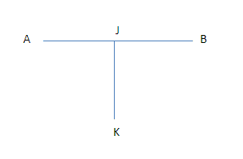

Figure 3:- Normal to a line [7]

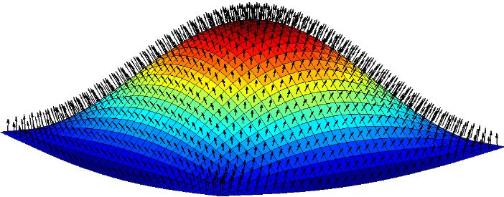

Figure 4:- Range of different Normals on a curved Surface [8]

### What is Reflection?

Reflection describes how a wave interacts at a reflective boundary, and rebounds, as shown in Figure 5. The angle of incident and the angle of reflection is always identical in pure reflection.

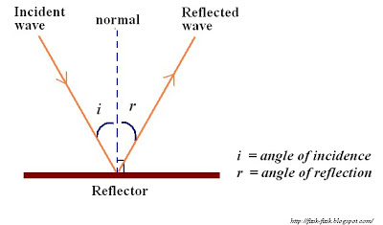

Figure 5:- Wave Reflection off a Boundary [9]

There are two main types of reflection, depending on how the wave connects to the boundary, fixed and free end reflection. In fixed end reflection when a wave hits the boundary, its reflection will be inverted, shown in Figure 6. Whereas in free end reflection the reflected wave will not be inverted, as shown in Figure 7 [10] [11].

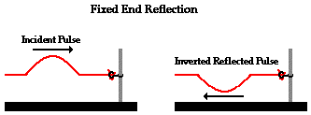

Figure 6:- Fixed End Reflection

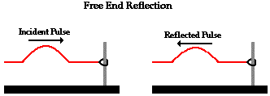

Figure 7:- Free End Reflection [12]

### What is Refraction?

Refraction is caused by a wave changing speed, if it slows down then it bends towards the normal, whereas if it speeds it up it bends away, both are shown in Figure 8. By using Figure 9 as a reference, how much a wave bends is governed by Snells law shown in Equation 1 which is used to calculate the refraction angle.

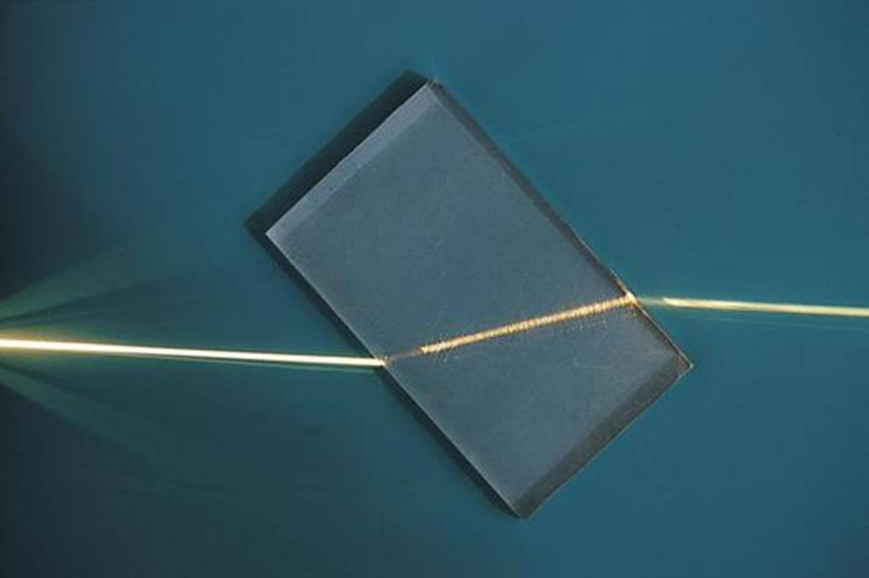

Figure 8:- Light Passing through a glass slab [13].

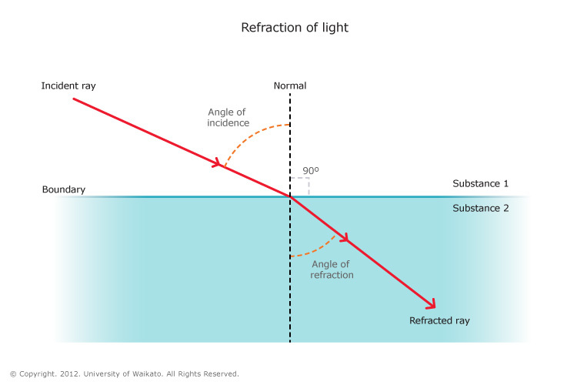

Figure 9:- Refraction of Light [14]

$$\frac{c_{i}}{c_{r}}=\frac{n_{r}}{n_{i}}=\frac{sin\left(θ_{i}\right)}{\sin\left(θ_{r}\right)} \\ where: \\ c_{i}=\begin{matrix}is the speed of light in \\ the incedence material \end{matrix} \\ c_{r}=\begin{matrix}is the speed of light in \\ the refracted material \end{matrix} \\ n_{i}=\begin{matrix}is the reactive index in \\ the incedence material \end{matrix} \\ n_{r}=\begin{matrix}is the reactive index in \\ the refracted material \end{matrix} \\ θ_{i}=is the angle of incidence \\ θ_{r}=is the angle of refraction$$

Equation 1:- Snells Law [15]

#### What is the Critical Angle?

As the angle becomes more extreme, at a boundary where the wave speeds up, eventually the angle of refection approaches 90° as shown in Figure 10. After this total internal reflection occurs as shown in Figure 11. The formula to find the Critical angle is found in Equation 2.

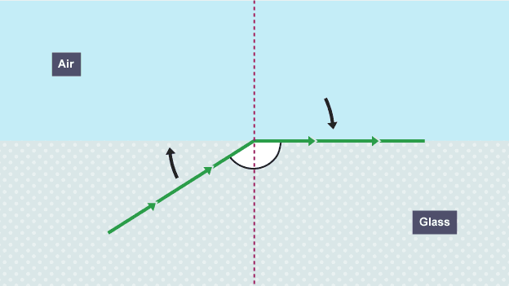

Figure 10:- Critical angle [16]

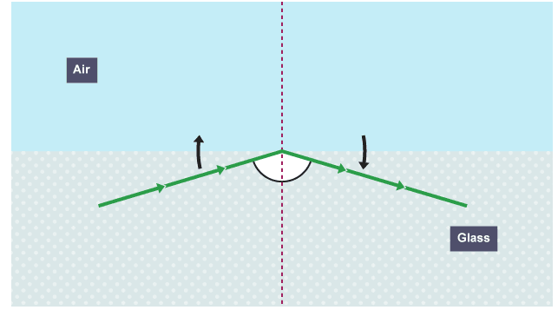

Figure 11:- Total Internal Reflection

$$\frac{n_{r}}{n_{i}}=\frac{sin\left(θ_{i}\right)}{\sin\left(θ_{r}\right)} \\ \frac{n_{r}}{n_{i}}=\frac{sin\left(θ_{c}\right)}{\sin\left(90\right)} \\ sim\left(θ_{c}\right)=\frac{n_{r}}{n_{i}} \\ where: \\ θ_{c}=the critical angle$$

Equation 2:- Critical Angle Equation

### What is Diffraction?

Diffraction is how waves separate after passing an object and obstacle. How much a wave diffracts depends on the wavelength and the gap width. For gaps close to the wavelength, signals diffract more, shown in Figure 12 a) compared to one much wider than the wavelength, shown in Figure 12 b). However, with the same fixed obstacle in the way, waves with longer wavelength will diffract more than waves with a shorter one, shown in Figure 12 c). As frequency and wavelength are related as shown in Equation 3, means lower frequencies have an increased ability to diffract compared to a higher frequency.

|  |  |
| --- | --- |
| 1. Wave passing through gap close to the wavelength. | 1. Wave passing through gap larger than to the wavelength. |
| 1. The effect of wavelength on diffraction. | |

Figure 12:- Diffraction based on different gapes and obstacles [17]

$$V=λf \\ where: \\ V=speed of the wave \left(ms^{-1}\right) \\ λ=the wavelenth of the wave \left(m\right) \\ f=frequency of the wave (Hz)$$

Equation 3:- Wave Speed Equation [18]

## What are RF Propagation losses?

An RF signal can travel extreme distances and still be recognisable, however they sometimes cannot go that far at all, sometimes barely into the next room never mind another continent. For example, a Wi-Fi Router, depending on where it is placed and what the walls are made of, can give a signal throughout the entire house, except in one specific room. This is caused by RF Propagation losses, which affects how far RF signals can travel. These losses are dependent on many factors including what medium it is travelling through. As well as objects in the signal’s way, like a door, tree, or mountains, which is why opening a door allows devices to connect [18].

For RF signals going vast distances however there are four main propagation methods, Free Space Path Losses, Ground Wave Propagation, Ionospheric Radio Propagation and Tropospheric Propagation.

### Free space Path Losses

Free space path losses, for when the transmitter and receiver have an unobstructed line of sight, as shown in Figure 13, in this case, the signal level for transmitting are found using Equation 4.

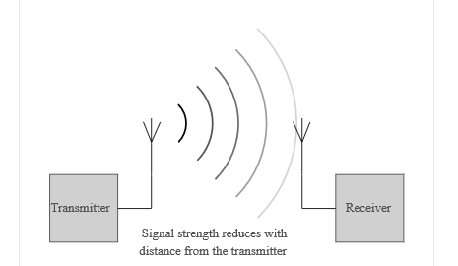

Figure 13:- Free Space Propagation Signal Level

$$signal level=\frac{k}{d^{2}} \\ where:k=contant \\ d= \begin{matrix}is the distance between the \\ transmitter and reciever\end{matrix}$$

Equation 4:- Free Space Propagation Losses

In free space, the loss between the transmitter and the receiver can be calculated using Equation 5 for wavelength and Equation 6 for frequency, this means higher the frequency, higher the losses.

$$L_{FSP}={\left(\frac{4πd}{λ}\right)}^{2} \\ where: \\ L_{FSP}= Free space path loss \\ d=\begin{matrix}is the distance between the \\ transmitter and reciever (m)\end{matrix} \\ λ=signal wavelength (m)$$

Equation 5:- Free Space Path Loss (wavelength)

$$L_{FSP}={\left(\frac{4πfd}{c}\right)}^{2} \\ where: \\ L_{FSP}= Free space path loss \\ d=\begin{matrix}is the distance between the \\ transmitter and reciever \left(m\right)\end{matrix} \\ f=signal frequncy \left(Hz\right) \\ c=speed of light (ms^{-1})$$

Equation 6:- Free Space Path Loss (frequency)

For an isentropic antenna, (that transmits uniformly in all directions), the losses in Decibels can be calculated using Equation 7, transmitter and receiver losses are added in with Equation 8.

$$L_{FSP}=20\log\left(d\right)+20\log\left(f\right)+32.44 \\ where: \\ L_{FSP}= Free space path loss \left(dB\right) \\ d=\begin{matrix}is the distance between the \\ transmitter and reciever \left(km\right)\end{matrix} \\ f=signal frequncy \left(MHz\right)$$

Equation 7:- Free Space Losses in dB

$$L_{FSP}=20\log\left(d\right)+20\log\left(f\right)+32.44+G_{tx}+G_{rx} \\ where: \\ L_{FSP}= Free space path loss \left(dB\right) \\ d=\begin{matrix}is the distance between the \\ transmitter and reciever \left(km\right)\end{matrix} \\ f=signal frequncy \left(MHz\right) \\ G_{tx}=\begin{matrix}Overall Transmitter Antenna gain \\ \left(including feeder losses\right)\end{matrix} \\ G_{rx}=\begin{matrix}Overall Reciever Antenna gain \\ (including feeder losses)\end{matrix}$$

Equation 8:- Free Space Losses in dB including transmitter and receiver losses. [19]

### Ground Wave Propagation

For Ultra Low Frequency ULF (300 Hz - 3 kHz), Very Low Frequency VLF (3 kHz – 30kHz), Low Frequency LF (30 kHz – 300 kHz) and Medium Frequency MF (300 kHz – 3 MHz) [20] ground wave propagation allows them to be transmitted much further than line of sight. These frequencies rely on ground wave propagation to propagate beyond the horizon. Ground wave propagation occurs for RF signals in the D region of the ionosphere, which is the region shown in Figure 14.

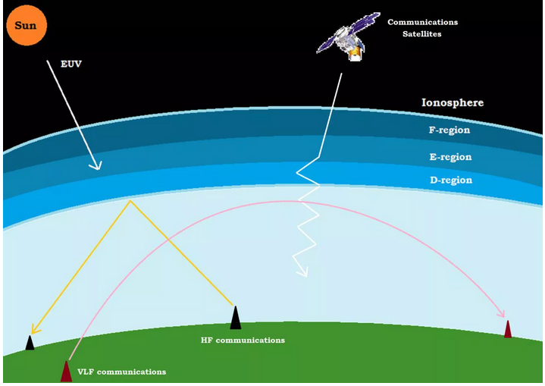

Figure :- Layers of the Ionosphere [21]

Ground wave propagation works by the RF signal spreading out while it travels, through diffraction this allows it to curve around the horizon and beyond the line of sight, shown in Figure 15.

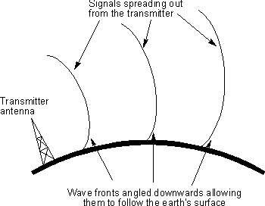

Figure :- Ground Wave Radio Propagation [22]

The amount the signal differentiates depends on many factors, including terrain and frequency. Meaning this propagation method becomes difficult at the bottom end of the High Frequency HF (3-30MHz) band. Because of this 3MHz signals suffer attenuation losses of 20-60 dB or higher compared to 500 kHz through this method. Meaning that High-Power Radio Broadcast stations broadcasting in HF can only be received for a few kilometres using only ground wave propagation.

The terrain the RF signal travels across also matters as it affects the attenuation, especially at lower frequencies, as ULF-LF can travel through the earth’s crust down to about 100m depending on the terrain’s material, this means transmitting over an ocean gives great transmission distances, agricultural land and marshy land is good but the worst by far are sandy and urbanised terrains like deserts, towns and cities.

### Ionospheric propagation

Ionospheric propagation affects HF (3-30 MHz) signals, this effect occurs when a skywave (an RF wave travelling away from earth), enters the ionosphere. Here some of the RF signal, if hitting at the critical angle or beyond, is reflected off the ionosphere. Thus allowing RF signals to propagate further than normally possible. As Figure 14 shows the ionosphere regions, these regions all differ in the amount of ionisation, the regions are:

* D region: This is the first region the skywaves high, this region attenuates the signal as it passes through, the amount it does do depends on the frequency in general, higher the frequency lower the attenuation.
* E region: This is where HF RF signals are refracted back to earth as well as some MF signals, there is some attenuation in this area, but it is much less severe than in the D region.
* F Region: This layer enables worldwide HF propagation, as signals that manage to pass through D and E and reach here, will be refracted returning to earth, often allowing the HF signals to transmitted across the world. During the day this region often splits into two separate regions named F1 and F2.

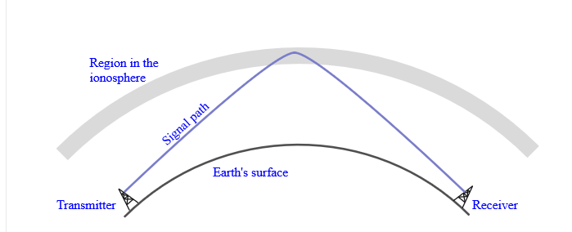

Figure 16:- Basic concept of ionospheric propagation [23]

### Tropospheric Propagation

Tropospheric Propagation operates on mainly Very High Frequency VHF (30-300 MHz), Ultra High Frequency UHF (300 – 3000 MHz) and some Super High Frequency SHF (3 – 30 GHz). The actual frequency range is roughly around 50 MHz to 10 GHz [24]. Although it is normally thought VHF-UHF waves require line of sight to transmit and receive them, it is often not the case, as these signals can be detected 500 – 1000 km away and sometimes even further, depending on the weather. This is because Tropospheric Propagation improves their range, as the RF signal is consistently refracted in the air, because the airs refractive index varies with height, as at ground it is approximately 1.0003 (varying between 1.00027 and 1.00035). Because of the tiny variations N units were introduced to make these small fluctuations easier to quantify, shown in Equation 9, and means the atmosphere varies between 270 and 350 N units.

$$N=\left(mu-1\right)*{10}^{6} \\ where: \\ N=\text{N }units, \\ mu=refraction index$$

Equation 9:- N Units Equation

As the skywave travels further away, the refractive index of air reduces by around 400 N/km or 0.0004 for every kilometre, meaning the RF signal refracts, allowing the RF signal to follow the earth’s curvature, thus travelling beyond the horizon. The actual distance it travels depends on several different factors including weather and frequency. However, waves under near perfect conditions can be transmitted as far as 2000 - 3000 km. These distances are caused by a much greater change in the refractive index than normal [25].

Because of this variance, forecasts for RF signal propagation called the Tropospheric Ducting Forecast, are created. These show predictions for the next 6 days, with one every 6 hours for the next 42 hours. An example prediction for Europe is shown in Equation 13 [26] [27].

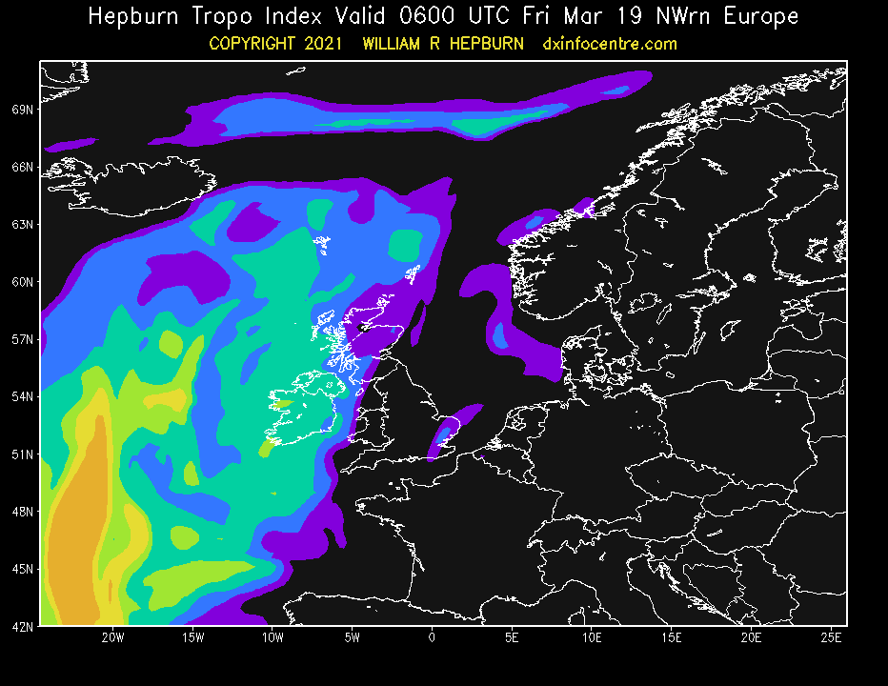

Figure 17:- Tropospheric Ducting Forecast for 19th of March 2021 [28]

## Antenna Tunning Units

### What is an ATU?

An Antenna Tuning Unit (ATU) or Antenna Tuner is a device used to impedance match to reduce SWR and maximise transmission power. This makes them important sections of any transmission device, as they minimise risk to the components.

### What is SWR?

EMC waves travelling through a conductor from a transistor has the follows ohms law, shown in Equation 10, this is shown in Figure 18.

$$\frac{I}{I}=Z_{0} \\ Where \\ Z_{0}=\begin{matrix}impedance of \\ a HF line\end{matrix}$$

Equation 10:- Ohms Law for EMC

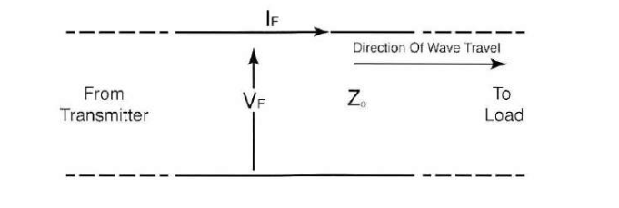

Figure 18:- Direction of Wave Energy Flow

The signal travels down the line until reaching the load, where the signal separates into two sections:

1. Some is absorbed by the load (usually an antenna), this is the useful power.
2. The rest is reflected, creating the situation that can be seen in Figure 19.

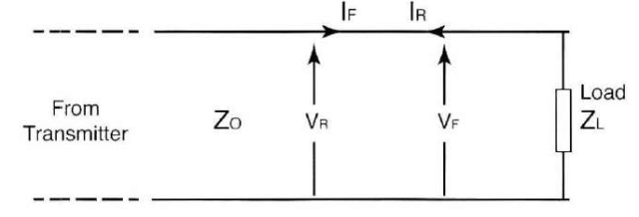

Figure 19:- Forward and Reverse Waves on a Transmission Line

In most situations two signals are acting on a line, one forward and one reverse. With this knowledge Equation 11 can be found for the reflected voltage.

$$Z_{L}=\frac{V_{F}+V_{R}}{I_{F}-I_{R}} \\ given:{ I}_{F}=\frac{V_{F}}{Z_{0}}, I_{R}=\frac{V_{R}}{Z_{0}} \\ Z_{L}=\frac{V_{F}+V_{R}}{\frac{V_{F}}{Z_{0}} -\frac{V_{R}}{Z_{0}}} \\ Z_{L}=\frac{Z_{0}\left(V_{F}+V_{R}\right)}{V_{F}-V_{R}} \\ Z_{L}V_{F}-Z_{L}V_{R}=Z_{0}V_{F}+Z_{0}V_{R} \\ Z_{0}V_{R}+Z_{L}V_{R}=Z_{L}V_{F}-Z_{0}V_{F} \\ V_{R}=V_{F}\frac{Z_{0}-Z_{L}}{Z_{0}+Z_{L}}$$

Equation 11:- Reverse voltage bases on impedances and forward voltage.

This shows if $Z_{0}=Z_{L}$, then the reflected voltage will be 0 however, if $Z_{L}=∞$, (the load was not connected) then $V_{R}=V_{F}$, which causes the line voltage to double. This can be then adapted into the reflection coefficient, as shown in Equation 12

$$ρ=\frac{Z_{0}-Z_{L}}{Z_{0}+Z_{L}}$$

Equation 12:- Reflection Coefficient

The relationship between the forward and reflected signal is called the Standing Wave Ratio (SWR). This can be separated into Voltage Standing Wave Ratio (VSWR) and Current Standing Wave Ratio (ISWR), but ISWR and VSWR are normally identical, so SWR is used. SWR is calculated using the Equation 13 [29] [30].

$$SWR=\frac{1+|ρ|}{1-|ρ|}$$

Equation 13:- SWR Equation

### How do ATUs work?

As mentioned ATUs are used to match impendence, this is usually done through an LC filter, which is varied to meet the desired impedance. An example of a common ATU design is shown in Figure 20. By changing the capacitance and inductance in a system the impedance of the amplifier device is changed, this then changes ρ, thus changing SWR. By tuning the filter correctly for the desired frequency SWR can be minimised increasing efficiency (sometimes dramatically) [31] [32].

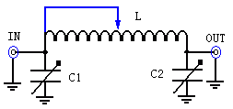

Figure 20:- Basic ATU diagram [33]

## Thermionic Emmsion Valves

### What is Thermionic emission?

Metal is electrically conductive because the outermost electrons become free and able to move in the material. As the number of missing electrons are the same as the number of free electrons, the material is stable. This means if a potential difference is applied across a metal the electrons will flow. However, they will not become dislodged from the material, to do this the electrons need additional energy, one method used is heating the material, this allows electrons to become free more easily as shown in Figure 21.

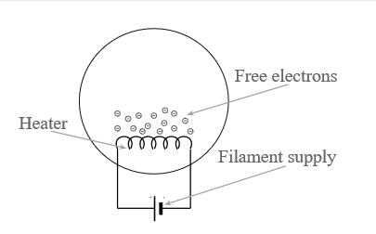

Figure 21:- Thermionic Emission

### What is a Thermionic Emission Valve?

A Thermionic Emission valve has many other names like Vacuum Tubes, Electron Tube and sometimes just Valve. They were first invented in the late 17th century, but it took till the 1850s before they could be mass-produced that they became more common. It is because it wasn’t until then that technologies such as glass blowing, vacuum pumps and Ruhmkorff induction Coil enabled this increased production.

Initially, valves and valve diodes were used in a many application like Alternating Current (AC) to Direct Current (DC) rectification (AC/DC Rectification), common amplifiers, RF broadcast, TV, and Radios, as well as many other technologies throughout the 20th century [34]. However, they were replaced by other technologies like LCDs and semiconductors at end of the 20th century and beyond. However, despite valves uses dwindling recently, they still have a use today, for example in devices like guitar amplifiers, high-fidelity audio amplifiers and high-power transmitters.

### How do Thermionic Emission Valve work?

Thermionic Valves are fundamentally a sealed-glass or metal-ceramic enclosure normally containing a vacuum, and operate around the concept of thermionic emission, to make the cathode electrode emit the electrons more readily. By adding a second electrode called the anode, and by adding potential difference (voltage) between the electrodes, then electrons are attracted to the higher potential, and thus a current would flow. It is possible to by adding another element, called a grid, which is normally made of gauze (a thin metal woven mesh [35]) the electron flow could be controlled by varying the voltage on this grid [36]. Figure 22 shows a triode symbol.

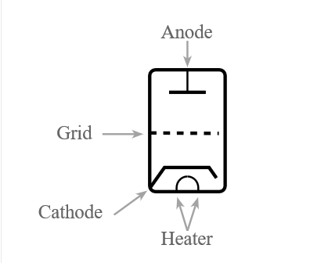

Figure 22:- Circuit symbol for the triode vacuum tube / valve showing the electrodes.

### What are Valves Made of?

The materials the valve is made of are important as it severely impacts how they operate.

* **The cathode** is an electrode that is heated to emit the electron via Thermionic Emission. Generally, it is made of pure tungsten, thoriated tungsten or an oxide blend of calcium, barium, and strontium.
  + Tungsten Cathode, its theoretical life depends on its evaporation rate however, it can operate under complete saturation (all electrons emitted are attracted to the anode plate). Its emission is around 7 mA per watt of heating power with a working temperature around 2550 °K (bright yellow). This temperature can be lowered allowing the valve to operate for much longer all be it with a lower emission rate. Its expected life is shown in Figure 23.

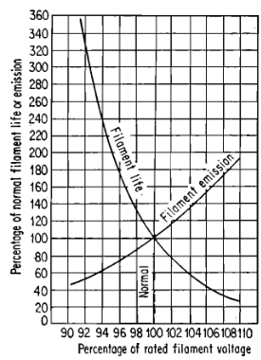

Figure 23:- Effect of filament voltage on the life and emission of a tungsten filament

* + Tungsten Cathode, by adding approximately 2% Thorium to a tungsten cathode, the emission of a cathode can be increased at lower temperatures. This allows emissions of 70-100 mA per watt at a working temperature of 2000 °K (bright yellow).
  + Oxide-coated cathode usually only used in valves with a plate dissipation under 100W in operation, which have an emission of around 200 to 300 mA per watt at a working temperature of around 1060 °K which is a dull red colour.
* **Filament/heater** is often separate from the cathode and heats it indirectly, the advantage of this approach is entire cathode will be at the same potential, rather than a slight change which can create a hum on the output signal however, this hum can be eliminated with a filter and using DC can help as well. In higher-power devices however, the shape of the cathodes shape means it is hard for indirectly heating so they are often combined.
* **The grid** is normally a mesh close to the cathode and heater meaning it must be able to dissipate any heat absorbed, as the self-generated heat is negligible. The grid material is determined by its proximity to the cathode and its working temperature. The most common metals are Tungsten, Molybdenum, Tantalum and Nickel-Manganese alloys and can be plated in Gold or Platinum to reflect some of the heat to the cathode, this also minimises oxidisation in the grid. Platinum is often chosen over gold due to its higher melting temperature. The grid by controlling the grid’s potential when the valve conducts can be controlled.
* **The Anode** is made of depends on the cathode, and the about of heat dissipated, Tungsten, Molybdenum, Graphite or Tantalum are normally used in higher powers. Tungsten is hard to work with so is rarely used and each metal has their benefits and disadvantages, so they are often selected based on the specific use case [37].

### Why is Valve Matching impotant?

When using two valves in parallel, the valves require matching. This is because without it, one device can get hotter than the others, which means it will experience more wear than another device, leading to a loss of clarity and definition. Whereas in a matched device they have been optimised for longevity and cause no loss in clarity and definition.

### How are Valves Matched?

A valve is matched mainly through its plate current, this works by making sure the plate currents in the two valves are within a certain amount of each other. This means a similar current pass into the plates, meaning the temperatures on the plates is similar between devices. Transconductance is also sometimes matched, ensure any voltage changes causes a similar reaction in all matched valves, which is important as it allows valves to be matched over a wide range of plate currents rather than just one [38].

### Who still makes valves?

Valves are manufactured by several different companies still, but the one being used is called Shuguang, which was initially set up on the 26th of December 1965, as a numbered factory (#770) providing Thermionic valve to the Chinese Military. When they first opened, they were brandless and were heavily guarded by military personnel. Shuguang means “dawn” which referred to the start of “Red China”, (Communist Control of China). At the time China had very few electronics manufactures and might be the only one which survived the 55 years till now.

Initially, they produced for the Chinese Military, opening up to the global market in 1983. Shortly after demand dropped and began other ventures however, they still produce valves to this day, in 2015 they produced around 80% of the global supply of the 300B Vacuum Tube [39]. Their valve can be purchased from several distributors like Alibaba and The Amp Doctor.

## Why are valves being used over semiconductors?

Because of their inherent ability to deal with low voltage, high current situations, in low power analogue and digital circuitry, semiconductors are the better choice over valves. However, in a high-power high voltage (HV) Linear amplifier these advantages at lower powers are no longer present, this is because a valve is inherently suitable for HV. This means by increasing the power, valve becomes more feasible compared to semiconductors. These semiconductors can however create this HV output, but they require transformers adding an extra stage of loss. On top of this valves can deal with large VSWR due to impedance mismatching for short periods, whereas semiconductors fail or avalanche under high amounts of VSWR.

Cost is another factor, again in lower power systems the cost of a valve is significantly higher than solid-state devices, but as the power goes up, the cost of solid-state devices goes up significantly compared to the valve. Figure 24 i) shows this cost difference, while this graph is from 1998 similar relationship still applies today, however the cross over may be at more powerful devices. Although this platform initial power might be under this threshold, the platform will be a scalable device, so these higher power situations might be operated in.

|  |  |
| --- | --- |
| i) | ii) |

Figure 24:- Normalized cost vs power of valve vs Solid-State [40]

Another factor is most RF transistors often provide few watts each, meaning if high-power outputs are required then multiple RF transistors are needed in parallel, compared to a single valve which can output a few hundred watts, making the system simpler. However, some semiconductors can provide this power it is often at lower voltages, high current and price unless a much narrower operating frequency than a valve is desired.

The frequency used also affects it, as a valve has a higher average output power compared to a semiconductor at high frequencies, as shown in Figure 24 ii). This shows a vacuum devices power on average is significantly higher than semiconductors at high frequencies. Although in most amplifiers this isn’t required, in a RF Linear Amplifier these higher powers are likely to be used.

## What are the requirements for a HAM radio transmit?

In the UK, HAM operators must first obtain an Amateur Radio License before transmitting. This is because of the wide range of freedoms given to operators, for example building their own equipment.

The UK has three licences, foundation, Intermediate and Full, each level has different permissions for the different levels of ability, but the main restrictions are in transmitting powers and allocated RF bands. For a foundation license, the maximum transmitting power is 10W on most allocated bands and band allocations are limited. Intermediate licence this increases to 50W and a Full license increases it to 400W again and grants access to all UK HAM Radio bands. The allocated bands for 192 kHz to 21 MHz is shown in Figure 25, and for frequencies above 21 MHz they are in Figure 98, Figure 99, Figure 100 and Figure 101 [41] [42].

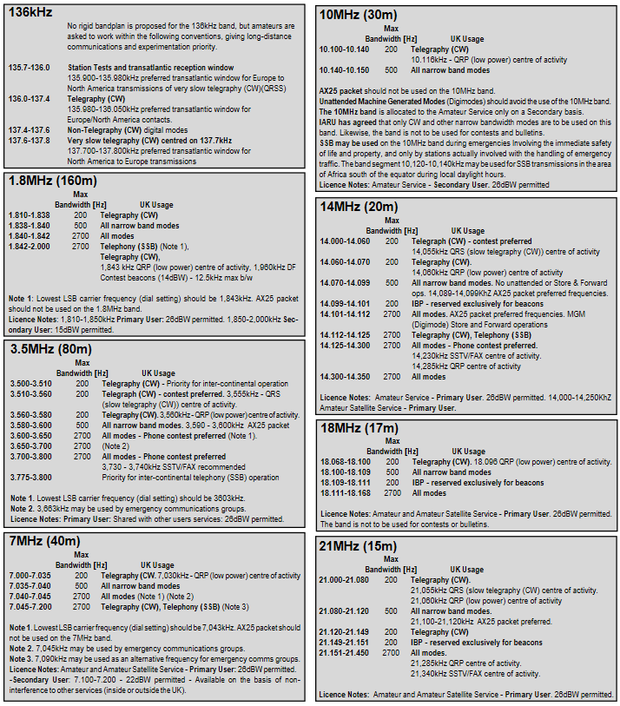

Figure 25:- HAM Radio Bands (182 kHz to 21 MHz)

## What in the design is new?

This project will be digitising traditional analogue circuitry and converting it to an experimentation platform. It will support both older and more modern technologies as although initially, it will be a valve amplifier, future support for various transistor amplifier may be added. On top of this digital ICs will be used for automatic measurement of voltage, current and SWR. The input and output RF signals will be fed into Software Defined Radios (SDR) and if need a Vector Network Analyzer (VNA) allowing live monitoring of the RF signal harmonic content. This will enable monitoring of the RF signals to check for distortion in the signals. Although these analysis circuits have been done before, it was all in isolation of individual test instrument, this project will pull all sections together into a modular low-cost integrated design solution.

# What was the Design process used?

The design process used, is the Design Process developed by the U.S. Government and NASA, this includes several different topics program/contract metrics, staffing, risks budget and schedule. And has 11 main steps, these steps in the order of completion, are:

1. **Mission Concept Review (MCR)**

The MCR examines the end goal objectives and proposes a method of completing them.

1. **System Requirement Review (SRR)**

The SRR examines functional and performance requirements. It also lays out an initial plan for meeting the objectives, confirming it will meet all goals.

1. **Mission Definition Review (MDR)**

The MDR examines the proposed requirements, overall architecture, and core components of the project. It confirms the project is achievable, and the proposed plan will achieve the project goals.

1. **System Design Review (SYDR)**

The SYDR examines the System Architecture, investigating how it affects the design as well as all functioning components of the overall system.

1. **Preliminary Design Review (PDR)**

The PDR confirm the design meets the requirements, and no excessive risks exist, it’s within budget and time constraints. It also shows the correct decisions were made, and the design interfaces are applicable for the task.

The most common objectives of the review are:

* The design complies with all system requirements which have been checked, assigned and then achievable and verifiable.
* Show the design complies with requirements and could operate without fault.
* Show the design is mature and does not have any faults.
* Show the design could be tested, confirmed it would work, additionally, any possible risk has been found, analysed and if possible, dealt with.

1. **Critical Design Review (CDR)**

The CDR shows the system’s maturity, to allow it to proceed into manufacturing, assembly, integration, and testing. Technical progress is also checked, ensuring its development it on time, requirements being met and it is within cost.

The most common objectives of the review are:

* The documentation of the project includes all specifications for hardware (e.g. material, engineering drawings) as well as software specifications meeting all relevant requirements for operation. [43]
* The designs have had an independent examination by other relevant engineering organisations and engineers.
* The manufacturing process and controls where were selected will be adequate for proceeding to fabrication.
* Set up any Quality Assurance (QA) tests and checks that are required to confirm the product will have a high quality.

1. **Production Readiness Review (PRR)**

A PRR is carried out to confirm that the device’s integration is possible into the wider system. It also ensures production and integration stages have the equipment and staffing required to allow production to start.

1. **Test Readiness Review (TRR)**

The TRR ensure all facilities, equipment, and skilled personnel for testing the functions of the system are available to begin.

1. **System Acceptance Review (SAR)**

The SAR confirms the product has a high maturity level and examines the designed device against other devices and expectations they hold for this one. The SAR also looks at the documentation, both test and production, to confirm it is a sufficient amount, which meets the requirements, to allow the device to be shipped/provided to the client/location.

1. **Operational Readiness Review (ORR)**

The ORR investigates a devices actual behaviour and other core features to ensure the deployed system requirements and the documented behaviours meet the deployed behaviours.

The most common objectives of the review are:

* Confirming the device can move to the operating mode, by checking all available test and demonstrations to this point results.
* The device can operate and supports all relevant states of operation, (e.g. nominal, fallback and unforeseen)
* Documentation about the device is complete and shows all information on modes of operation.

1. **Test Readiness Review (FRR)**

The TRR is an independent examination of all documentation especially tests, demos and similar, confirming the device has demonstrated an ability to ensure a safe and successful flight. It also confirms it will be operational for all its requires uses. Additionally, it confirms the hardware and software are ready for a full operation, and the operating personnel and procedures are ready to interact with this device.

The most common objectives of this review are:

* The device has certifications that it will operate safely during a flight with only the acceptable risk.
* All systems and supporting elements are configured to operate with this device, thus are ready for launch.
* Confirming any interfaces with this device are compatible, as well as operating as expected and within specification.
* Confirming the device supports the launch “go” condition, based on a go/no-go situation.

Although this process was designed for aerospace projects, it relates well to other projects as well. Although depending on the product it might need some minor adaption. The more common change is the FRR, which will be changed to Radio Transmission Readiness Review (RTRR), this however is a minor change as “flight” is changed to “transmit” [44] [45].

# Amplifier Design

## System Concept

First the initial concept for the design were hashed out with the client, and the objective were set. and a MCR was carried out.

1. It should have a scalable high-power output.
2. It should have a high frequency output on the HF HAM radio bands.
3. It should be affordable so its within reach for the average home HAM radio enthusiasts.
4. It should be able to be manufactured by an experienced home HAM radio enthusiast.
5. It should be configurable to operate within the legal limits for the UK.
6. It should have a failsafe design.
7. It should have internal monitoring so operating conditions and health can be monitored.
8. It should have an easily accessible user interface.
9. It should initially be a valve amplifier (for reasons mentioned above).
10. It should be able transmit an RF signal with minimal risk to the operator.

Using a MCR it was decided that the best solution would be a modular linear amplifier which using off the shelf components and/or components made with minimal skill (e.g. a custom toroid winding). For home constructors to access the design a github was made at the end of the project [46]. The system itself would have live monitoring of operation allowing the system to have failsafe by cutting the input and output signals in the event of a component failure or other detected faults. To do all this a known good design from the past was selected, modernised, and adapted meeting the objectives.

## System Architectre

The objectives that were created in the MCR were turned into requirements, shown in Figure 26, these meet the original objectives and add in additional design objectives.

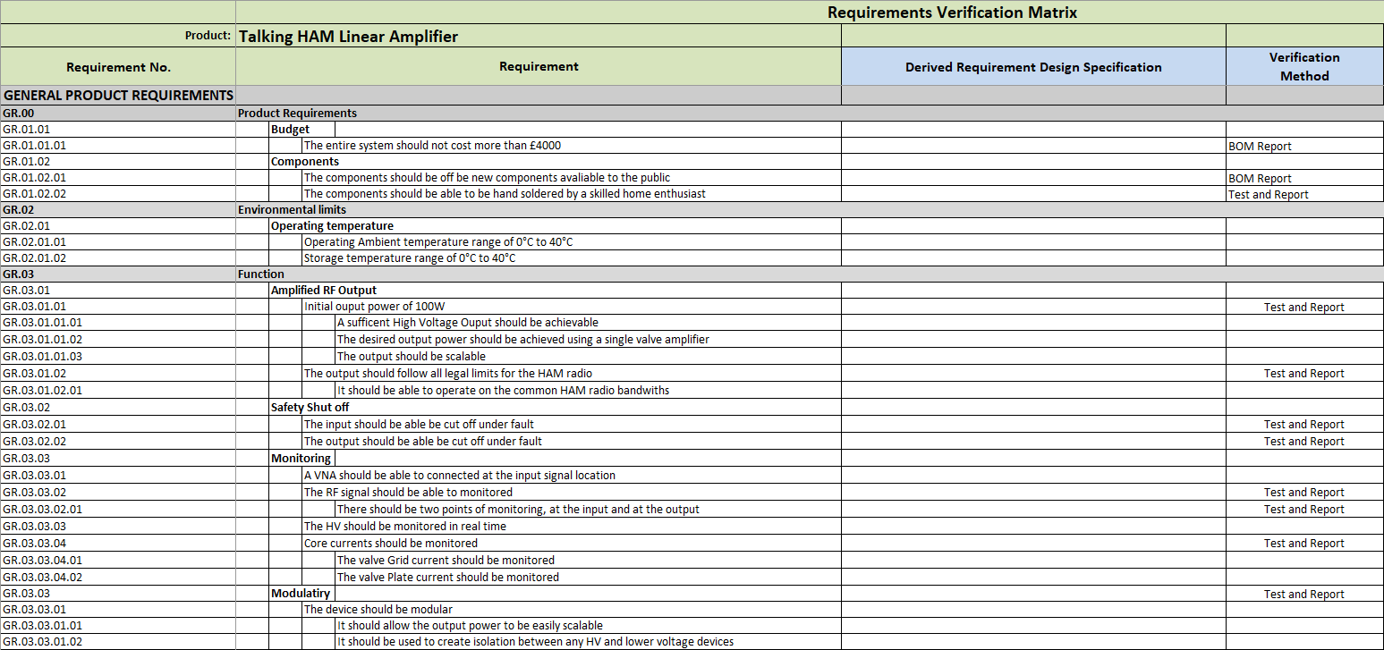

Figure 26:- Requirements for the Amplifier

A SRR was carried out, and an initial time plan was created, shown in Figure 27. This was thought to be more than enough time to achieve the objectives. Some risk existed from COVID-19, but it was thought this would be mitigated via using Mage Control Systems premises which are external to the university.

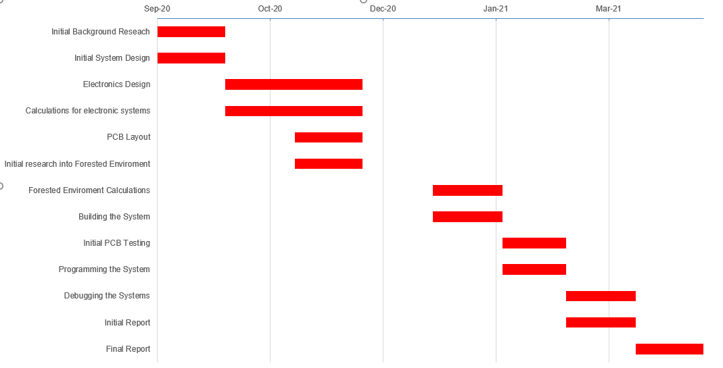

Figure 27:- Initial Gantt Chart

## Initial Overall System architecture

Two initial system architecture was then designed, as shown in Figure 28 and Figure 29 these show the overall idea with how the device will be operate.

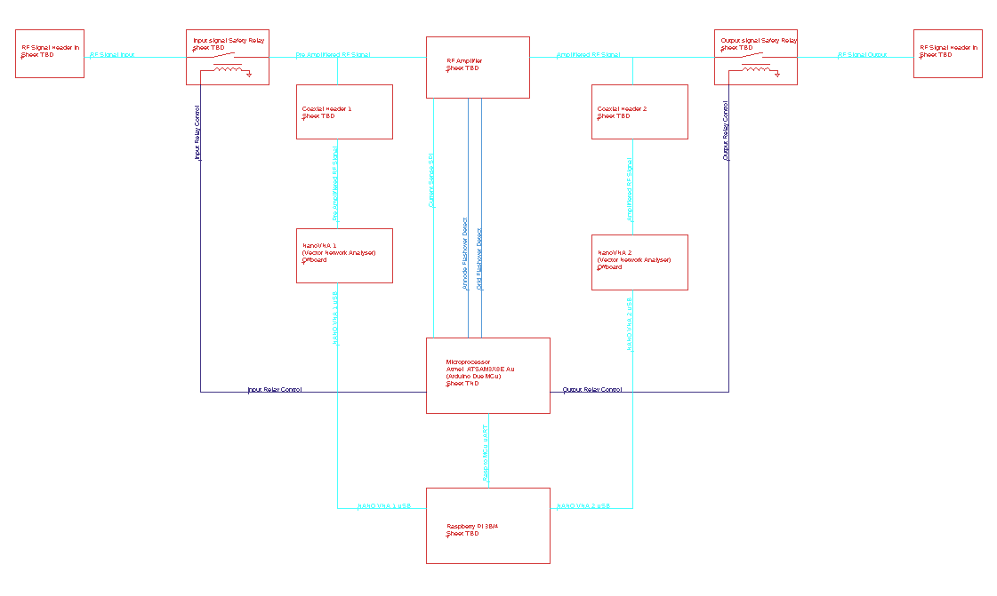

Figure 28:- Initial System Architecture (Raspberry Pi + Arduino Due)

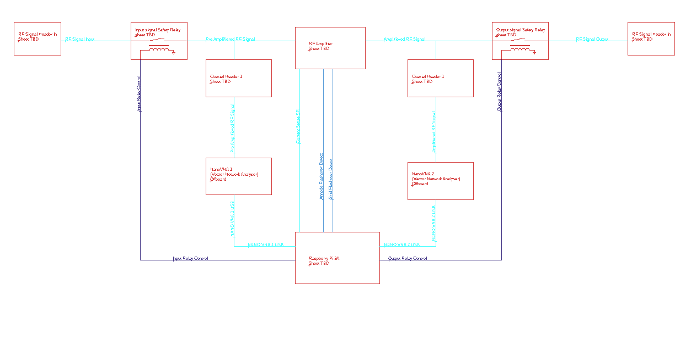

Figure 29:- Initial System Architecture (Raspberry Pi only)

These two possible system architectures were then compared. The only difference between them is one uses an Arduino Due and Raspberry Pi rather than just a Raspberry Pi, a comparison was then carried out as shown in Table 1. Ultimately the Arduino Due was chosen as the number of GPIO might exceed the Raspberry Pi offerings. Additionally, this separates the computationally load and a supervisory device for an additional layer of protection.

Table 1:- Raspberry pi vs Raspberry Pi and Arduino Due

|  |  |
| --- | --- |
| Arduino Due + Raspberry Pi | Raspberry Pi |
| More Expensive | Cheaper |
| More devices to programme | One device to programme |
| Two devices to control | One device control |
| Backup MCU to increase safety | One device to fail to cause issues |
| Command Translation required | No command translation required |
| Separated computing allowing offloading of easier tasks to the Arduino Due | All computing done on the Raspberry Pi |
| Specialised MCU designed for IO control | MCU not designed specially designed for IO Control |
| Significantly more digital IO | Significantly less digital IO |

Then a MDR was help on the system architecture, where the system architecture was analysed and was found to be too limited in scope, as it did not show everything it will need to operate. Because of the MDR the System Architecture was revised, into Figure 30, Figure 31 and Figure 32, these are more detailed system architectures, showing all circuit sections. However, with board being modularised later, another revision will be made when the schematics were finished. Also, individual boards should show what their sections are doing as well.

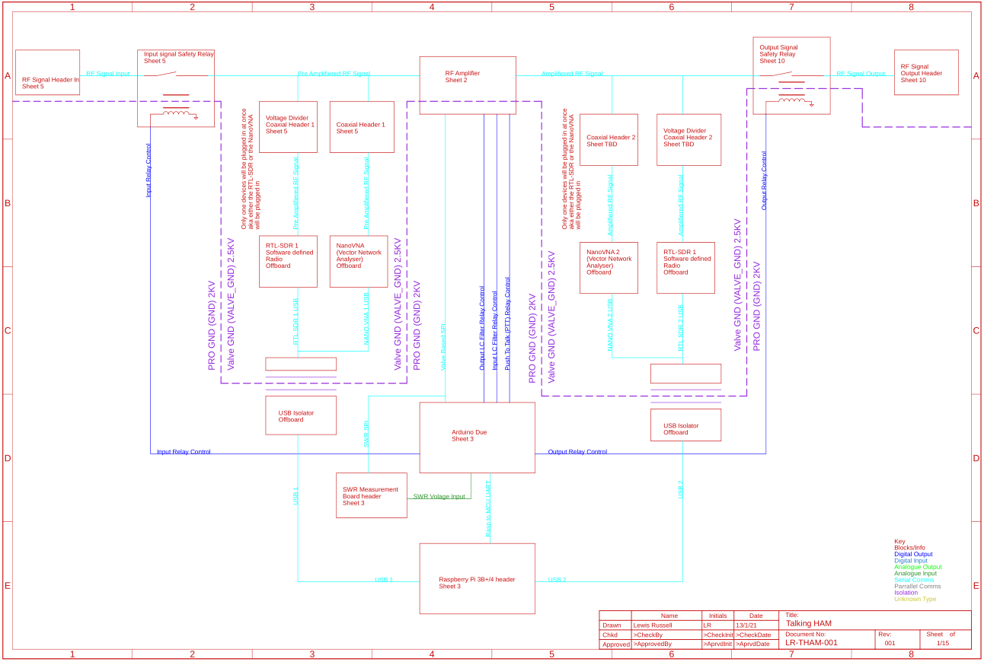

Figure 30:- Revised System Architecture Sheet 1

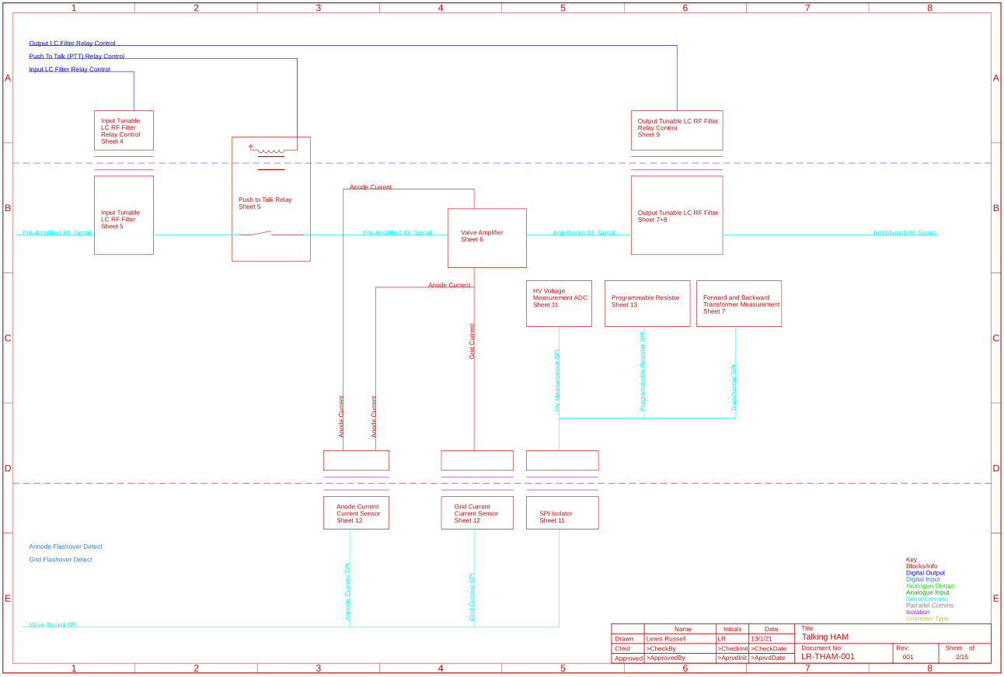

Figure 31:- Revised System Architecture Sheet 2

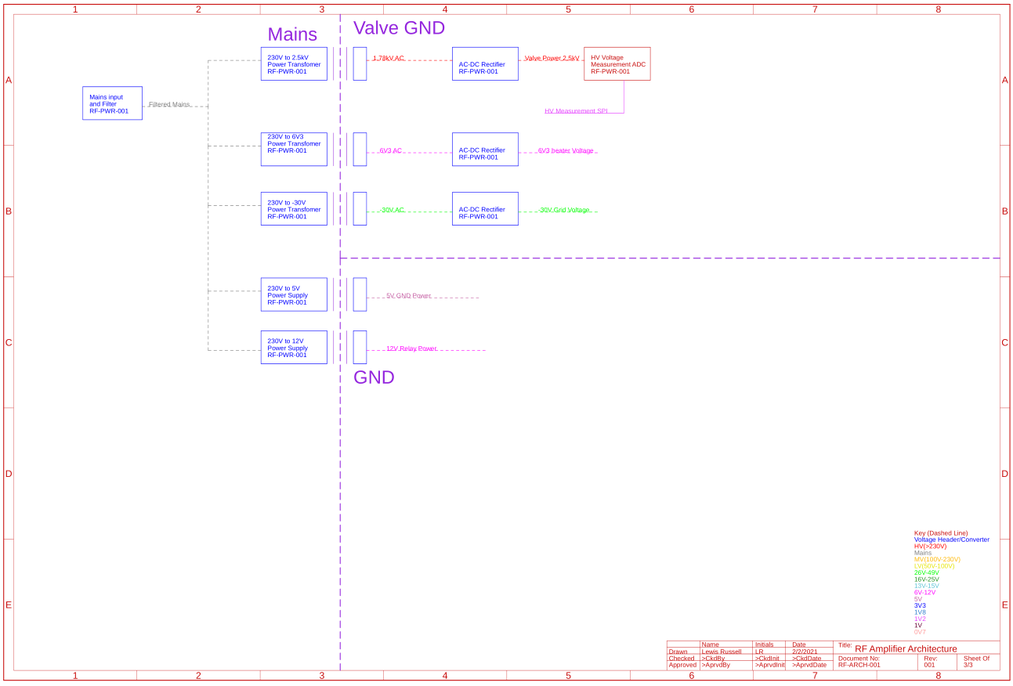

Figure 32:- Power Regulation Architecture

A second MCR was then carried out, and how the requirements will affect the design was then considered. The following things were decided:

* The initial version would ignore modularity until some level of maturity is shown. This is because this makes the schematics easier to review and also only one engineer is working on it.
* The temperature requirement is also minor as it is within standard operating temperatures, but components will be check to operate within this temperature, and components at risk of over temperature heatsinking would be added to minimise risk.

## Initial Schematic Design

A SYDR was then carried out to evaluating how the initial design would be created from the Architecture. It was thought initially the design would be built in a single schematic and then separated out. The initial design was a modified design from K.W. Electronics, (an electronics firm which specialised in Amateur Radio Electronics, founded in the 1950s and operated till the 1970s). The Amplifier chosen was the KW1000, which was manufactured during the 1970s [47] [48]. It was chosen as the base for the design because the schematics were legible and readily available and the KW1000 is a well-respected and good quality amplifier, so the design was built upon a robust, known good platform. The circuits used were from original Instruction manual [49] and a more legible modified version, with component valves and clear nets to allowing for the circuit to be more easily understood [50].

### Initial Design

The initial design is shown in Figure 33, Figure 34, Figure 35, Figure 36, Figure 37, Figure 38, Figure 39, Figure 40, Figure 41, Figure 42, Figure 43 and Figure 44.

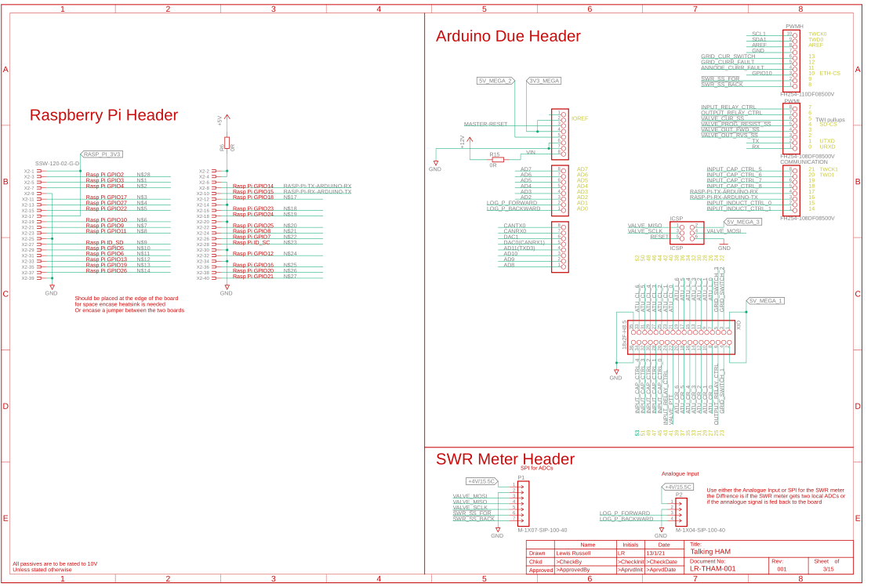

Figure 33:- Header Pin Out

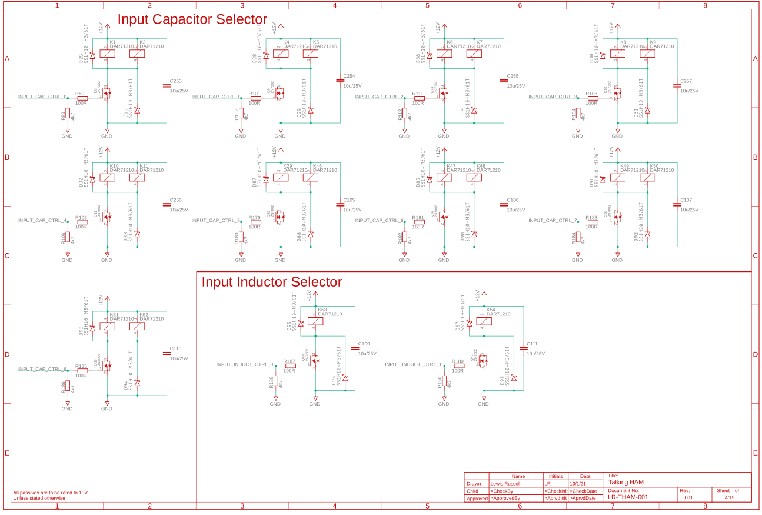

Figure 34:- Input Capacitor and Inductor Control

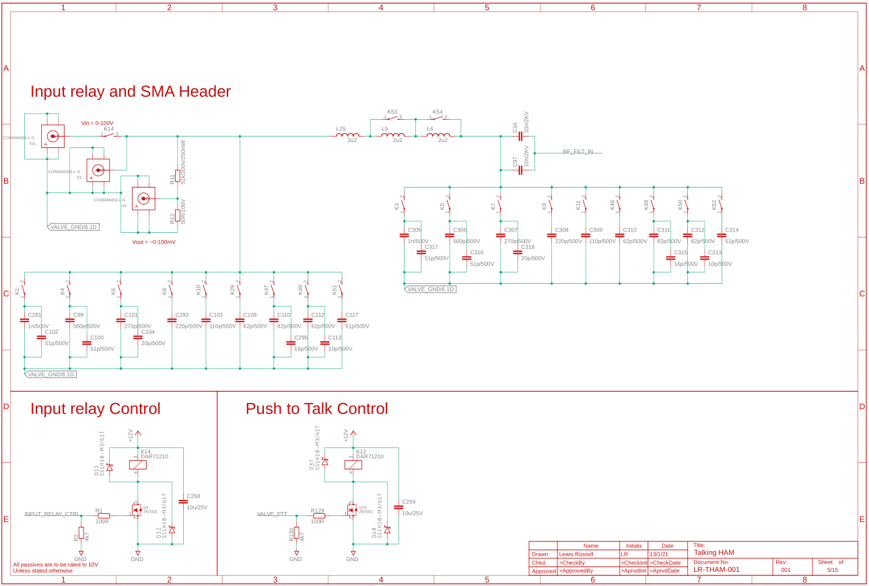

Figure 35:- Input and LC filter

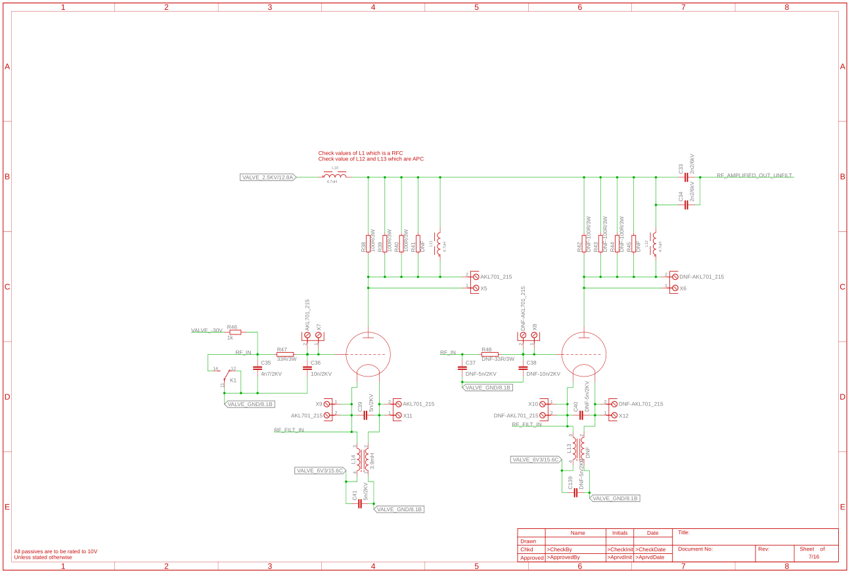

Figure 36:- Valve Amplifier

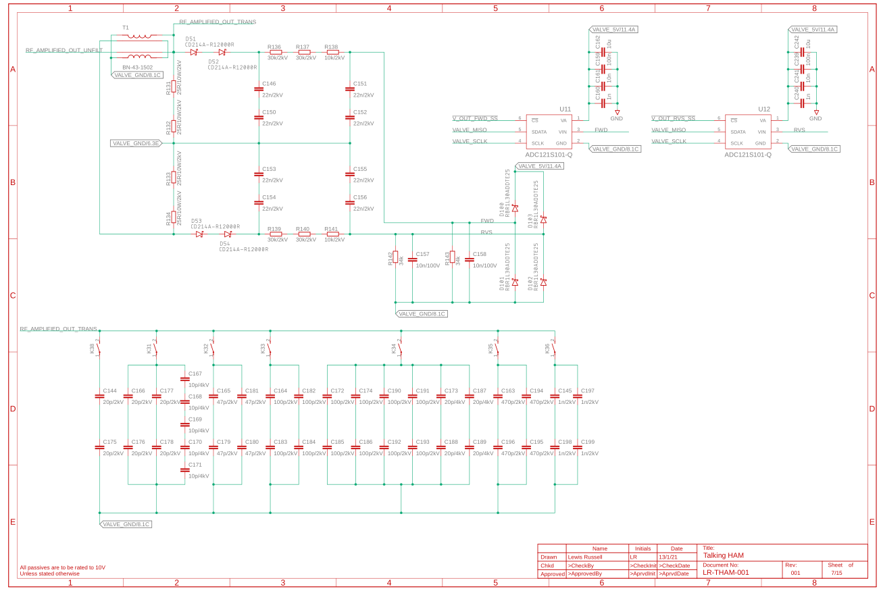

Figure 37:- SWR measurement and ATU part 1

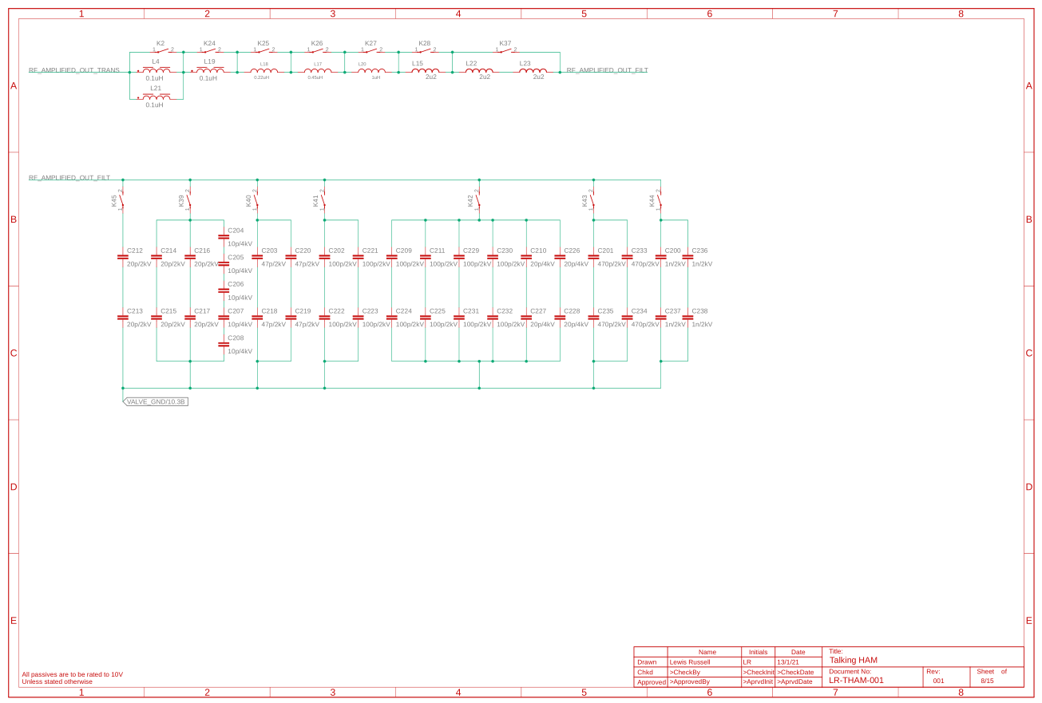

Figure 38:- ATU part 2

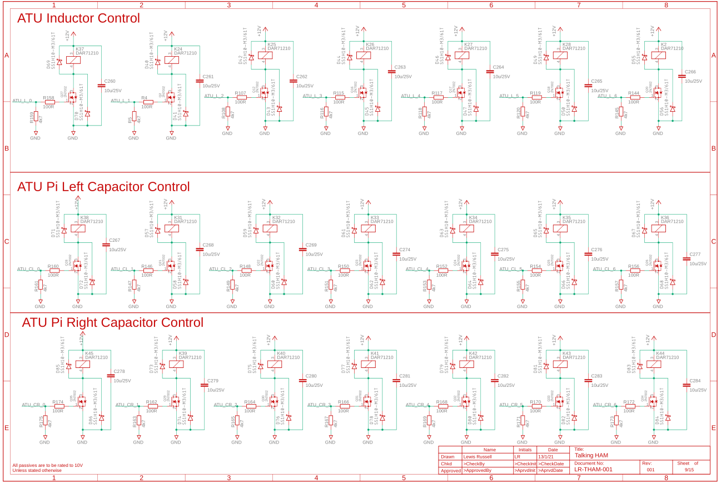

Figure 39:- ATU control

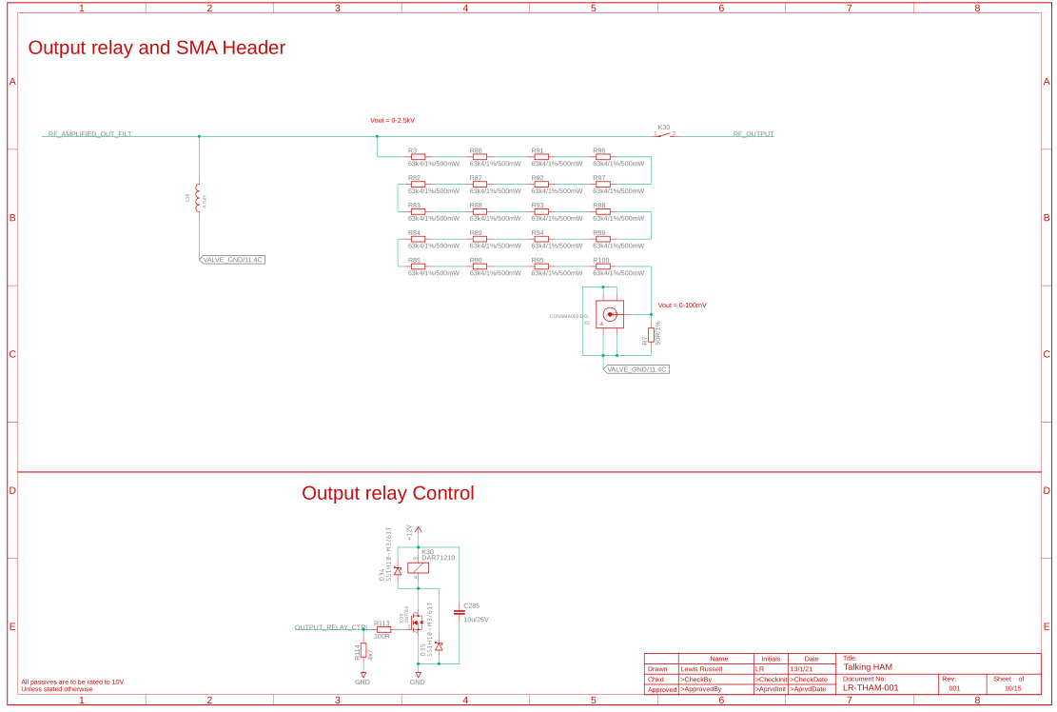

Figure 40:- Output and voltage divider for SDR

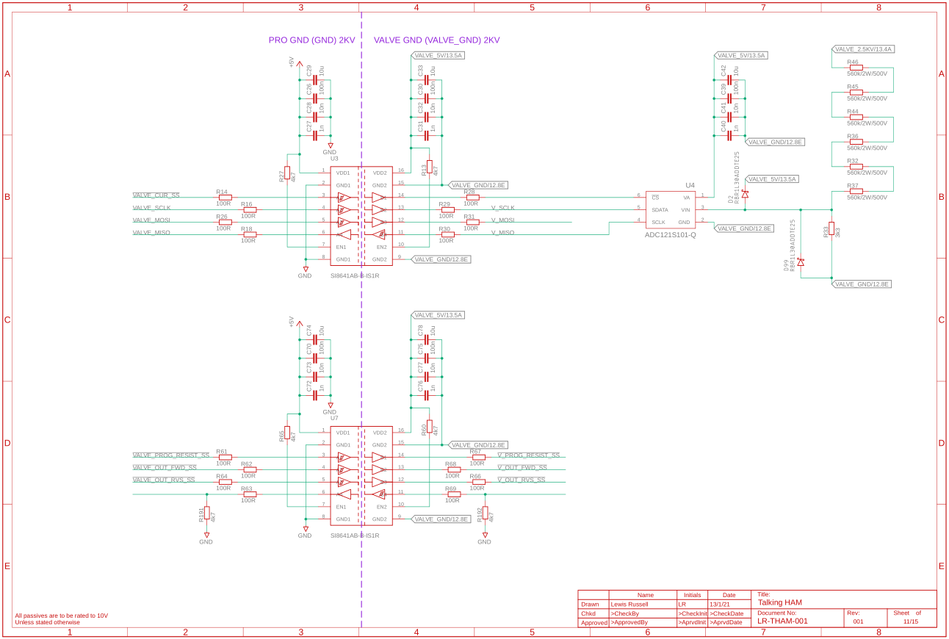

Figure 41:- Isolation and HV measurement

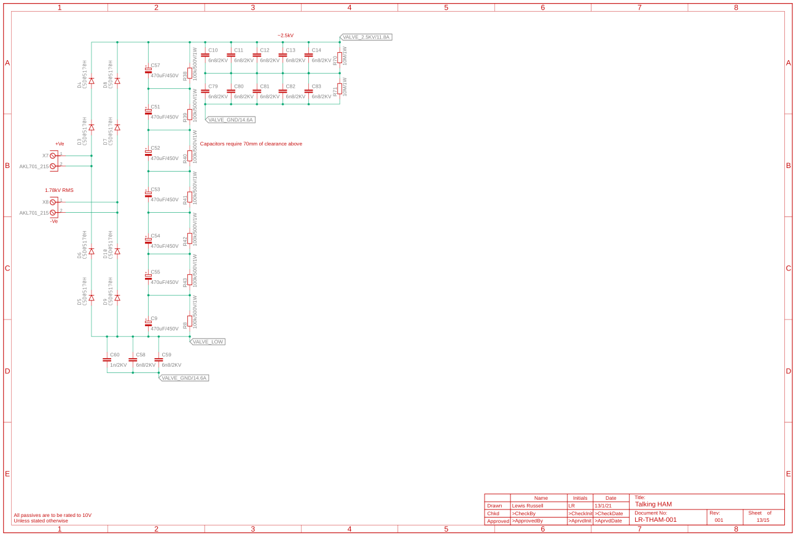

Figure 42:- HV generation

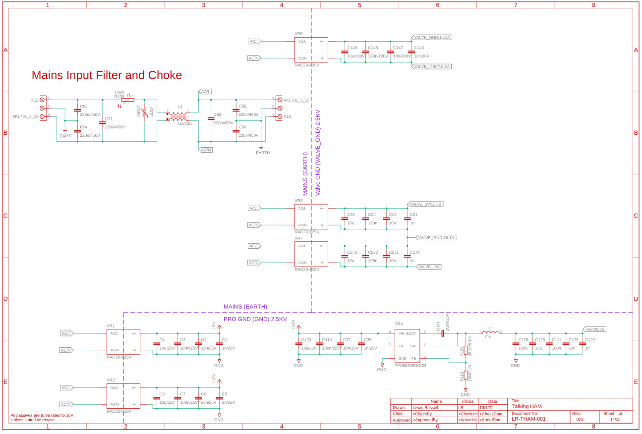

Figure 43:- Mains input and Voltage Regulation

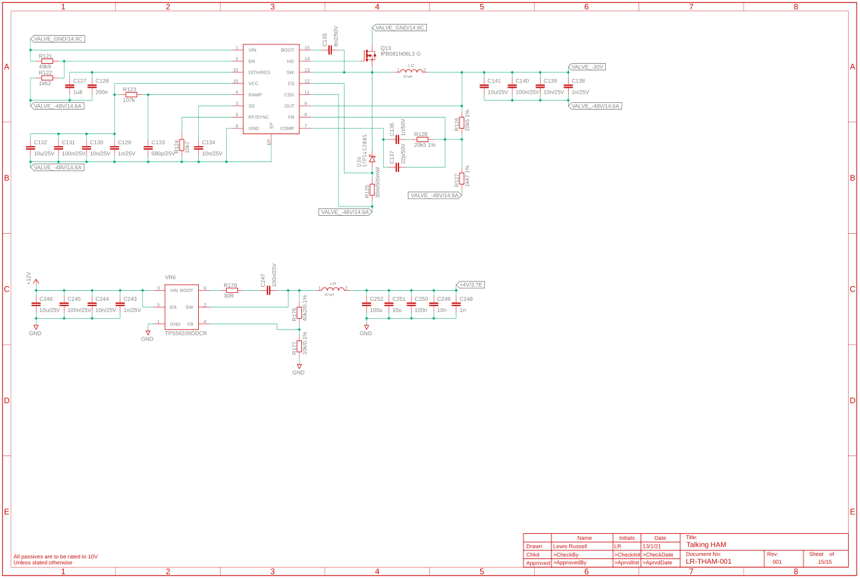

Figure 44:- Voltage Regulation part 2

#### Sheet 1 Header Pin Out

This is the Arduino due and Raspberry pi pin out, these headers will not be on the final design but are here for reference.

#### Sheet 2 Input Capacitor and Inductor Control

This sheet shows the relay control for the input LC filter, use to filter out noise to maximise the Signal to Nosie Ratio (SNR). The relays are controlled by MOSFETs, with two fly back diodes for switch off and on to prevent voltage spikes over the MOSFET or Relay which could damage or break them. A 10u Capacitor was also connected across the relay to supply a surge current during switch on. The MOSFETs will be held on for extended periods of time, so a gate driver is not needed, and they can be driven off the GPIO pin. The input resistors for the MOSFETs were chosen to limit current flow from the GPIO pin preventing overcurrent, and the pulldowns create default low state for when the GPIO is not connected.

#### Sheet 3 Input and LC filter

Shows the input RF stage, it comes on through X11, then through a safety relay, then back out to the VNA and divided down for the SDR. It’s also passed through a LC filter matched for the signal frequency, increasing the SNR. Two capacitors are also in series with the RF signal filtering out any DC on the line on either side which could cause amplification issues.

#### Sheet 4 Valve Amplifier

The Valve amplifier has a number of key components, it has a Push To Talk (PTT) relay, K1, which transmitting pulls the grid to GND enabling transmission, otherwise pulls it to -30V disabling transmission. 6V3 supply is also over the valve heater filament and is where the RF is inserted due to the cathode being connected to the heater filament. The valve being designed for is a 572B, because it is the same type as the one in the KW1000. It is also considered to be a robust high-power valve. This design has 2 valves connected in parallel, but Do Not Fit (DNF) meaning only one will be used at once.

#### Sheet 5 SWR measurement and ATU part 1

This sheet has the SWR measurement, which is taken by passing the RF through a wideband 2-hole Ferrite Core with a 10:1 ratio, shown in Figure 45. This measurement has been designed for operating at high voltages which is why series capacitors and resistors are used for the voltage and power ratings. The SWR Measurement adapted from the ATU 100 Mini Board open-source project which has onboard SWR measurement [51]. The first section of the ATU matching filter is also shown with the capacitors.

|  |  |
| --- | --- |
|  | Image 1 |

Figure 45:- Transformer Windings and core [52]

#### Sheet 6 ATU part 2

This shows the inductors and the final capacitors for the ATU these values were calculated and were thought, at the time to be good valves for the ATU, however as discussed later were later changed.

#### Sheet 7 ATU control

This is the relay control system for all of the ATU capacitors and inductors. The design philosophy for these was the same as in Sheet 2.

#### Sheet 8 Output and voltage divider for SDR

This shows the output safety relay for cut off during faults, and a voltage divider to output through a SMA coaxial header for the SDR for the real time monitoring of the output RF signal.

#### Sheet 9 Isolation and HV measurement

This sheet shows the isolators for the Serial Peripheral Interface (SPI) signals, it also shows the voltage divider for the HV monitoring, dividing the HV signal down and passing it to an Analogue to Digital Converter (ADC) with clamping diodes to voltage spikes damaging components.

#### Sheet 10 HV generation

Shows the HV transformer input, where it is rectified, creating a 2.5 kV supply for the valves to operate off. This offers flexibility, allowing the operating voltage to be easily changed by just changing the transformer.

#### Sheet 11 Mains input and Voltage Regulation

This shows the mains input which passes through a choke, then goes to several voltage regulators, creating the voltages required throughout the system.

#### Sheet 12 Voltage Regulation part 2

Shows the buck converters used in generating the -30V for the grid current for the valve as and the 4V used on an external SWR board, which is currently DNF.

### Part Selection

Several different parts needed to be selected for this design, some of the reasoning for the are is shown.

#### Arduino Due

Is being used for the reasons mentioned in 6.3 Initial Overall System architecture, additionally the Due is used over the Mega because Due has a higher operating clock (84 Mhz vs 16 MHz) and the computational load is unknown.

#### Raspberry Pi

The Raspberry Pi is being used to connect the USB devices, the Raspberry pi also offers ability to host a webUI and allowing real time analysis on the RF signals comparing and monitoring them to confirm there isn’t any issues with them. The Raspberry Pi was chosen because it has a UART port to easily communicate with the Arduino. It is currently up to debate between a Raspberry Pi 3 or 4 will be used, but a Raspberry Pi 3 is likely to be initially chosen due to its better thermal management over the Raspberry Pi 4, however this may be switched out if Raspberry Pi 3 doesn’t offer enough computational power.

#### DAR71210 Relay

The DAR71210 relay were used as Rhodium contacts are used for a low contact resistance of 15 mΩ (typical), with an operating voltage of 12V. They also have isolation of 10 kV meaning that they can operate issue on HV. Main specs are shown in Figure 46. The issue with them is their high cost at £27.58 each, reducing to £25.07[3] at the quantities likely to be used.

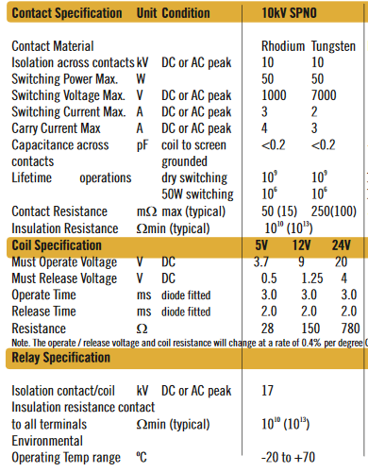

Figure 46:- DAR71210 Datasheet Info [53]

#### 2N7002 MOSFET

A 2N7002 MOSFET is a generic N-Channel MOSFET, the specific one being used is the Nexperia 2N7002NXAKR. It comes in a SOT-23 Package which is useful as it is smaller and thus easier for layout. Main specs are shown in Figure 47. The 2N7002NXAKR offers a 190 mA continuous current. They cost roughly 5.6p each[4]

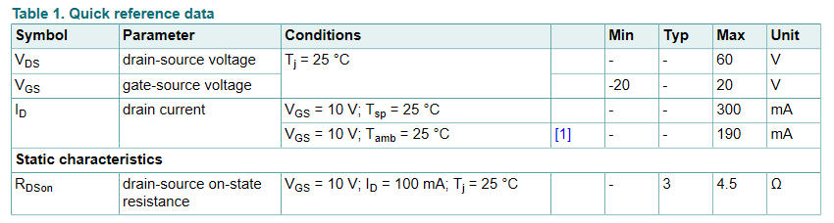

Figure 47:- 2N7002NXAKR Datasheet [54]

#### SMA Header

The SMA Header was chosen as it is a common header type for RF, and the same type used on the SDR or VNA. The exact SMA header being used is the Linx Technologies CONSMA002-L-G, which is a right-angle connector making connecting to the PCB easier, with a maximum frequency of up to 18GHz which is well above the HAM bands targeted. More information is shown in Figure 48. They cost £3.11 each[5].

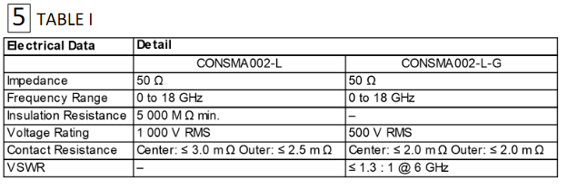

Figure 48:- CONSMA002-L-G SMA Header Datasheet [55]

#### Common Mode Choke

The Common Mode Choke chosen is the Wurth Elektronik 74437529203470, which has an inductance of 47uH and a maximum current of 18.7A. They are designed for low frequencies mains meaning it will block RF, which is desired for this purpose. Basic species are shown in Figure 49 and they cost £6.75[6].

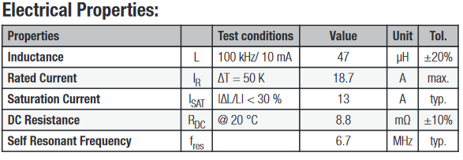

Figure 49:- 74437529203470 Common Mode CHoke Datasheet [56].

#### Valve Amplifier

The 572B Valve is being used, as it is used on the KW1000. Another reason it’s being used is it is a very robust valve which can operate at 2.5kV, and can be bought in matched sets, allowing scaling, with a pair having an output up to 400W. An individual valve should have approximately a 200W output. Its heater filament operates at 6.3V at 4A maximum, and the valve is a “sensibly equivalent” to the 811A and T160L [57]. Basic Information on the valves are shown in Figure 50 and Figure 51.The valves are still manufactured by Shuguang and cost €81[7] each, or approximately £70.45.

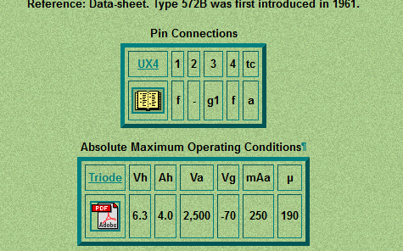

Figure 50:- 572B Basic Specs

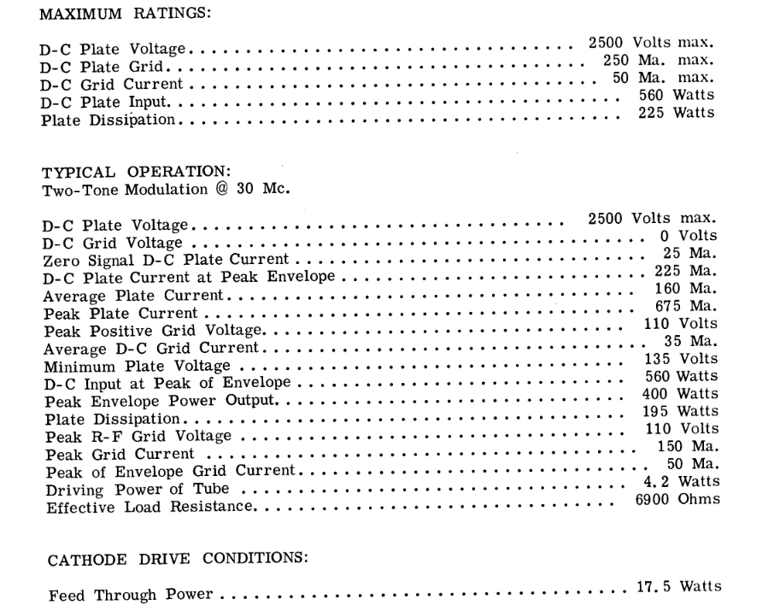

Figure 51:- 572B Datasheet [58]

#### ADC

The Texas Instruments ADC121S101QIMF/NOPB is being used, with its 12 bit resolution, supply range of 2.7-5.25V, using the SOT23-6 package. It uses 3 line SPI only using Master In Slave Out (MISO), Serial Clock (SCLK) and a Slave Select (SS). A Master Out Slave In (MOSI) is not used as ADC only has a single register which it outputs when the called via the SS, making it easier for coding for the device. A datasheet extract is shown in Figure 52. It costs approximately £4.29[8].

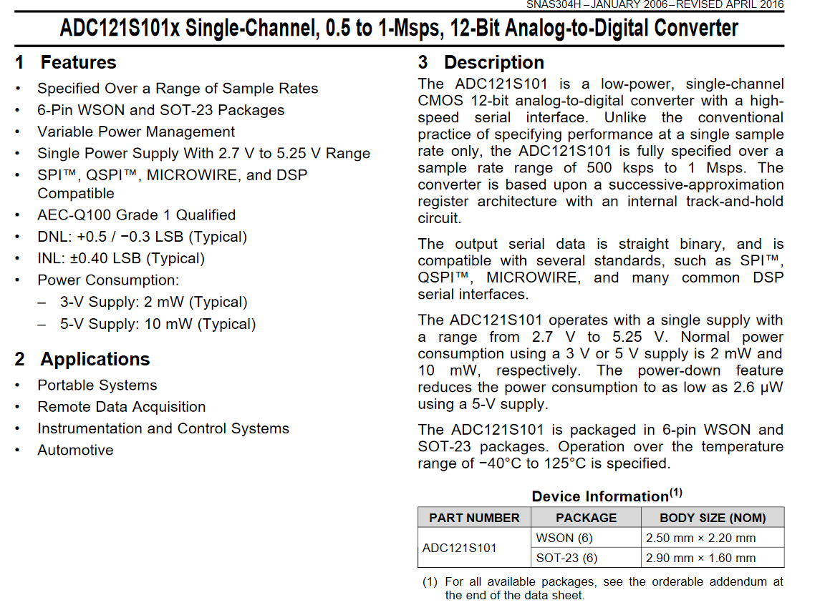

Figure 52:- ADC121S101x Datasheet Extract [59]

#### Clamping Schottky Diode

The RBR1L30ADDTE25 Schottky Diode is used to clamp the voltages for any voltage spikes. It has a low forward voltage meaning the line voltage will be clamped close to the rail voltages. It also has a very low max reverse current of 50 μA at 30V, meaning it should have minimal effect on the reading. A datasheet Extract is shown in Figure 53. The cost of the Schottky diode is 37.4p each[9].

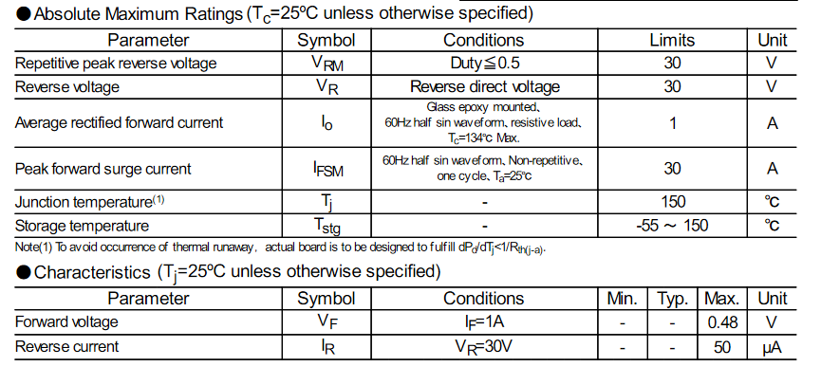

Figure 53:- RBR1L30ADD Datasheet Extract [60]

#### HV Schottky Diode

The CD214A-R12000R Schottky Diodes has a reverse voltage of 2 kV and a maximum forward voltage of 1A, with a forward voltage of 1.1V. They have a reverse current of 50 μA, they are in the SMB package (DO-214AA). Two are needed in series to get the required reverse voltage. An extract from the datasheet is shown in Figure 54. They cost about 41p each[10].

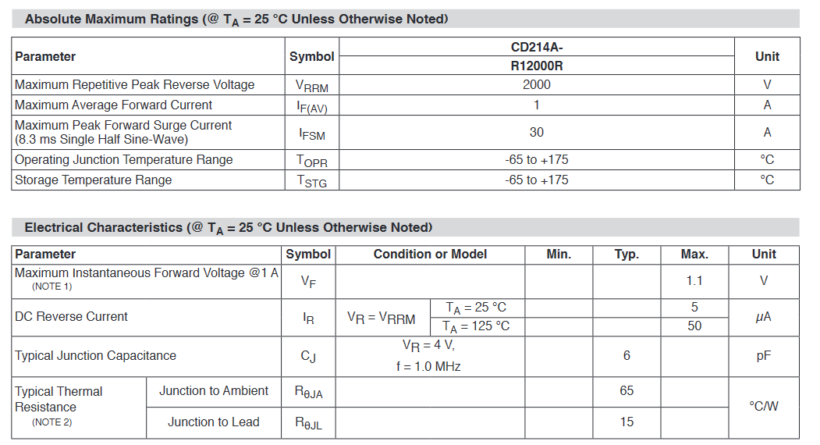

Figure 54:- CD214A-R12000R Datasheet Extract [61]

#### Binocular Ferrite Transformer

For the SWR measurement a Binocular Ferrite Transformer is needed, the BN-43-1502 was chosen as it has been used as it has the correct frequency range when used in a broad band transformer configuration. It will need to be custom wound, with plastic inserts to increase voltage isolation. The basic aspects of this core are shown in Figure 55. This core is still manufactured but the only normal supplier is Amidon directly for $0.80, but for free shipping, a minimum order of $20 is required, and if shipping from the US is paid for, it will cost approximately $88, making it significantly cheaper for a new core from a reseller on ebay as they only cost £1.99[11].

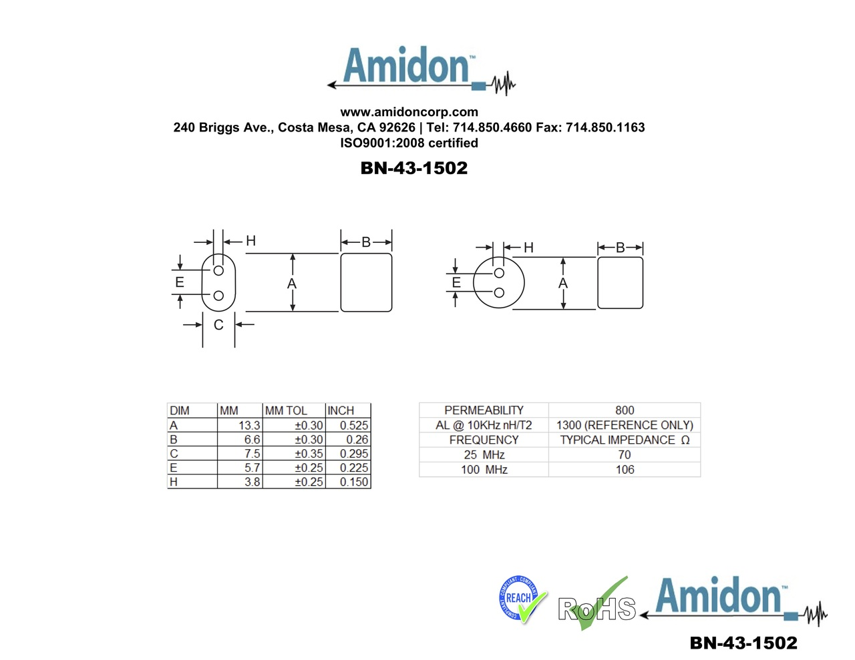

Figure 55:- BN-43-1502 Specs [62]

#### Isolator

The SI8641AB-B-IS1R is a 4 Way 3 forward 1 backwards isolator, which can operate at up to 1 Mbps, which is faster than the SPI baud rate used. It operates at 2.5-5.5V and offering isolation up to 2500 V. Its default state when one side is unpowered was also looked at, which is low when in an unpowered state, although this is not crucial in this design. The datasheet is shown in Figure 56. They will cost about £1.29 each[12].

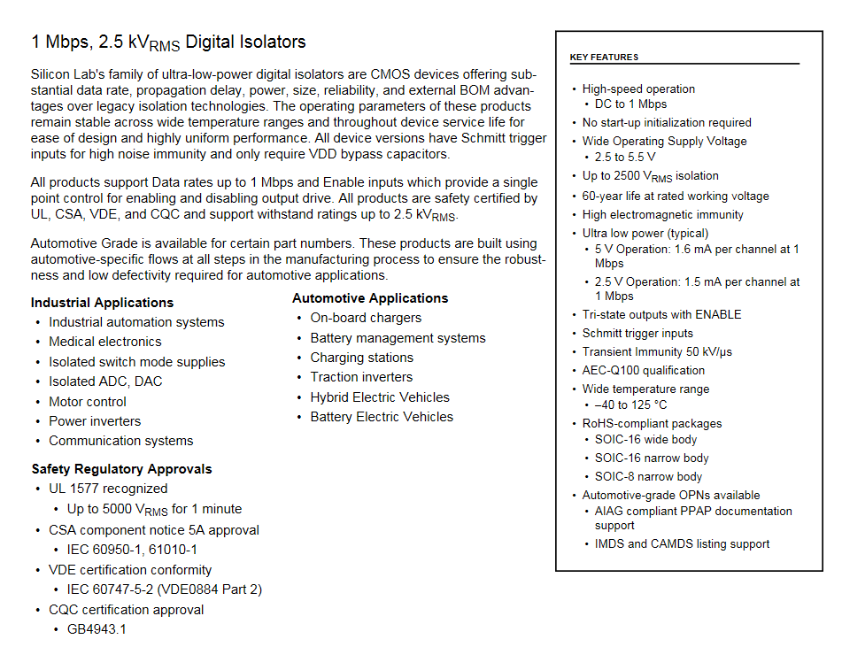

Figure 56:- Si86xx 1 Mbps Datasheet [63]

#### Resistor Calculations

##### Input Voltage Divider

A voltage divider is needed to divide the input voltage from around 100V to around 0.1V for the SDR. Assuming numbering as in Figure 57, the equation for R1 was found in Equation 14, using this R1 was calculated in Equation 15, where R­2 is 50 Ω. 50 Ω was selected as it’s a standard termination resistor for RF impedance. The power for the main resistor power was then calculated shown in Equation 16.

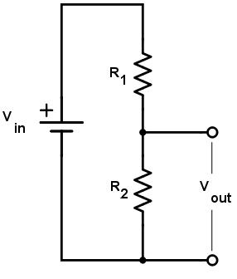

Figure 57:- Example Voltage Divider [64]

$$V_{O}=V_{i}\frac{R_{2}}{{R_{1}+R}_{2}} \\ \frac{V_{O}}{V_{i}}=\frac{R_{2}}{{R_{1}+R}_{2}} \\ \frac{V_{O}}{V_{i}}R_{1}+\frac{V_{O}}{V_{i}}R_{2}=R_{2} \\ R_{2}-\frac{V_{O}}{V_{i}}R_{2}=\frac{V_{O}}{V_{i}}R_{1} \\ R_{1}=\frac{R_{2}-\frac{V_{O}}{V_{i}}R_{2}}{\frac{V_{O}}{V_{i}}}$$

Equation 14:- R1 for Voltage Divider from output voltage

$$R_{1}=\frac{R_{2}-\frac{V_{O}}{V_{i}}R_{2}}{\frac{V_{O}}{V_{i}}} \\ R_{1}=\frac{50-\frac{0.1}{100}*50}{\frac{0.1}{100}} \\ R_{1}=49950 Ω \\ R_{1}≈50 kΩ$$

Equation 15:- Input resistor Calculation

$$P=\frac{V^{2}}{R} \\ P=\frac{{\left(100-0.1\right)}^{2}}{50} \\ P=\frac{9980.01}{50} \\ P=199.6002 mW \\ P ≈200 mW$$

Equation 16:- Input Power Calculation for R1

##### SWR Resistors

Two 50 Ω resistors are needed from the signal to GND, this could have up to a 2.5kV signal across them meaning if two in series are used, each need to be 1.25kV minimum rating is needed. Two 10W resistors in series should be sufficient.

The Resistors in series are also used to get the 58 kΩ, two 30 kΩ and a 10 kΩ resistors are used in series, this is done to get the voltage rating up to about 2.5kV.

##### Output Voltage Divider

A voltage divider is also needed for the output for the SDR, this has a voltage of 2.5 kV and needs to be divided to 0.1V again. R2 will again be 50 Ω, calculation for this is shown in Equation 17 using Equation 14. This will be the total resistance, as the output power was then calculated in Equation 18, and a 1.25 MΩ, 5W, >2.5 kV resistor does not exist, so multiple E96 resistors were used instead. It was found 63.4 kΩ would give a total of 20 Resistors, calculated in Equation 19. By using 20 resistors only 250mW would be lost in each resistor, shown in Equation 20. And only 125 V would be dropped across each, this is important as a 2.5 kV dropped across a single resistor also cause a large clearance on the board making it impractical, where as 20 125V drops is more manageable. This was thought to be a good balance between number of resistors, cost, clearance and power. The actual voltage output was then calculated in Equation 21, this is minimal difference so should not cause any issue.

$$R_{1}=\frac{R_{2}-\frac{V_{O}}{V_{i}}R_{2}}{\frac{V_{O}}{V_{i}}} \\ R_{1}=\frac{50-\frac{0.1}{2500}*50}{\frac{0.1}{2500}} \\ R_{1}=1249950 Ω \\ R_{1}≈1.25 MΩ$$

Equation 17:- Output Resistance Calculator

$$P_{T}=\frac{V^{2}}{R} \\ P_{T}=\frac{{2500}^{2}}{1250} \\ P_{T}=5000 mW \\ P_{T}=5W$$

Equation 18:- Output Resistor Power

$$N=\frac{R_{2}}{R_{Res}} \\ N=\frac{1250}{63.4} \\ N=19.716 \\ N=20$$

Equation 19:- Number of Resistor

$$P_{Rest}=\frac{P_{T}}{N} \\ P_{Rest}=\frac{5}{20} \\ P_{Rest}=0.25 W \\ P_{Rest}=250 mW$$

Equation 20:- Power Per Output Resistor

$$V_{o}=V_{i}\frac{R_{2}}{\left(R_{Rest}*N\right)+R_{2}} \\ V_{o}=2500*\frac{50}{\left(63400*20\right)+50} \\ V_{o}=\frac{125000}{1268000+50} \\ V_{o}=\frac{125000}{1268050} \\ V_{o}=0.099 V$$

Equation 21:- Actual Voltage Output

### PDR

A PDR of this design was then carried out, this was done by carefully explaining each section of the design to another engineer, and then by doing so discussing and possible faults in the design. By doing so often possibly fatal flaws in the system can be found and mitigated. These reviews were the only time another engineer was working on this project. From this first review several changes were required, shown in Table 2. None of these were critical changes, apart from the Modular Design, so the core design should stay the same.

Table 2:- PDR Changes

|  |
| --- |
| **Change** |
| Change Relays to standard relay to reduce cost |
| Change to have a 3PDT for the RF Input and output for Antenna switching or 3 relays in parallel |
| Change RF inductors for the ATU to toroids (Q > 30). OD 25-30 T80-6+ (toroids.info) |
| Change PTT to have a hardware button, 2 pin screw terminal |
| Change filter capacitor and inductors to values copied direct from ATU 100 Mini |
| Break up into Modular Design |
| Use the sockets for the valves |
| The 100R and APC and RFC for the Valve will be external components to the PCB |
| Change Bucks on valves to a LDO, or a transformer with bridge rectifier as the switching noise could cause noise on the RF output |
| RF header should SMA Connectors, but output should be done through 2 pin screw terminals due to voltage |
| Add a DNF Op Amp in for Current sensing encase output voltage is too low. |
| Add grid current measurement on -30V line. Grid Current = 25-50mA Max 60mA |
| Change caps for HV Bulk to cheaper ones off CPC, CA08626. Same Package |
| Change caps from SMD to TH for better voltage ratings |
| Change Common Mode Choke for the AC and the Valve to a cheaper higher inductance one. 4A min |
| Change to cheaper AC/DC Converters or to transformers |
| Remove the Valve 12V just for the 6V3 and move to a Transformer and rectifier |
| System Architecture is missing the antenna header, and switch for connecting antenna to the input |

## Modular Schematic Design

First how the design will be broken up was decided Modular design:

1. The first board is the power and isolation board. This means all HV generation would all be done on one board, meaning that other boards could be tested safely. Isolation was also done on this board due to the fact all voltage rails will be on this one meaning it is the easiest board add it onto, without specific board for isolation.
2. The second board is the input filter, this is its own board, as it allows the input filter board adapted if the operating frequencies changed.
3. The third board decided was the valve amplifier board, due to it requiring external components connected to the anode cap. This would also allow the output power to be easily scaled, by adding boards in parallel.
4. The fourth board is the output filter, this was separated out for the same reasons as the input board, it also created the isolation boundaries much cleaner.

### RF-ARCH-001

The overall system architecture was modified in the RF-ARCH-001 schematic, which is the overall system architecture, what was modified for the modularity stating what board each is sections on. A couple additional changes to this were also made, the main one was adding PTT button header being added as well as the input relays for PTT in the correct place showing its purposes. These 3 sheets of the Architecture are shown in Figure 58, Figure 59 and Figure 60. Each board will also have its own architecture, showing what the individual board does.

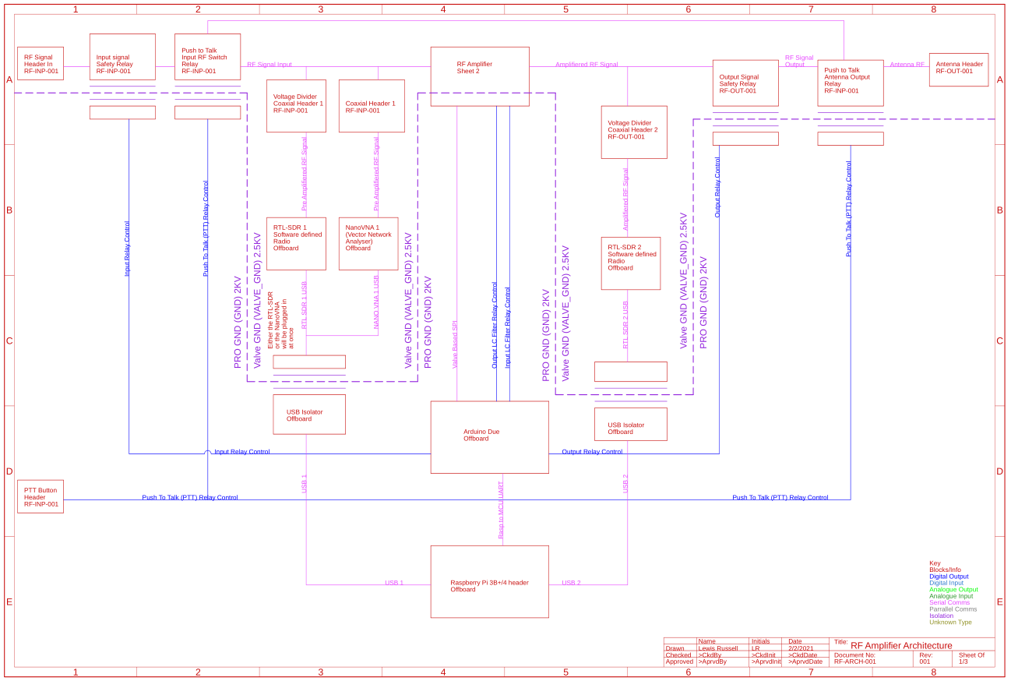

Figure 58:- Overall System Architecture

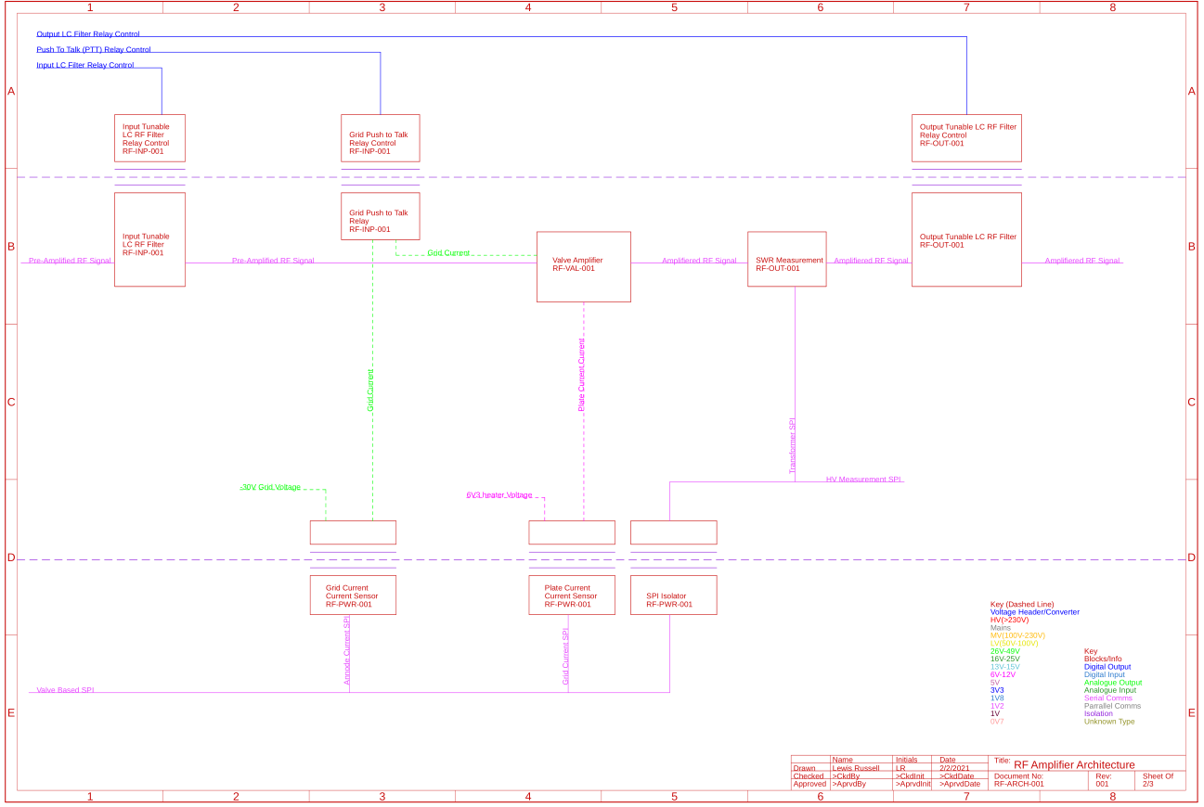

Figure 59:- Valve Amplifier Architecture

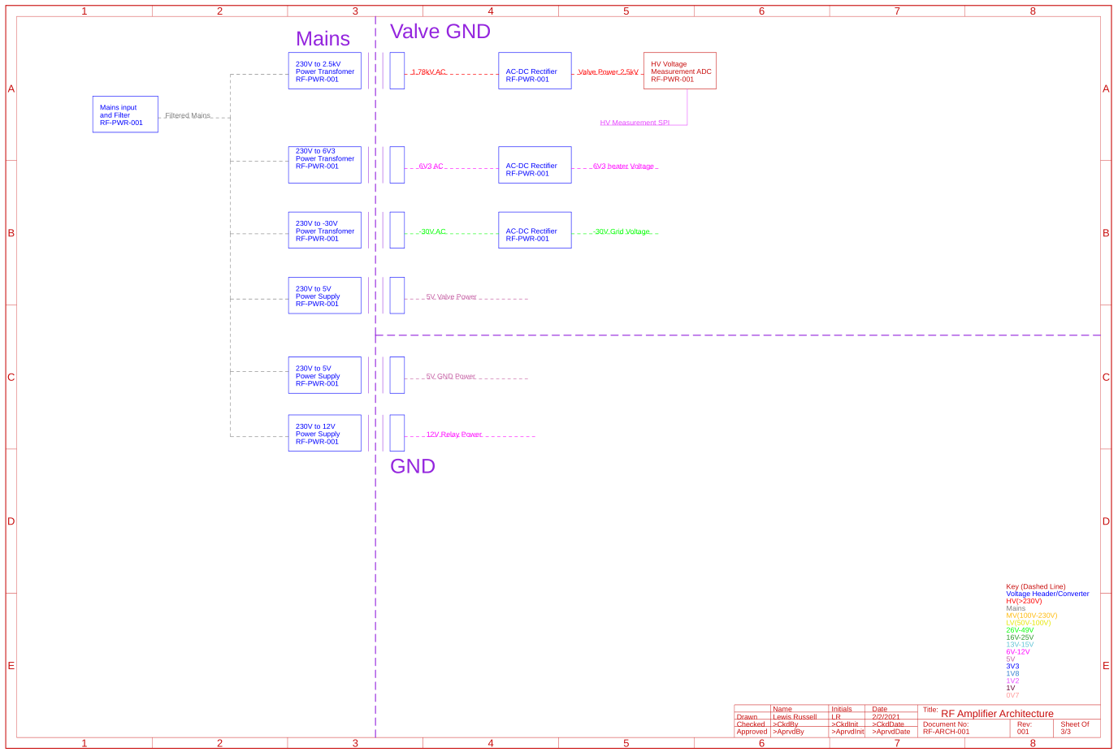

Figure 60:- Power Architecture

### RF-PWR-001

This board generates all the power supplies for each board as well as isolating the SPI used in the other board.

This shows how all the induvial voltages are generated from mains through transformers for 5V, 6V3, -30V and 2.5kV which are then rectified for lower noise, the noise for these voltages is important as all 3 are used directly in the amplifier, meaning any noise on these could be amplified onto the RF adding noise. On top of this the 5V and 12V for GND are generated via AC/DC Converters. This also shows how every board has its own voltage header.

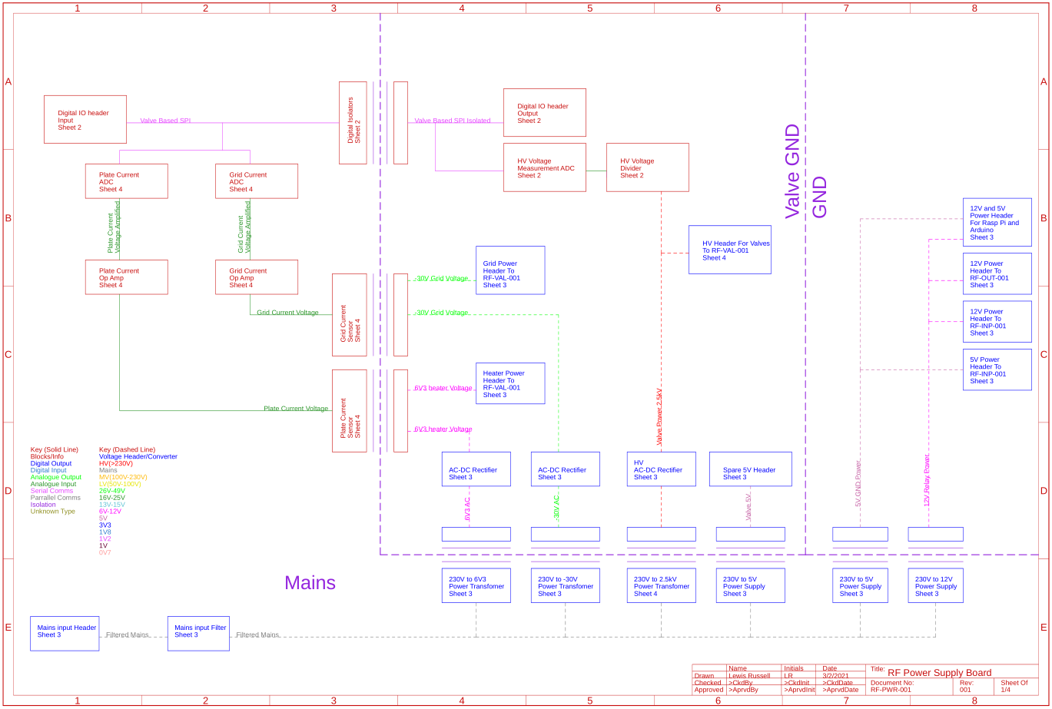

Figure 61:- System Architecture for the RF-PWR-001

The schematics which this system architecture is describing is shown in Figure 102, Figure 103 and Figure 104. There are 3 sheets in this schematic, the sheet numbering starts at 2, because sheet 1 is the schematic.

#### Sheet 2

This is where the SPI comes onto the board get isolated going directly to a ADC for the HV monitoring ADC, which has a voltage divider with clamping diodes for voltage spikes, it also has an output header.

#### Sheet 3

This has the mains input passing it through a Common Mode Choke and then passing mains back out to 3 transformers. The returns for the transformers are also shown which pass into a full bridge voltage rectifier, then passing it out to other boards. The mains are also fed into AC/DC converters regulates to required voltages, also passed out to other boards. There is a 4V buck converter for a SWR measurement board, it is unlikely to be used so is left as DNF.

#### Sheet 4

This shows the HV 1.78 kV AC voltage input, which is then full bridge rectified using 2 diodes per normal diode for reverse voltage. This is then passed into a bulk capacitance and filtering caps, needed for reducing noise on the line, also to provide current during power surges. Two current sensors are also used, for the grid and plate current, these ICs output an analogue voltage which is either passed to the ADC, or through a non-inverting op amp to boost the voltage if needed.

#### Thermal Calculations

There are several diodes at risk of overheating, these are the rectification diodes for 6V3, -30V and HV. For the power losses to be calculated, the following information is needed, the conduction percentage, as the diodes are rectifying an AC signal in a full bridge rectifier, it is assumed it will conduct 50% of the time, next the forward voltage, forward current, reverse voltage, max leakage current, this information was all gathered from the diode’s datasheets and individual use case. The diodes being used for 6V3 and -30V are the MBR10100-M3/4W an extract from their datasheet is shown in Figure 62. For the HV rail C5D05170H is used, an extract is shown in Figure 63. The worst-case scenario for temperatures and voltage were used to get the highest possible power loss.

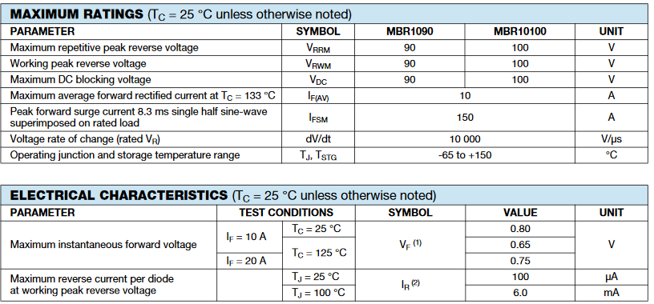

Figure 62:- MBR10100-M3/4W Diode Datasheet extract [65]

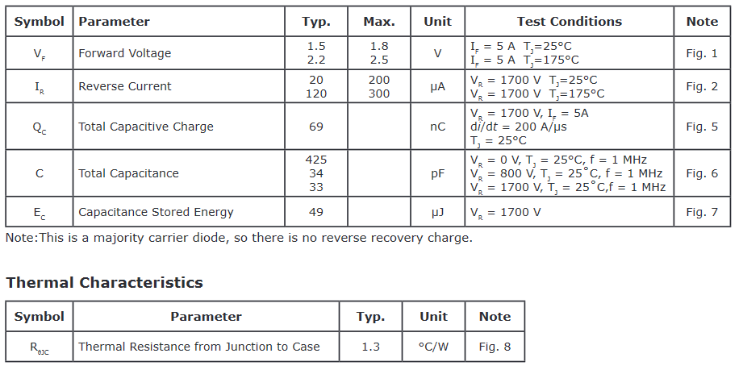

Figure 63:- C5D05170H Diode Datasheet extract [66]

The power losses for the HV didoes were calculated in Equation 22. It was calculated with a forward current of 202 mA which is the maximum output of the transformer, the actual current likely to be lower, but the worst case is being calculated for.

$$P_{con2.5kV}=η_{con}I_{f}V_{f} \\ P_{con2.5kV}=0.5*0.202*2.5 \\ P_{con2.5kV}=0.5*0.505 \\ P_{con2.5kV}=0.2525 W$$

Equation 22:- Conduction Power Losses for 2.5 kV

Next the reverse leakage losses were calculated in Equation 23. This assumed that when not conducting the reverse voltage, and the reverse current is at its maximum, however in reality this is unlikely due to the nature of AC. This is a good assumption though for maximum power loss. The reverse voltage across these diodes will be approximately 1.25 kV for these diodes as there are 2 in series.

$$P_{leak2.5kV}=\left(1-η_{con}\right)I_{r}V_{r} \\ P_{leak2.5kV}=\left(1-0.5\right)*0.3*1.25 \\ P_{leak2.5kV}=0.5*0.375 \\ P_{leak2.5kV}=0.1875 W$$

Equation 23:- Leakage Power Loss for 2.5kV

Then the total power loss was calculated by summing the two power losses together. This is shown in Equation 24.

$$P_{loss2.5kV}= P_{leak2.5kV}+P_{con2.5kV} \\ P_{loss2.5kV}= 0.1875+0.2525 \\ P_{loss2.5kV}= 0.44 W$$

Equation 24:- Total Power Loss for 2.5kV

Finally the temperature rise was then calculated, it has a thermal resistance from the junction to the case of 1.3 C/W, and then a heatsink attached which is the WV-T247-101E which an extract is shown in Figure 64 which shows it has a thermal resistance of 12 °C/W, this means the total thermal resistance is calculated in Equation 25. This value is then used to calculate the temperature rise in Equation 26. This then added to the ambient temperature in Equation 27, this max temperature is well within spec for this diode that can operate at up to 175 °C.

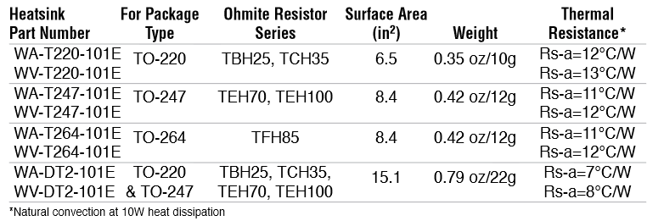

Figure 64:- WV-T247-101E Heatsink Datasheet Extract [67]

$$R_{T2.5kv}=R_{WV-T247}+R_{J-HS} \\ R_{T2.5kv}=12+1.3 \\ R_{T2.5kv}=13.3 °C/W$$

Equation 25:- Total Thermal Resistance

$${∆T}_{2.5kV}=P_{loss2.5kV}*R_{T2.5kv} \\ {∆T}_{2.5kV}=0.44*13.3 \\ {∆T}_{2.5kV}=5.852 °C$$

Equation 26:- Temperature Delta

$$T_{max2.5kV}=T_{ambiant}+{∆T}_{2.5kV} \\ T_{max2.5kV}=40+5.852 \\ T_{max2.5kV}=45.9 °C$$

Equation 27:- Maximum Temperature

This was then repeated for the other diodes and the results are shown in Table 3. The diodes for the 6V3 and -30V are not using heatsinks this the lack of heatsink Thermal Resistance, this shows all diodes should be kept within safe conditions. It is likely the C5D05170H could operate without a heatsink however no data was given on this, so one was added encase.

Table 3:- Diode Power Loss and Temperature rise

|  |  |  |  |
| --- | --- | --- | --- |
|  | 6V3 | -30V | 2.5kV |
| % conduct | 50% | 50% | 50% |
| Vf (V) | 0.8 | 0.8 | 2.5 |
| Current (A) | 4 | 0.06 | 0.202 |
| Reverse Voltage Per Diode(V) | 6.3 | 30 | 1250 |
| leakage Current (mA) | 6 | 6 | 0.3 |
|  |  |  |  |
| Power Loss Conduct (W) | 1.60 | 0.02 | 0.25 |
| Power Loss Leak (W) | 0.02 | 0.09 | 0.19 |
| Power Loss Total (W) | 1.62 | 0.11 | 0.44 |
|  |  |  |  |
| Thermal Resistance to Case (°C/W) | 60 | 60 | 1.3 |
| Thermal Resistance Heatsink (°C/W) |  |  | 12 |
| Total Thermal Resistance (°C/W) | 60 | 60 | 13.3 |
| Ambient Temperature (°C) | 40 | 40 | 40 |
|  |  |  |  |
| Temperature Delta (°C) | 97.1 | 6.8 | 5.9 |
| Max Temperature (°C) | 137.1 | 46.8 | 45.9 |
| Max Operating Temperature (°C) | 150 | 150 | 175 |

#### Changes done to RF-PWR-001

The voltage generation were changed from using all AC/DC converters to a combination of AC/DC Converters and transformers which are later rectified. This also removed the buck converters which were used before, this is both a cheaper solution and one which will output less power onto the valve amplifier as this will reduce the noise on the output RF signal. On top of this the noise which will be added will be high frequency as buck converters previously used operated at 50 kHz to 1 MHz for the LM5088 [68] and 500 kHz [69]. These frequencies are high enough that they are somewhat close to the frequencies being amplified, which would mean although a matched filter would filter out this noise, the noise will still be there so it would be best to not add it in the first place than to add it then try to remove it, as the second option will offer the best option.

The Op Amp for the Current sensors was added, which will be used if the voltage output from the Op Amp is too low for the ADCs to accurately measure the output voltage.

The Grid current sensor has been added on the -30V line.

The Bulk Capacitor has been changed in the BOM to cheaper equivalent electrolytic capacitors.

Any HV capacitors have been changed to Through Hole capacitors as a wider cheaper option is available.

The Choke type was changed to the same type as the RF-VAL-001 boards.

### RF-INP-001

#### Board System Architecture

This board system Architecture is shown in Figure 65, it shows the RF signal coming in on the left and then passing through a safety relay, then out to a VNA and divided down for a SDR. After this it passes into the Antenna Selector Relays controlled by the PTT button, which is an external button wired up, used to select between outputting the output signal for transmitting or connecting the Antenna to the input for receiving. The PTT button also controls a relay for the valve grid to enable transmitting. The RF signal then goes into a LC filter controlled by relays to change it to a matched LC filter and then outputted to the valve amplifier.

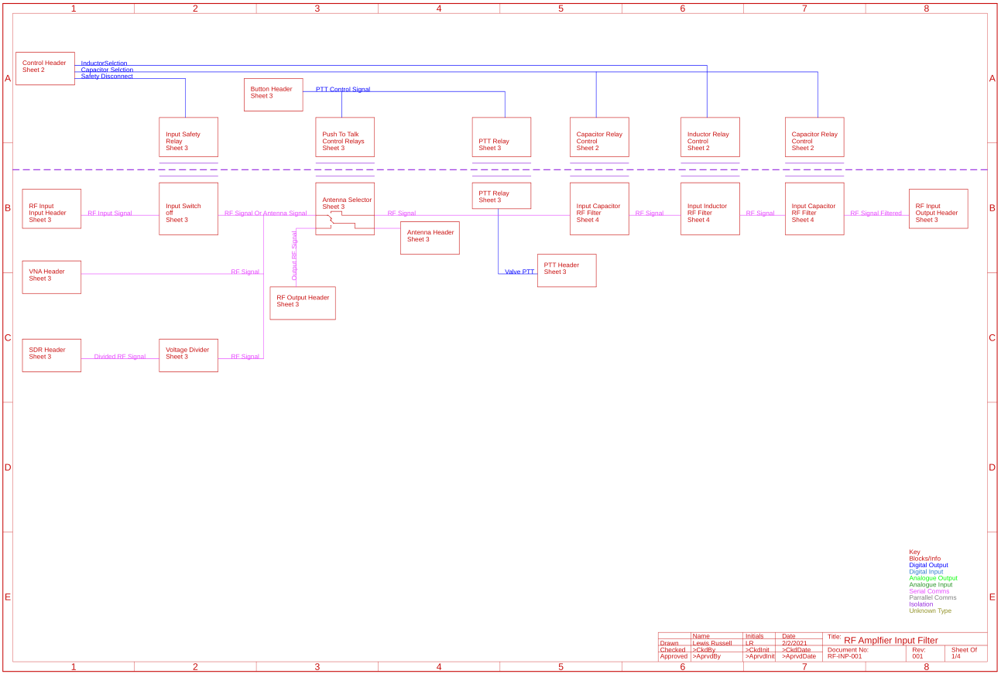

Figure 65:- RF-INP-001 System Architecture

The schematics which this system architecture is describing is shown in Figure 105, Figure 106 and Figure 107. There are 3 sheets in this schematic, the sheet numbering starts at 2, because sheet 1 is the schematic.

#### Sheet 2

Has the input header which connects directly to the Arduino GPIO pins. These GPIO pins are used to the control relays for the input LC filter. The number of relays here has been cut down as the values were changed to the ones on the LC on the ATU 100 Mini.

#### Sheet 3

Shows the input stage for the RF, this shows how the RF comes on passing through the Safety relay, then outputted via a SMA header to the VNA and a voltage divider is also used to outputs via a SMA header for the SDR. The RF input is then passed on to a Relay selector, which selects between connecting the RF input with the antenna when receiving and then the RF input with the amplifier and the RF output with the Antenna when transmitter.

#### Sheet 4

Contains the LC input filter, these values are the same as the ones on the ATU 100 mini. It has two capacitors in parallel, in series with the RF signal to block any DC voltages which could be on either side which would cause issues.

#### Changes done to RF-INP-001.

A PTT Button header has been added, this was done on Sheet 2 this controls what the antenna is connected to and pulls the grid to GND for transmitting.

The Relays were changed to G5LE-1-VD DC12 and RZ02-1C4-D012 types, the G5LEs are general purpose relays which work well for the lower voltage input RF signal. The RZ02 was chosen for the output RF over a 3PDT Relay because it could have clearance issues, and over the G5LE because it offers much better clearance. The G5LE would be fine with the HV if laid out correctly using internal layers, which can be done on the RF-OUT-001 board, which means this is only an issue on this board. More on these relays in 6.5.6 Component Selection Changes.

The inductors have been changed to custom toroid inductors, windings noted on the schematic, more on these toroids in 6.5.6 Component Selection Changes.

The capacitors were alco changed to the same value as the ATU 100 Mini.

The RF headers have been connected up correctly, so the input RF is using SMA headers whereas the HV RF uses 2 pin headers.

### RF-OUT-001

The RF-OUT-001 is an the matched output filter, this is very similar to the RF-INP-001 board, but it operates at a much higher voltage than that, but at a much higher voltage.

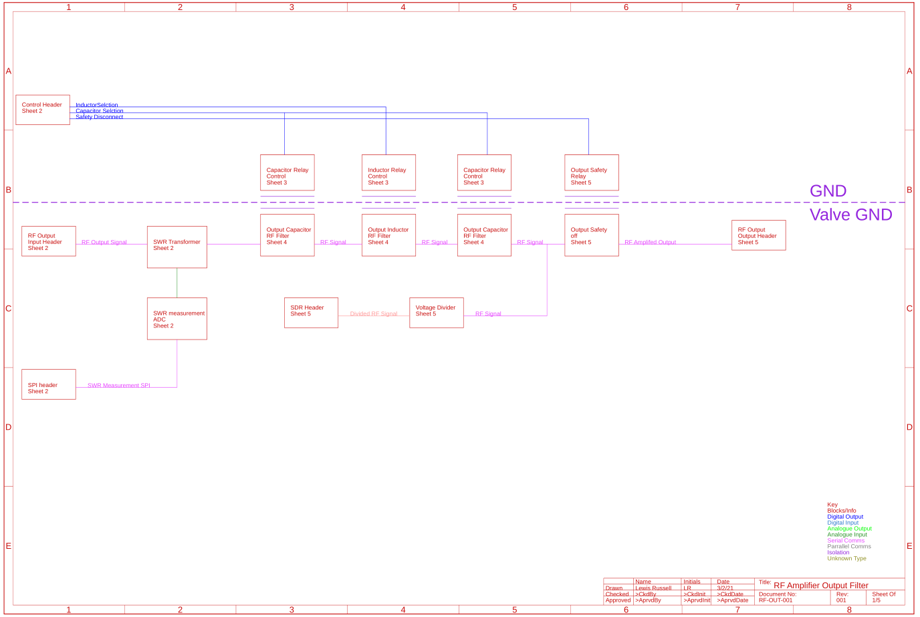

Figure 66:- RF-OUT-001 System Architecture

The schematics which this system architecture is describing is shown in Figure 108, Figure 109, Figure 110 and Figure 111. There are 4 sheets in this schematic, the sheet numbering starts at 2, because sheet 1 is the schematic.

#### Sheet 2

This sheet is the SWR Measurement. This shows the SPI input header coming in for the two SWR measurement ADCs, on top of this the main SWR measurement is completed.

#### Sheet 3

Next is the ATU Relay control, this is all of the control MOSFETs which are used to select what capacitors and inductors are needed for the antenna matching for the system.

#### Sheet 4

This is the ATU inductors and capacitors this is how the ATU filters the RF wave for antenna impedance matching purposes.

#### Sheet 5

This is the final page which shows the resistor divider for the SDR, safety disconnect relay and the output header.

#### Changes done to RF-OUT-001

The resistors have had heatsinks added to manage any excess heat generated, however they the heat over them should be manageable with them.

It has changed to use the LC values of the ATU 100 Mini.

### RF-VAL-001

The Valve board is a simplest board out of the four and is shown in Figure 67. This is where the actual RF signal is amplified, it works by passing in the 6V3 power for the heater filament in and then passed through a choke, this then is combined with the RF input and passed into the Vacuum Tube Amplifier. The PTT control is also passed in here an connects to the Vacuum Tube Amplifier, there is also some external components which are connected to Anode Cap which is where the actual output RF is generated and outputted.

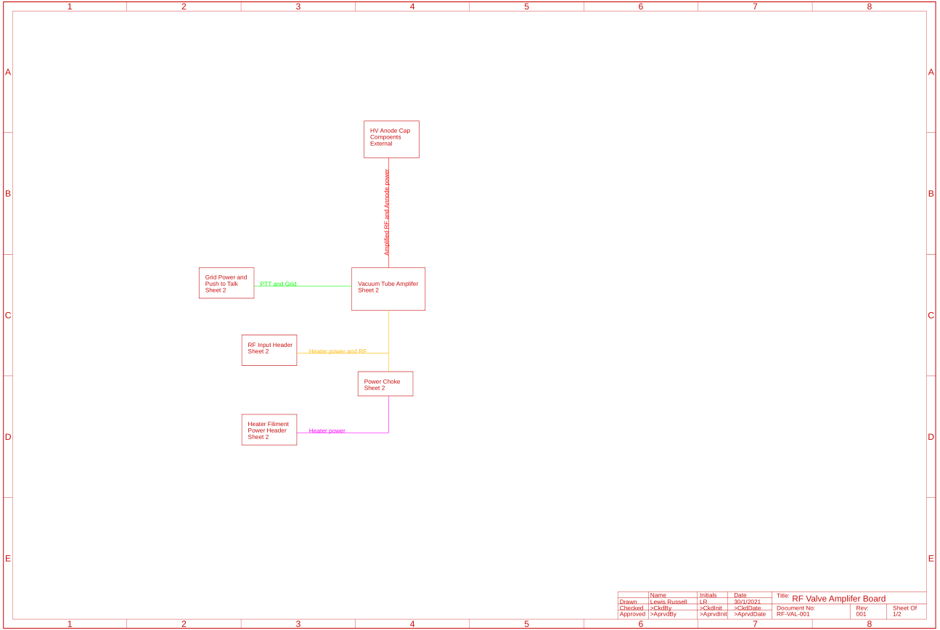

Figure 67:- RF-VAL-001 System Architecture

The schematics for this are shown in Figure 68. This shows how this works how the PTT is pulled to -30V when not transmitting. It also shows how the 6V3 is passed in and then goes through a choke where it is combined with the RF Filtered Input. It also has components which are connected to the anode cap of the valve, and shows how output RF signal is separated from the 2.5kV power and is supplied.

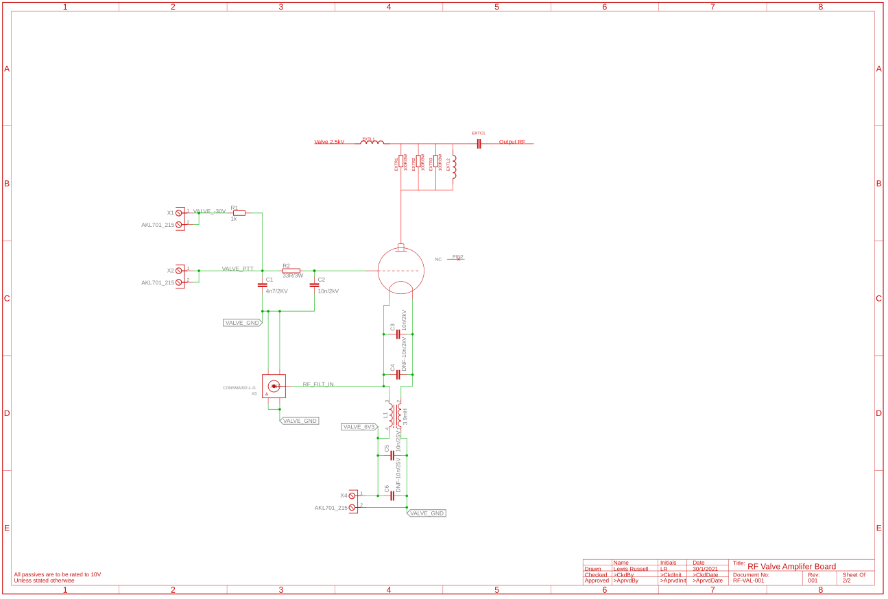

Figure 68:- RF-VAL-001 Schematics

#### Changes done to RF-VAL-001

The External resistors, inductors and capacitors have been changed to external ones rather than ones which would be on the PCB.

### Component Selection Changes

#### 5 V 5 W AC/DC Converter

One of the AC/DCs used is the IRM-05-5, this is being used as it outputs 5V at 1A which is what is needed on this voltage rail. The basic specs of it are shown in Figure 69. They will cost around £5.94[13].

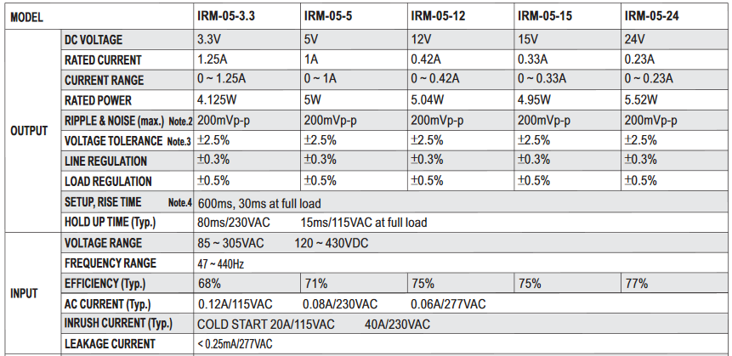

Figure 69:- IRM-05-5 Datasheet Extract [70].

#### 5 V 2 W AC/DC Converter

One of the AC/DCs used is the IRM-02-5, this is being used as it outputs 5V at 400mA which is what is needed on this voltage rail. The basic specs of it are shown in Figure 70. They will cost around £4.42 [14]. This is being used alongside the IRM-05-5 because one of the 5V rails only need around 2W of power, which saves around £1.50 from the cost.

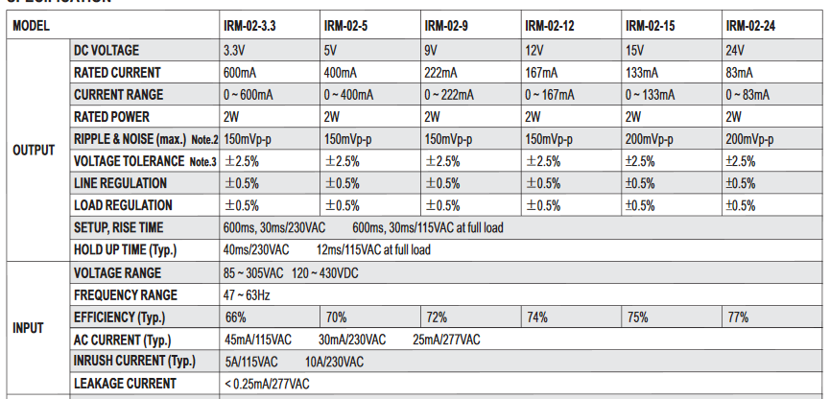

Figure 70:- IRM-02-5 Datasheet Extract [71].

#### 12 V 20 W AC/DC Converter

One of the AC/DCs used is the IRM-20-12, this is being used as it outputs 12V at 1.8A which what is needed on this voltage rail. The basic specs of it are shown in Figure 71. They will cost around £7.79[15].

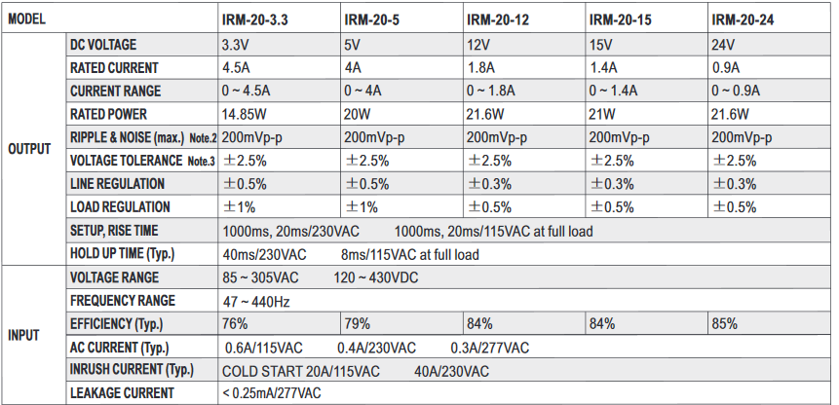

Figure 71:- IRM-20-12 Datasheet Extract [72]

#### HV transformer

The HV transformer being used is the Hammond Manufacturing 726A, this outputs 1.78kV @ 202 mA whish when rectified would be around 2.5 kV, the main information on this transformer is shown in Figure 72. This costs around £87.78[16].

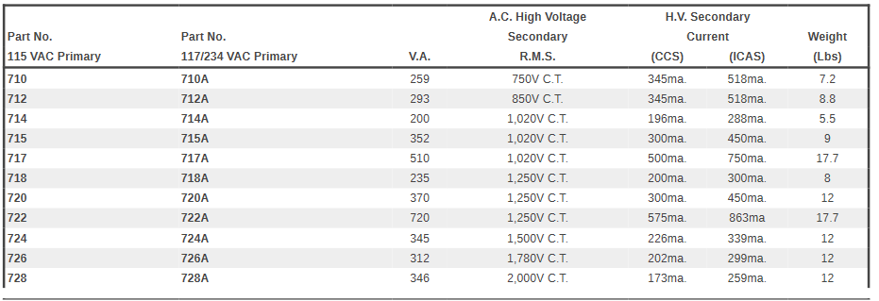

Figure 72:- 726A Datasheet Extract [73]

#### LV Transformers

The transformer being used is a main to 6V3 and 30V transformer, which will be bought off ebay, these are still in production as it is a generic transformer being used. These are easy to buy and there are enough alternatives that any home user could easily get this one or an alternative with minor difficulties. The ones being used are the 6-0-6 Vac Type 8A Secondary which outputs 6V at 8A, only about 4A of this is needed, meaning when rectified will supply the 6V3 rail with minimal issue, this device will cost £14.91. The second transformer is the 30-0-30 Vac Type 2A Secondary this transformer will be used -30V at 2A max, only 60 mA of this will be needed, meaning it will provide the -30V rail with ease, it only cost £17.30 [17].

### Modular Schematic Design PDR

A PDR was also carried out on this design and no major faults were found, so it was decided the design was mature enough to move to the layout stage.

## Modular Layout Design

Next the layout for the four PCBs were created.

### Trace Width and Clearances

One of the most important things to look at before starting a layout is trace widths of any high current signals, this is important as a trace which is too thin can cause issue with the trace overheating or significant power losses. This is normally done using trace width calculators based on IPC-2221. But this calculation can be done manually using Equation 28 and Equation 29. Using a 4A signal, the required area was calculated in Equation 30. This signal will be on an external layer with a maximum temperature rise of 10 °C and a 1 oz board, thus the minimum trace width calculated in Equation 31.

$$A\left(mil^{2}\right)={\left(\frac{I\left(A\right)}{k*{∆T}^{b}}\right)}^{\frac{1}{c}} \\ For internal layers:k=0.024, b=0.44 and c=0.725 \\ For external layers:k=0.048, b=0.44 and c=0.725$$

Equation 28:- Area of a trace width based off current [74].

$$W\left(mm\right)=\frac{A\left(mil^{2}\right)}{T\left(oz\right)*1.378(\frac{mil}{oz})}*0.0254(\frac{mm}{mil})$$

Equation 29:- Width of a trace based off area and board thickness.

$$A={\left(\frac{4}{0.048*{10}^{0.44}}\right)}^{\frac{1}{0.725}} \\ A={\left(\frac{4}{0.1322}\right)}^{\frac{1}{0.725}} \\ A={30.2565}^{\frac{1}{0.725}} \\ A=110.28 {mil}^{2}$$

Equation 30:- Area of trace.

$$W=\frac{110.25*0.0254}{1*1.378} \\ W=\frac{2.8011}{1.378} \\ W=2.03 mm$$

Equation 31:- Width of the Trace

Another important thing that needs to be done before layout is clearance, this is needed to prevent any issues HV arcing into other signals causing issues with them. This is done using the table shown in Figure 73, how this works by first selecting the board type, we will be using B1 for internal traces and A5 any external layers, this is because a conformal coating will be used over the components after being laid. For voltages under 500V you just read the clearance off the table, e.g. a A5, 50V signal would have 0.13mm clearance, where as a 500V B3 signal would have a clearance of 12.5mm. However, for voltages above 500V the equation shown in Equation 32 needs to be used. An example of this being used is shown in Equation 33 for a B1 board at 2.5 kV.

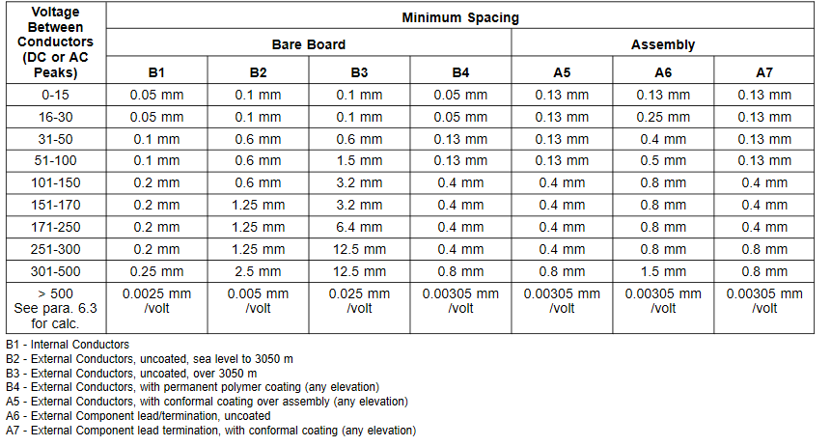

Figure 73:- Electrical Conductor Spacing [75]

$$C=C_{500V}+\left(M_{C}*\left(V-500\right)\right) \\ where: \\ C=clearance (mm) \\ C_{500V}=Clearance at 500V (mm) \\ M_{C}=Clearance Multiplyier (\frac{mm}{V}) \\ V=Voltage (V)$$

Equation 32:- Calculating Clearances for Voltages above 500V

$$C_{2.5kV}=C_{500V}+\left(M_{C}*\left(V-500\right)\right) \\ C_{2.5kV}=0.25+\left(0.0025*\left(2500-500\right)\right) \\ C_{2.5kV}=0.25+5 \\ C_{2.5kV}=5.25 mm$$

Equation 33:- Calculating for a B1 signal at 2.5 kV

### RF-PWR-001

First board that was laid out was the RF-PWR-001 board, which supplies the main power for each of the boards, the layout for this board is shown in Figure 74 a), with an annotated version in Figure 74 b). The board design is 200 mm in width and 220 mm in height, 2 layer, 1oz. The annotated version shows several sections of the layout:

The red box is the Mains input which with its choke, and then is outputted onto the transformers and also into the AC/DCs.

The orange box is the GND based voltage outputs and also 4V DNF regulator, the other voltages come from the IRMs between the Red box.

The purple box is the 6V3 transformer input and rectifiers, the connections between the diodes has been done via planes because of the current required rather than traces due to the trace width requirement of 2mm. This plane mean a much higher trace width is achievable much easier.

The pink box is the -30V transformer input and rectifiers, the connections again between the diodes because this was easier to layout than using the traces,

The light green box is used as the -30V Current Sense IC for the grid current

The blue box is the isolators used to isolate the signals to be outputted onto other boards and to the HV ADC measurement

The yellow box is the HV transformer input which is then rectified and goes into the bulk capacitors (the large circular components) which do hand off the edge of the board, this will not cause any issue, as all boards in the enclosure will be laid out with enough space.

The dark green box is the HV voltage divider down to for the ADC and the voltage measurement ADC.

The brown box is the current sensor for the plate current which is taken between the low voltage point of the HV generation and the valve ground.

The board has also been shown in Figure 74 c) which shows the PCB layout with planes to see the planes. They have been inspected and any stitching which was required has been done (stitching in this case mean inserting vias in order strengthen plane connections due to them being too thin) on top of this the planes have made as wide as possible wherever possible.

|  |  |
| --- | --- |
| 1. Unannotated | 1. Annotated |

|  |  |
| --- | --- |
| 1. With planes |  |

Figure 74:- RF-PWR-001 PCB Layout

#### RF-PWR-001 PDR

A PDR was carried out for the RF-PWR-001 and several recommended changes were made, and carried out, the changes have already been done in the board shown in Figure 74. These changes were adding silkscreen for the HV side, all headers have been labelled better saying where they are going and finally the pin outs between boards were checked. Mounting holes were also missing, so they were added as well.

### RF-INP-001

The RF-INP-001 schematics without the planes are shown in Figure 75 a) and with planes in Figure 75 c). An annotated version is shown in Figure 75 b), which has 15 main parts which are.

1. This is the BNC output from the board, a BNC connector is being used so the input and output connectors are different.
2. This is the GPIO header this is where all the GPIOs for the Relay control are brought on.
3. This is the 12V power header which is inserted here for the relay power.
4. This is the 5V power header this is used the PTT button control.
5. This is the SDR output, which has its voltage divider to its left.
6. This is the RF output for the VNA.
7. This is the RF input.
8. This is the input safety disconnect.
9. This is the PTT button connector.
10. This is the Antenna selector circuitry.
11. This is the Antenna header
12. This is the Amplified RF output which is used for switching to the antenna.
13. This is the PTT grid control for the valve.
14. This is the first set of capacitors in the LC filter.
15. This is the inductor selector for the LC filter.
16. This is the second set of capacitors for the LC filter.

|  |  |
| --- | --- |
| 1. RF-INP-001 Layout Unannotated | 1. RF-INP-001 Layout Annotated |
| 1. RF-INP-001 With Planes |  |

Figure 75:- RF-INP-001 Layout

#### RF-INP-001 PDR

A handful of changes were found and recommended during the PDR, these was rerouting the PTT signal so it was further away from the RF. It passed DRC where it was, but it was not an issue. The RF Output was moved to an internal layer to improve isolation boundaries. The silk screen needed to be changed so X2 and X5 names were on the board. The input RF line was thickened up to 2 mm throughout the board except at headers where it is not possible. The net INPUT_RELAY_CTRL had not been taken to a header, so this needed to be routed. It was also noted that Arduino Due wouldn’t know it is in transmission mode, although wouldn’t cause too many issues, to do this a voltage divider from 5V to 3V3 was added and outputted to the Arduino Header. The voltage divider resistor values were calculated using an excel sheet which simulates voltage divider values shown in Figure 76 which shows an E24 grouping of a 4k7 and 9k1 would work with no issue. This changed the schematic to be as shown in Figure 77 and change in layout shown in Figure 78, which shows the change was rather minor with the change signal highlighted and R10 and R33 being the changed components.

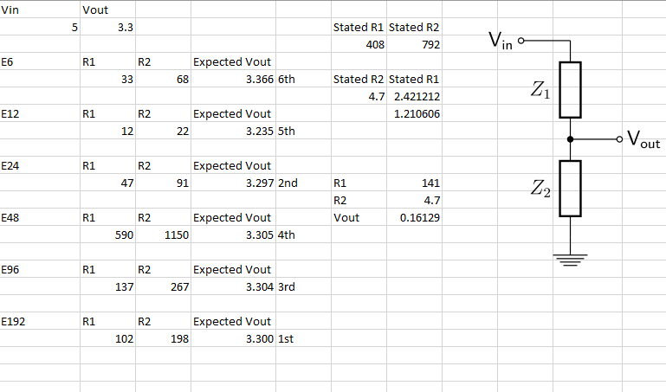

Figure 76:- Voltage Divider Excel Sheet

|  |  |
| --- | --- |
| 1. New Arduino Header | 1. New Button Header |

Figure 77:- Schematic Changes

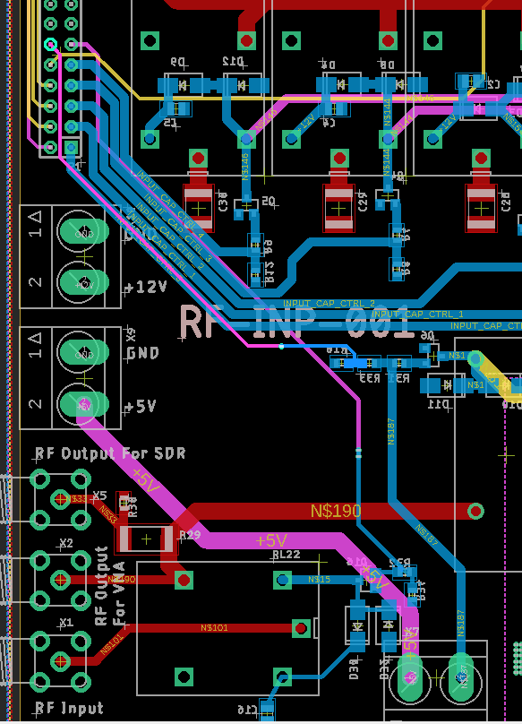

Figure 78:- Layout Change

### RF-VAL-001

The layout for the RF-VAL-001 is shown in Figure 79 a), which is the main amplification board. Due to the simplicity of the board an annotated version is not needed, but a version with a plane is shown in Figure 79 b). The board design is 100 mm by 100 mm in height, 1 layer, 1oz. The annotated version shows several sections of the layout:

|  |  |
| --- | --- |
| 1. Without Planes | 1. With Planes |

Figure 79:- RF-VAL-001 Layout

#### RF-INP-001 PDR

The only changes with this board were with the valve footprint as the pads for the signals being connected were too small, so they were made much thicker as shown now. That and the 6V3 line needed thickened from 2mm to 3mm, although 2mm would work, 3mm would be safer, especially due space available. Mounting holes were also missing, so they were added as well. The PCB name had also been missed so needed to be added. The RF input was changed from an SMA to a BNC to be compatible with the RF-OUT-001 Board

### RF-OUT-001

The RF-OUT-001 PCB layout is shown in Figure 80 a) without planes and in Figure 80 c) with planes. In addition, there is an annotated version in Figure 80 b). The core parts the circuitry for Figure 80 b) this shows that there is 1 main section which are:

1. RF output SDR voltage divider and SMA header.
2. The GPIO headers for the relay control
3. 12V power header for relays
4. SPI header for ADCs
5. SWR measurement ADCS
6. SWR transformer and divider for ADCs
7. First set of capacitors relays for ATU filter
8. RF input from the valve onto board
9. Inductor relays for ATU
10. Output safety relay
11. RF output header
12. Second set of capacitor relays for ATU filter.

|  |  |
| --- | --- |
| 1. RF-OUT-001 Unannotated | 1. RF-OUT-001 Annotated |
| 1. RF-OUT-001 With Plane |  |

Figure 80:- RF-OUT-001 Layout

#### RF-OUT-001 PDR

There was a handful of changes which were needed for this board, one of the biggest was moving the RF to an internal layer to increase the isolation, this was needed because without it the isolation needed was too extreme. The RF line needed to be made 2mm to avoid issues with impedance mismatching.

## BOM Review

Next the Bill of Materials (BOM) needed to be reviewed to ensure the components are within budget. Review

### RF-PWR-001 BOM

The BOM is shown in Figure 81 this shows a total cost of this board is £256.84, there is a total for 181 components for this board. The majority of the cost for this board is the HV transformer, the price break down by component type is shown in Figure 82

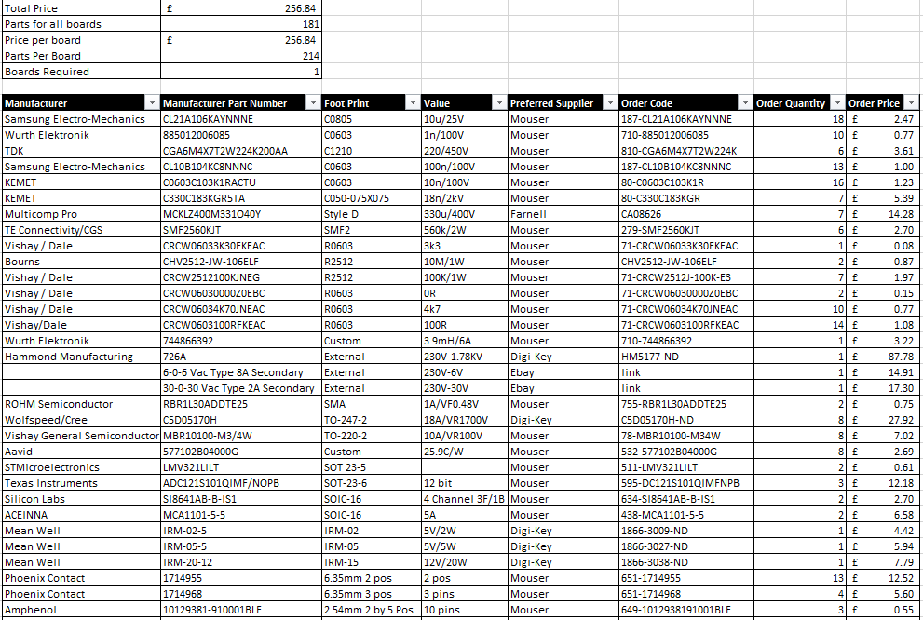

Figure 81:- RF-PWR-001 BOM

Figure 82:- RF-PWR-001 BOM Breakdown

### RF-INP-001 BOM

The BOM is shown in Figure 83 this shows a total cost of this board is £55.27, there is a total for 109 components for this board. A BOM break down is shown in Figure 84, which shows majority of the cost is in the headers and the IC and other category, this is because of the cost of SMA headers and relays which are counted in this category.



Figure 83:- RF-INP-001 BOM

Figure 84:- RF-INP-001 BOM Breakdown

### RF-VAL-001 BOM

The RF-VAL-001 BOM output is shown in Figure 86, this shows the total cost is £105.08. The price break down is shown in Figure 89, this shows that majority of the price is the valve and valve holder at a total of 76% or £80.24 of the total price.

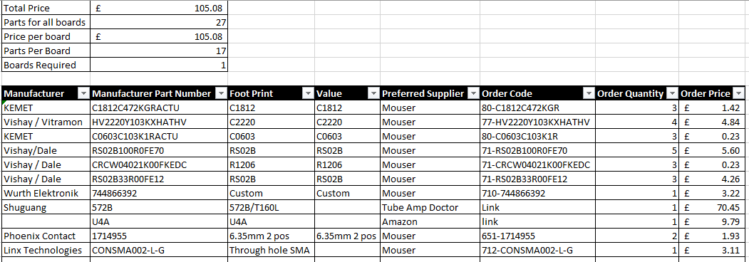

Figure 85:- RF-VAL-001 BOM

Figure 86:- RF-VAL-001 BOM Breakdown

### RF-OUT-001 BOM

The RF-OUT-001 BOM is shown in Figure 87, which show the total cost is £76.37. The price break down is shown in Figure 88, this shows that majority of the price is the IC and other category which cost 33% or £25.24 of the total price.



Figure 87:- RF-OUT-001 BOM

Figure 88:- RF-OUT-001 BOM Breakdown

### RF-EXTRN-001 BOM

The external and PCBs components are in the RF-EXTRN-001 BOM, the output is shown in Figure 89. This shows the total price of the external components, there is 5 total components, 1 Arduino Due, 1 Raspberry Pi, 1 Nano VNA and 2 RTL-SDR which is the SDR used, which is based on the RTL2832U chipset. The specific one being used here can tune in for the full 500 kHz to 1.7 GHz range [76] [77]. This gives a total price of £297.53 for this set of equipment, and a breakdown shown in Figure 90, where it can be seen that on these components the PCB only takes up 29%.

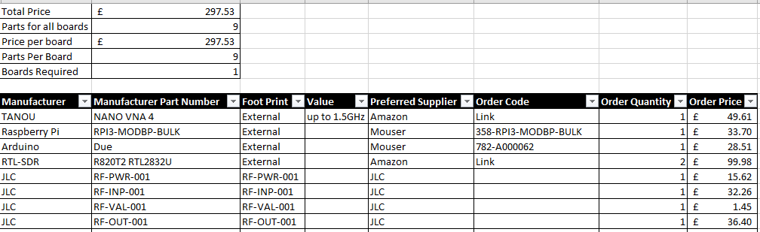

Figure 89:- RF-EXTRN-001 BOM

Figure 90:- RF-EXTRN-001 Price Breakdown

### Total

The total was then calculated in Equation 34, this shows the entire project will cost £791.09 to build, this is well under the £4000 which was the maximum target price, this makes this system affordable for HAM Radio enthusiast to build.

$$£_{Total }=£_{RF-PWR-001}+£_{RF-INP-001}+£_{RF-VAL-001}+£_{RF-OUT-001}+£_{RF-EXTRN-001}+£ \\ £_{Total }=256.84+55.27+105.08+76.37+297.53 \\ £_{Total }=£791.09$$

Equation 34:- Total Cost of the RF Amplifier

### Are the boards easy enough to build?

There is nothing too complicated to solder on these board, with the most common hardest components to solder being the 0603 Resistors and Capacitors, the SOT23-3 MOSFETs and the SOT-23-6 ADCs, but all of these packages could be by a semi experienced Surface Mounted Device (SMD) solder.

## CDR

A CDR was then carried out on the design for manufacturing, assembly, integration and testing. All boards would be getting printed on standard FR-4 PCBs, on 1 oz copper, this is the standard for PCBs with normally only specialist PCBs breaking this rule. All the information however on the PCBs material, copper weight and size will be generated when generating the GERBER files which contain this information. These designs have also been checked at this point by 2 external engineers who have checked the Schematics and Layout for any errors and were present for the PDRs as well. The manufacturing process which will be used is the standard process used at JLC PCB, which will be more than sufficient for this board, as for the components that go on the board, they will be hand soldered on by a semi experienced SMD solder. JLC PCB has their own internal Quality Assurance methods, including flying probes test, which checks that all traces are connected as expected with no short circuits, however it will be inspected once again once the PCB arrives to ensure there is no other obvious issues that occurred during shipping, and solder joints will be checked again in the testing phase to ensure there are no dry solder joints or other issues. These

# Operation

The amplifier would have several operating modes, depending on what it is currently doing, these are Receiving (7.1), Transmitting (7.2), Filter Switch (7.3) and Fault (7.4). The device switches between receiving and Transmitting mode through pressing the PTT button. This would be all controlled through a Web UI described in 7.5. But throughout this any reading found by the Arduino Due would be reported to the Raspberry Pi.

## Receiving Mode

When the PTT button is not pressed, the device would operate in receiving mode during this time, the antenna and the RF input would be directly connected with the safety relay being closed. Also, during this time, the filters would be held in their modes to start transmitting at a moments notice. The HV voltage would be constantly measured looking for any faults alongside the grid and plate currents, and any were found the device would switch to Fault mode as described in 7.4. There would also be basic communication between the Raspberry Pi and Arduino ensuring both were still active and checking in for any changes to the operating frequency, however the Raspberry Pi would not be checking the SDRs.

## Transmitting Mode

To switch to transmitting mode the PTT button would be pressed. When pressed the antenna would be automatically connected to the output RF and the Input connected to the filter and thus amplifier connected with the safety relay being closed. Then the device would start amplifying during which the HV voltage, grid current, plate current and SWR, while the Raspberry Pi would live monitor the SDRs looking for any major distortion. This would be the same with the HV, currents and distortion however they would all have different thresholds.

## Filter Switch Mode

There is two version of the Filter Switch Mode, the first one is described in 7.3.1 for when in Receiving Mode and 7.3.2 for when in Transmitting Mode.

### Filter Switching (Receiving)

When the command to switch filter comes in from the Raspberry Pi during Receiving mode, then the previous filter would be disconnected then, and the new filter switched in simultaneously. This would be done on both the Input and Output Boards at the same time, so a matched filter on both boards is being used.

### Filter Switching (Transmitting)

When the command to switch filter comes in from the Raspberry Pi during Transmitting mode, first the input safety relays would be disconnected stopping amplification, then after a short time delay giving the relays time to switch the output relay would be disconnected, then after another short delay the filter would be switched over to the new one, then after one more final short delay the safety relays would close again. This is being done this way because switching filters while the amplifier is like can cause large spikes in SWR which could cause damage due to the impedance of the transmitter changing dramatically and into unknown values, due to relays not switching instantly.

## Fault Mode

When a fault is detected both safety relays would be immediately disconnected, and an error message sent to the user.

## Web UI

A basic web UI would be used, this would run hosted on the raspberry pi using either the Ethernet or Wi-Fi Connection, Ethernet preferred due to increased stability. On this live data could be monitored about the SWR, the voltage of the HV rail and current. This may have been extended as well to have the ability to tune into the SDR as well so you could monitor the signal directly if wanted, this would be helpful as humans can hear issues better than a computer due to our innate ability to hear, rather than through other devices.

From this filter the transmitting frequency could be set which would in turn be passed onto the Arduino as a Filter Mode for the Arduino to switch to. During warning or fault conditions this UI would also have alerts pushed to it for the user to see in an attempt to avoid using the the Fault Mode.

## Arduino Pseudo Code

The Arduino start up Pseudo code is shown in Code 1, this shows how the Arduino would operate and connect to the other pseudo codes here. This is a basic overview of how it would be coded once the project had had got to that stage.

Code 1:- Start Up Pseudo Code

|  |
| --- |
| 1. Initialise UART to Raspberry Pi 2. Set up threshold variables 3. Set up other variables 4. Wait for configuration data from Raspberry pi. 5. Extract Filter Mode 6. if PTT has been pressed    1. <Go to transFiltSwitch (Code 4)> 7. else    1. <Go to normFiltSwitch (Code 5)> 8. <Go to main Loop (Code 2)> |

Code 2:- Main Loop Pseudo Code

|  |
| --- |
| 1. While true    1. Report readings to Raspberry Pi    2. Check for new messages from Raspberry Pi    3. if Raspberry Pi Timeout       1. <go to fault (Code 3)>    4. if Fault Reported       1. <go to fault (Code 3)>    5. if filter mode change       1. if PTT has been pressed          1. <Go to transFiltSwitch (Code 4)>       2. else          1. <Go to normFiltSwitch (Code 5)>    6. Check HV Voltage    7. If Volt fault found       1. <go to fault (Code 3)>    8. Check Plate Current    9. If Plate fault found       1. <go to fault (Code 3)>    10. Check Grid Current    11. If Grid fault found        1. <go to fault (Code 3)>    12. Check SWR ADC    13. Calculate SWR    14. If SWR fault found        1. <go to fault (Code 3)> |

Code 3:- Fault Pseudo Code

|  |
| --- |
| 1. Disconnect Safety Relays 2. Delay relay time 3. Disconnect Filter Relays 4. Delay relay time 5. Wait for resume from raspberry pi 6. <Go to transFiltSwitch (Code 4)> 7. Return to main Loop |

Code 4:- transFiltSwitch Pseudo Code

|  |
| --- |
| 1. Disconnect input Safety Relay 2. Delay relay time 3. Disconnect output Safety Relay 4. Delay relay time 5. Change Filter Relays to new mode 6. Delay relay time 7. Reconnect input Safety Relay 8. Delay relay time 9. Reconnect output Safety Relay 10. Delay relay time 11. Return |

Code 5:- normFiltSwitch Pseudo Code

|  |
| --- |
| 1. Change Filter Relays to new mode 2. Return |

# RF Propagation in a Forested Environment

Additionally my supervisor required an experiment into RF propagation in Forested environments was also carried out to see how this would affect the attenuation of a signal. To do this the following set experiment was carried out using a hedge, a bush was used as a good substitute for early testing, there is a bush located next to the testing grounds meaning a generator or battery source would be required. For this the following testing method would be used.

## Density of a forest

The density of a planted forest varies widely depending on two main variables density at breast height DBH, which is the diameter of the tree at breast height, approximately 1.37 m above the ground [78], and the variant of tree as a tree which is more shade tolerant, or a tree that requires less light than others e.g. American Beech Balsam Fir will be packed more dense than other trees like the Aspen and Balsam Poplar which require much more light in comparison [79]. Both of these are then compared to Figure 91 where the range of stems per acre can be found.

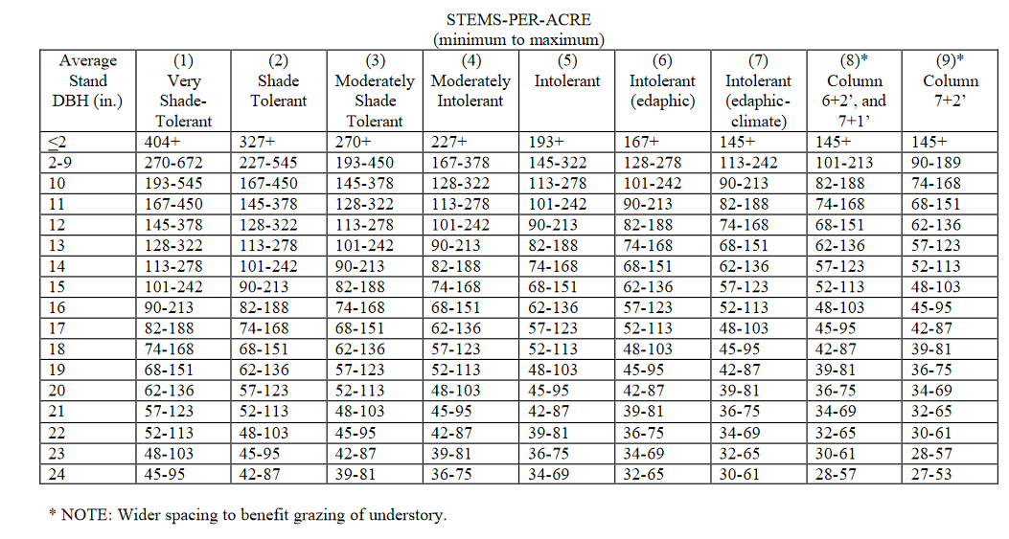

Figure 91:- Density of a Forest based on DBH and Shade Tolerance [80]

## Equipment used

The equipment used are shown in Table 4.

Table 4:- Part Numbers for Equipment

|  |  |  |
| --- | --- | --- |
| Equipment | Manufacturer | Part Number |
| Signal Generator | RIGOL | DG832 |
| Spectrum Analyser | RIGOL | RSA3030-TG |
| Antenna | Custom | 1 m long unshielded cable |

## Set up

First the signal generator was configured to the create a 1.8410 MHz 0.25 W RF signal, which would then be passed out to a 1m long antenna which would be in the testing hedge. Then a Spectrum Analyser was set up, as the receiver centred around the testing frequency, and was connected to another 1m long antenna for receiving. The receiving antenna was then moved along the hedge to a number of different locations, where the distance between the two antenna was measured. After the attenuation of the signal measured and noted, and a screenshot of the spectrum analyser created, this was repeated for several different distances. After all distances were completed the test was repeated using a 27.405 MHz. After the hedge was tested, the experiment was then repeated running alongside the hedge, using the same test frequencies. The spectrum analyser is shown in Figure 92 and the Signal Generator in Figure 93.

After this a section of the hedge was selected and the width and length of the hedge was measured. In the section the number of stalks was also counted in the section and this value was then used to calculate the number of stalks per acre.

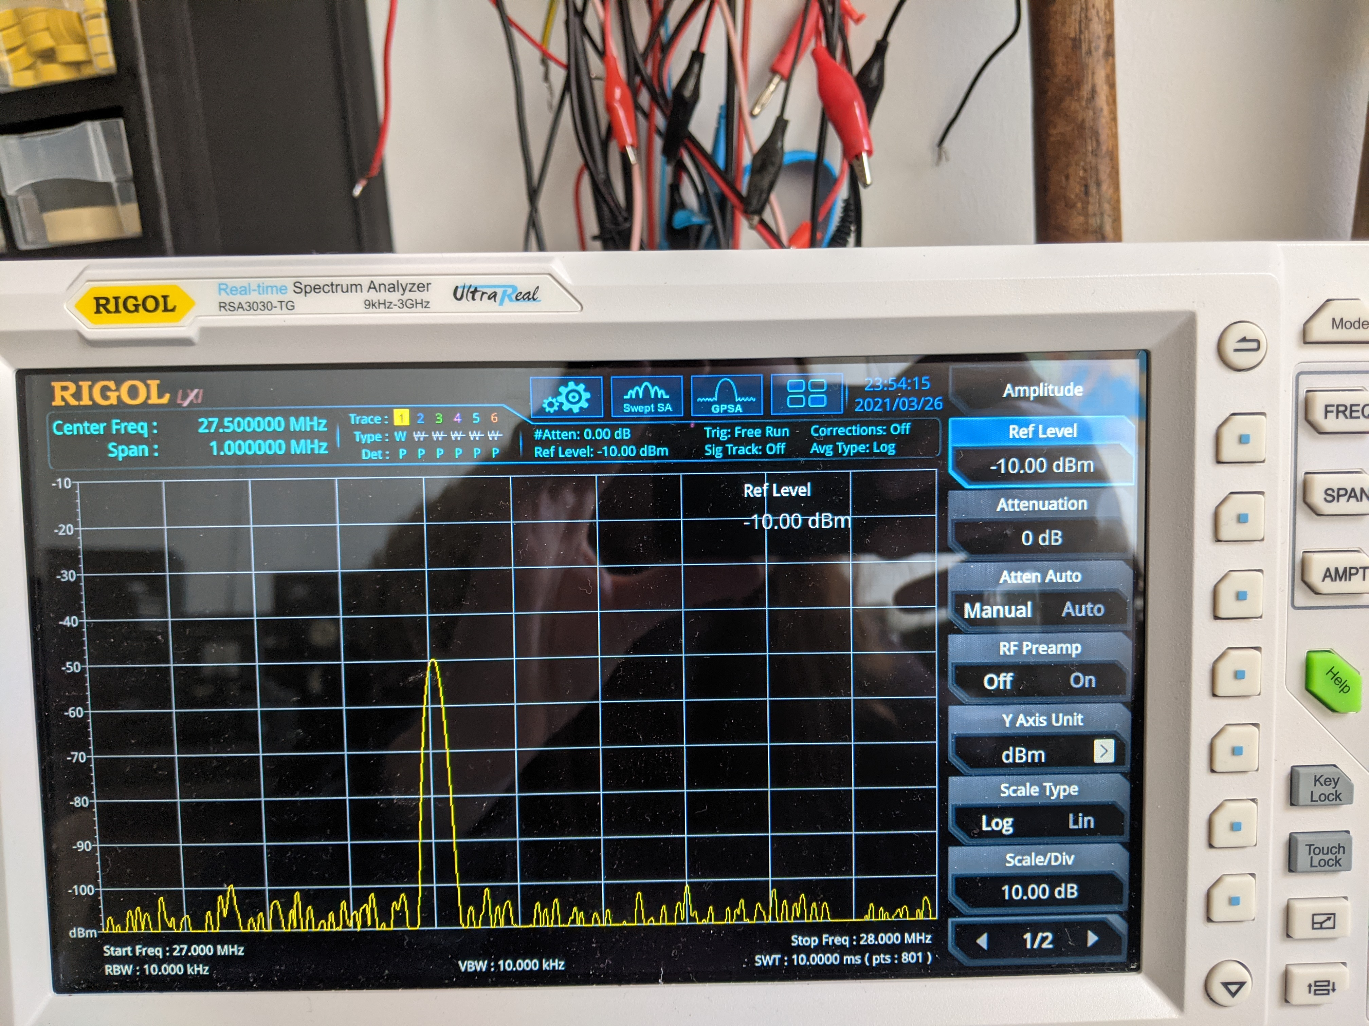

Figure 92:- Spectrum Analyser for the RF propagation

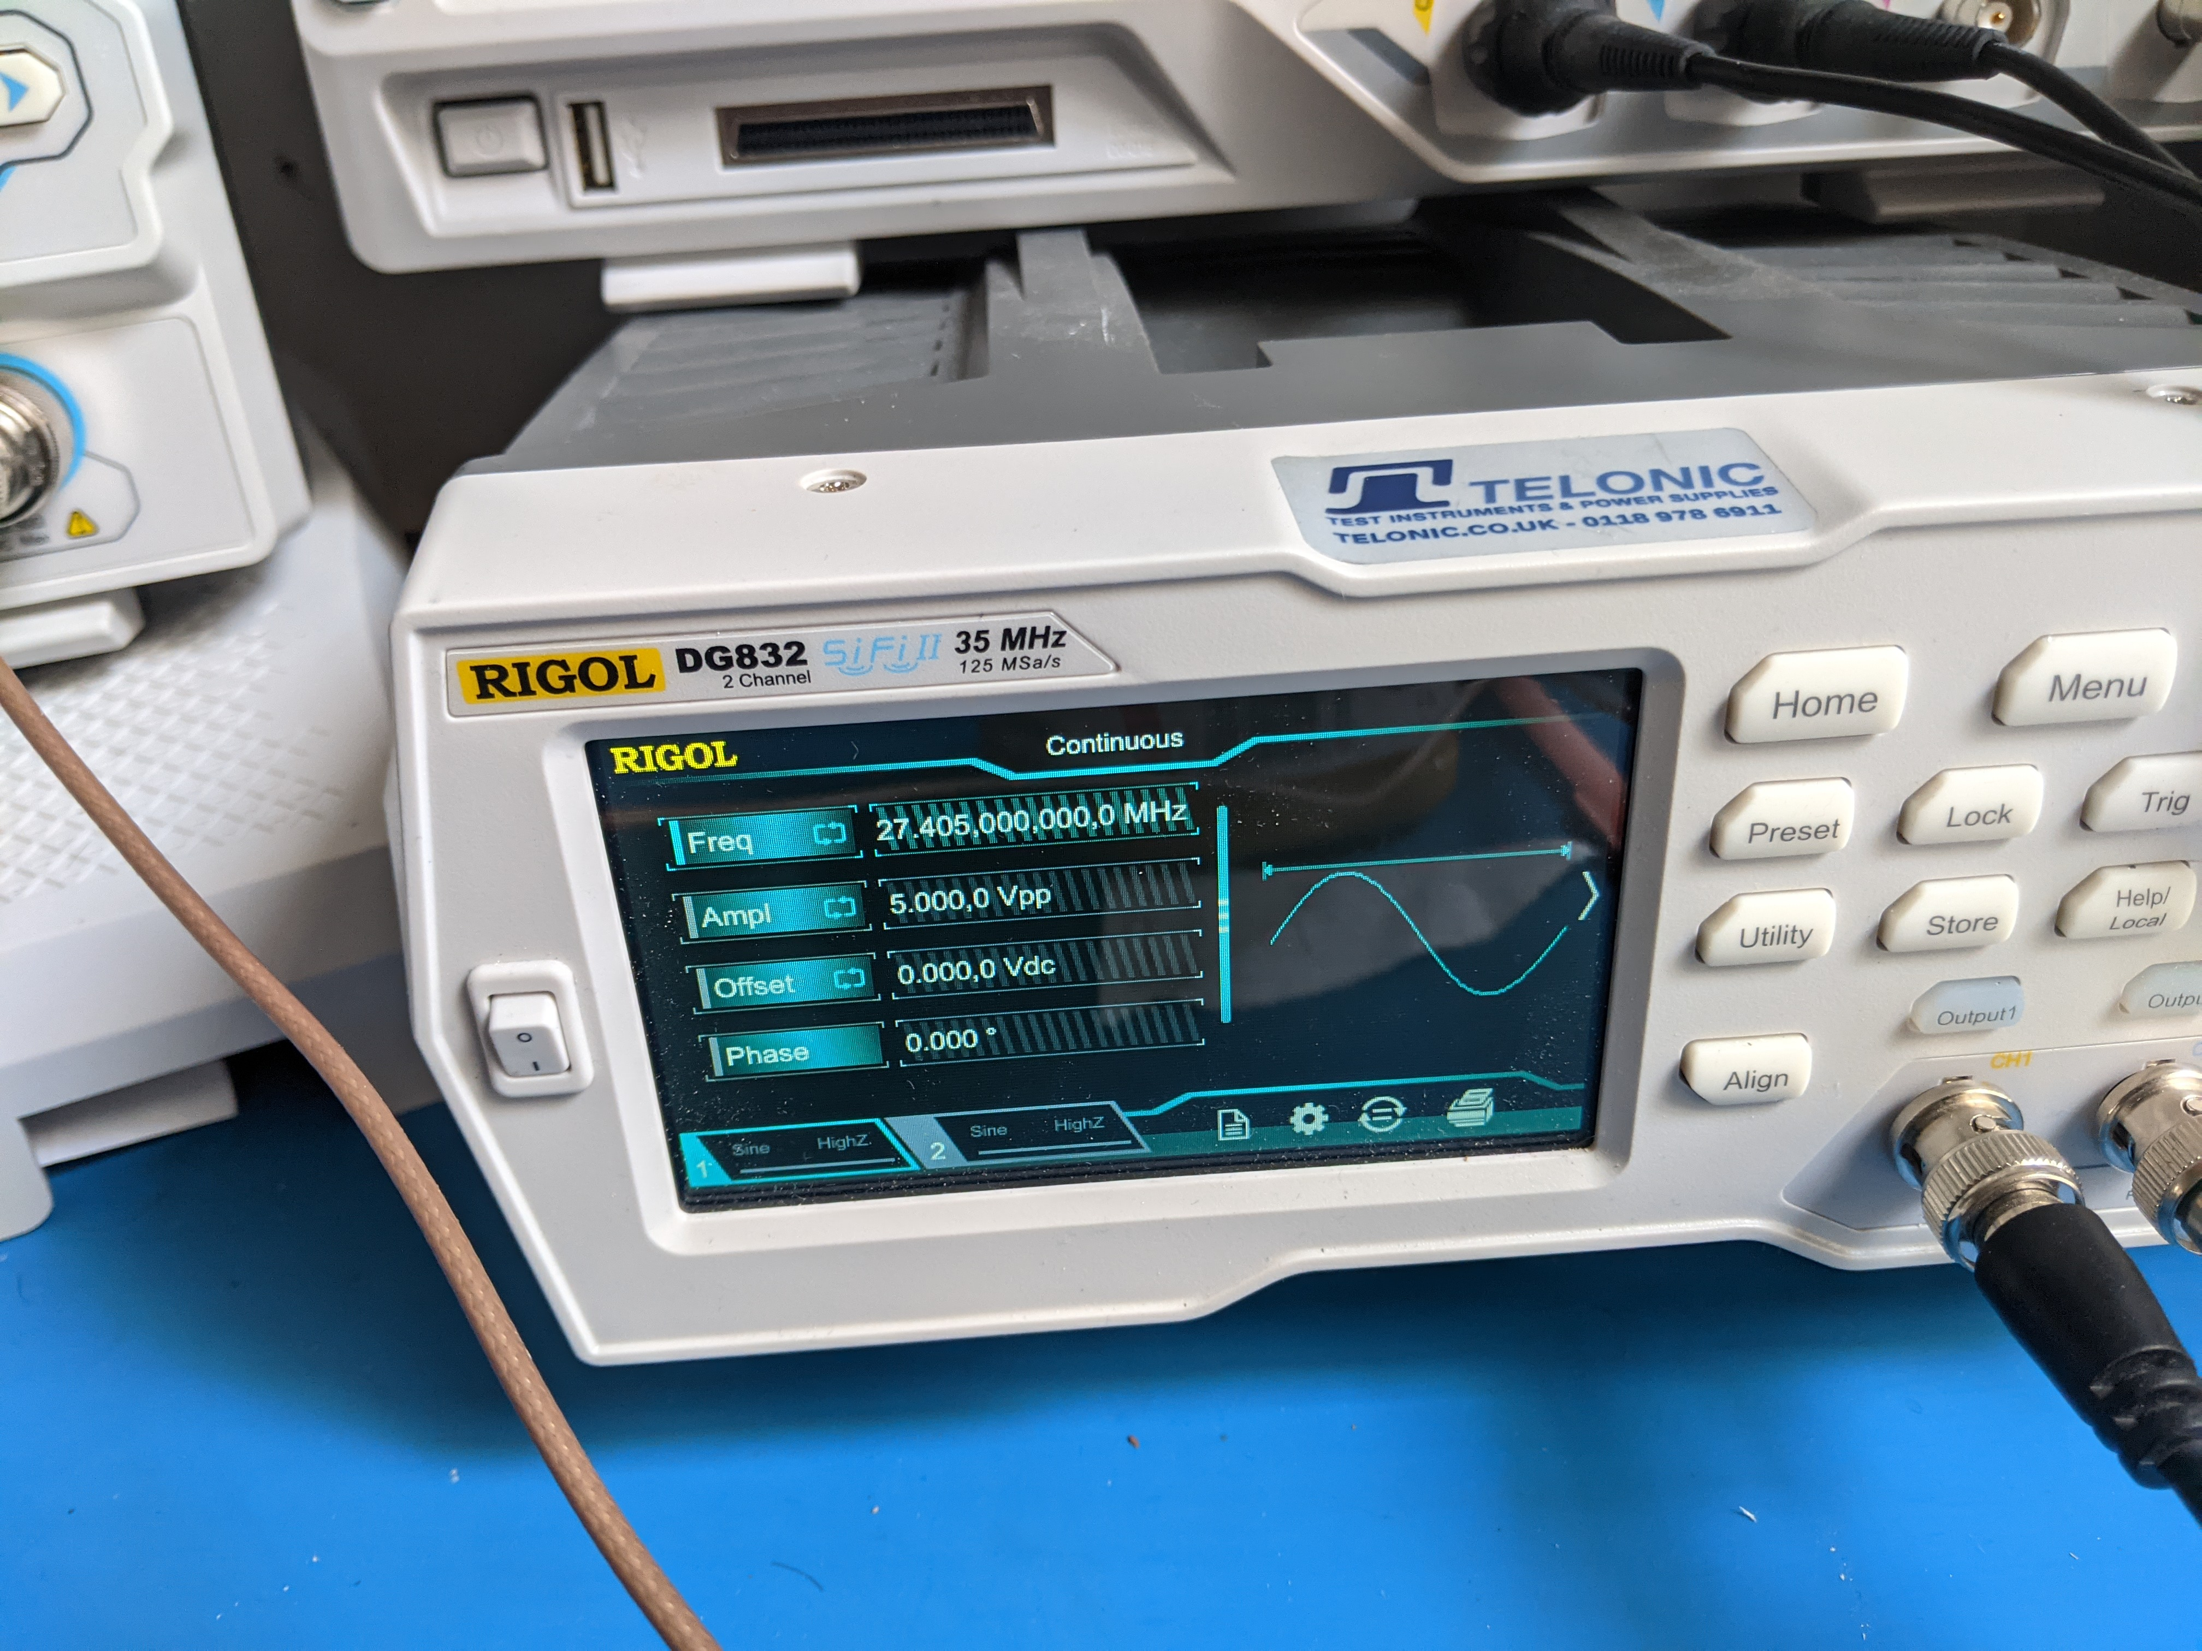

Figure 93:- Signal generator for the RF Propagation

## Hedge Information

The hedge information is shown in Table 5 this shows how the was calculated hedge density per acre. Next the DBH was calculated as shown in Table 6. Using this data and the chart shown in Figure 91 and assuming its very shade tolerant trees the equivalent it was found for a forest to be 404+ stalks per acre. Although the difference between hedge density and the forest density is significantly different as the hedge is significantly denser. This however is not a problem as it means a hedge should be a more difficult environment to propagate through.

Table 5:- Stalks per acre

|  |  |  |  |  |  |  |
| --- | --- | --- | --- | --- | --- | --- |
| Reading | Width (m) | Length (m) | Stalk Number | Area (m^2) | Stalks per m^2 | Stalks per acre |
| 1 | 0.5 | 2.58 | 24 | 1.29 | 18.6 | 75290.4 |
| 2 | 0.7 | 2.16 | 52 | 1.512 | 34.4 | 139177.6 |
| 3 | 1.7 | 2 | 30 | 3.4 | 8.8 | 35707.6 |
| Average |  |  |  |  | 20.6 | 83391.8 |

Table 6:- Diameter at Breast Height of the Hedge

|  |  |  |
| --- | --- | --- |
| Reading | DBH (mm) | DBH (in) |
| 1 | 25 | 1.0 |
| 2 | 35 | 1.4 |
| 3 | 32 | 1.3 |
| 4 | 30 | 1.2 |
| 5 | 25 | 1.0 |
| Average | 29.4 | 1.2 |

## Results

The results for the 1.841 MHz in a hedge are shown in Table 7, 27.405 MHz in a hedge is shown in Table 8. The results for 1.841 MHz outside the hedge are shown Table 9 and 27.405 MHz is shown in Table 10.

Table 7:- 1.8410 MHz In Hedge Results

|  |  |  |
| --- | --- | --- |
| Distance (m) | Attenuation dBm | Appendix |
| 0 | -85.4 | Figure 112 |
| 1.8 | -85.4 | Figure 113 |
| 4.1 | -86 | Figure 114 |
| 5.9 | -86 | Figure 115 |
| 8.1 | -87.2 | Figure 116 |
| 12.1 | -89.6 | Figure 117 |
| 17.2 | -89 | Figure 118 |

Table 8:- 27.405 MHz In Hedge Results

|  |  |  |
| --- | --- | --- |
| Distance (m) | Attenuation dBm | Appendix |
| 0 | -40 | Figure 119 |
| 2.1 | -42 | Figure 120 |
| 4.2 | -50 | Figure 121 |
| 7.75 | -50 | Figure 122 |
| 9.22 | -50.1 | Figure 123 |
| 10.44 | -50.5 | Figure 124 |
| 13.92 | -54 | Figure 125 |
| 17.02 | -56 | Figure 126 |

Table 9:- 1.8410 MHz out of Hedge Results

|  |  |  |
| --- | --- | --- |
| Distance (m) | Attenuation dBm | Appendix |
| 0 | -74.8 | Figure 127 |
| 2.1 | -74.8 | Figure 128 |
| 4.2 | -74.4 | Figure 129 |
| 7.75 | -79.2 | Figure 130 |
| 9.22 | -79.2 | Figure 131 |
| 10.44 | -79.2 | Figure 132 |
| 13.92 | -88.4 | Figure 133 |

Table 10:- 27.405 MHz out of Hedge Results

|  |  |  |
| --- | --- | --- |
| Distance (m) | Attenuation dBm | Appendix |
| 0 | -42 | Figure 134 |
| 1.1 | -44 | Figure 135 |
| 3.35 | -46 | Figure 136 |
| 5.1 | -46 | Figure 137 |
| 7.2 | -46 | Figure 138 |
| 10.5 | -48 | Figure 139 |
| 12.4 | -54 | Figure 140 |

Figure 94:- 1.8410 MHz Attenuation Comparison

Figure 95:- 27.405 MHz Attenuation Comparison

Figure 96:- RF Propagation with lines of best fit 1.8410 MHz

Figure 97:- RF Propagation with lines of best fit 27.405 MHz

## Propagation Conclusion

The effects of the hedge on the signal were small, however, being in the hedge did affect the attenuation as could be seen in the graphs for certain frequencies. It had more of an effect on the 1.8410 MHz where there was an initial 11 dB difference which slowly faded away as the distance between the antennas was increased. Whereas on the 27.410 MHz signal the difference can be seen to be almost negligible, which can be seen in the two lines of best fit being very close to each other and being within margin of error. This suggests that although the forest will influence the signals antennation it will be minor. This experiment does have an issue with the RF possibly passing out the side of the hedge and then propagate round it then passing back into the antenna, however this would be possible in a forest through its canopy. Due to a change in the 1.8410 MHz signal this suggests that this effect was minor. The hedge is denser than a forested environment, which means that antennation losses would be decreased further, which suggests that transmission in a forest would be both possible and able to be received clearly.

# Future Work

Due to COVID, the project needed to stop early, however a large amount of work had been done up to this point, but it did leave other work unfinished. So future work is:

* Complete the design process by building the system and developing a thorough test plan. Then through a TRR the test plan would be examined, once approved the system would be tested and the software algorithms would be fully developed.
* After tests and software has been completed then a SAR would take place, to ensuring the test data shows high maturity level. Once approved, the documentation would be finalised and then an ORR completed to ensure all documentation accurately reflected the system. Finally, after the ORR was completed a RTRR would be carried out to confirm the device was ready to transmit over free air on a HAM radio band.
* Additionally, other amplifier boards would be designed. These boards would allow different RF semiconductors and valves to be tested, allowing their differences to be investigated. This is an improvement on the current system, which only operates with U4A values. This comparison could investigate what option offers the best gain, power, and cost for various uses. In addition to this testing non-RF Transistors could be interesting, as these devices can be used for RF amplification even if it is not specifically advertised. For example, the 2N7000 MOSFET is defined for RF amplification however it has been used as one although with a terribly low efficiency of around 20% [81].
* Finally, the investigation into RF propagation in a forested environment, would be expanded by repeating a similar experiment in a forested environment. This would be done by going to a forest and setting up a transmitter and then measure the propagation at various away in various direction, at different direction for example 0, 5, 10, 20, 50, 100, 200 and 500 meters away north, south east and west. This would be a good way to test how a forested environment impacts RF propagation.

# Changes

If I were to work on this project again starting from scratch, working without the limitations of cost, time, and COVID-19 then I would do several things a bit differently.

The first thing I would have done is include a fifth PCB for the isolators, this would be handy as it would then mean the RF-PWR-001 board was purely for power and was not also needing to do isolation, it would also mean that if the power board were to be redesigned for the platform the isolators would not need to be too as they would be the more certain board due to their simplicity. On top of this I would have also added aboard for current sensing for the grid current, this would be useful as it would mean if the grid voltage were changed this circuitry is unlikely to need to change, it would also make sense if the isolators were being removed from the board.

Also, when redesigning the RF-INP-001 Board I would use an internal layer for the RF like done in RF-OUT-001, this is not necessarily due to the operating voltages, but this would make clearances better overall and would be better for noise.

On top of this using HV reed relays would also be used for the RF-OUT-001 board, this would be useful as they deal with HV, although this should not cause issue for this project, it would be better practice to use these reed relays.

The RF propagation test would be rerun but using a longer antenna which would be closer to the ideal length for the selected frequency for a better transmission, although the current solution is good enough for this test, this would make the solution more accurate.

# COVID-19

Unforchantly due to COVID-19 the project was not able to be completed to the degree that was first intended, this was due to several reasons. One reason was there was a plan to try and mitigate the issues with COVID-19 by using an external company’s premises for building and testing, however due to COVID-19 this premise was not able to provide a space that it original thought it could. This held the project back a lot as the final device was unable to be built and tested.

Also due to COVID restrictions it was not possible for the RF Propagation to be tested in an actual forest thus why a hedge was used, this is a good starting point however for this and does show promising signs for a forest.

# Conclusion

In this project a RF amplifier was researched and designed, based on the K.W. Electronics KW1000 Amplifier, which was chosen because of its historically good performance. This was then modified and modernised to use more modern ICs, relays and other devices which were not available when the Amplifier was originally made. On top the system was broken up into 4 smaller sub sections which are used to create a basic test platform which could be easily changed out and modified so a range of different MOSFETs and Valves could be used. On top of this, an investigation into RF propagation losses in forested environments was carried out. This experiment was carried out using a hedge measuring the propagation loss, which was an 11 dBm drop for 1.8410 MHz with a difference decreasing with distance whereas both 27.405 MHz inside and outside the hedge where approximately the same, within error. This initial testing suggests the propagation loss in a forest will be minimal enough to allow RF transition and to still receive a recognisable form over a short to medium distances depending on its frequency. Overall, this project was mostly a success, but due to COVID-19 not all of the goals were achievable. If COVID did not limit it then the amplifier would have been fully built and tested, on top of this the propagation loss experiment would be repeated in a forest.

# References

|  |  |
| --- | --- |
| [1] | britannica, “Amplifier,” britannica, [Online]. Available: https://www.britannica.com/technology/amplifier. [Accessed 16th March 2021]. |
| [2] | P. Horowitz and W. Hill, THE ART OF ELECTRONICS Third Edition, New York: Cambridge University Press, 2016. |
| [3] | S. Gupta, “Classes of Power Amplifiers,” Circuit Digest, 11 December 2018. [Online]. Available: https://circuitdigest.com/tutorial/classes-of-power-amplifier-explained. [Accessed 8 December 2020]. |
| [4] | D. L. William, “What is a Linear Amplifier,” HAM'S Life, 23 July 2012. [Online]. Available: http://www.hamslife.com/what-is-a-linear-amplifier/. [Accessed 8 December 2020]. |
| [5] | Silicon Labs, “RF Range Calculator,” 2nd Feburary 2017. [Online]. Available: https://www.silabs.com/community/wireless/proprietary/knowledge-base.entry.html/2017/05/02/rf_range_calculator-SYIA. [Accessed 3rd April 2021]. |
| [6] | Techopedia, “Radio Propagation,” Techopedia, [Online]. Available: https://www.techopedia.com/definition/9077/radio-propagation. [Accessed 24th March 2021]. |
| [7] | Math Open Reference, “Normal,” Math Open Reference, 2011. [Online]. Available: https://www.mathopenref.com/normal.html. [Accessed 24th March 2021]. |
| [8] | H. Wen-Yu, S. Ying, Y. Mudan and H. Lin, “Creating in-plane pseudomagnetic fields in excess of 1000 T by misoriented stacking in a graphene bilaye,” Department of Physics, Beijing Normal University, Beijing, 100875, People’s Republic of China, March 2014. [Online]. Available: https://www.researchgate.net/figure/color-online-The-curved-surface-represents-a-strained-graphene-sheet-We-can_fig1_260628831. [Accessed 24th March 2021]. |
| [9] | Fizik, “Reflection of waves,” Fizik , 22nd December 2010. [Online]. Available: http://fizik-fizik.blogspot.com/2010/12/reflection-of-waves.html. [Accessed 24th March 2021]. |
| [10] | The Physics Classroom, “Reflection of a Pulse at a Fixed End,” The Physics Classroom, [Online]. Available: https://www.physicsclassroom.com/mmedia/waves/fix.cfm. [Accessed 24th March 2021]. |
| [11] | The Physics Classroom, “ Reflection of a Pulse at a Free End,” The Physics Classroom, [Online]. Available: https://www.physicsclassroom.com/mmedia/waves/free.cfm. [Accessed 24th March 2021]. |
| [12] | Wave Behaviour RAFT, “Reflection,” Wave Behaviour RAFT, [Online]. Available: https://sites.google.com/site/wavebehaviourraft/reflection. [Accessed 24th March 2021]. |
| [13] | Veerendra, “Explain Refraction Of Light Through A Glass Slab,” A Plus Topper, 19th December 2020. [Online]. Available: https://www.aplustopper.com/refraction-of-light-through-glass-slab/. [Accessed 24th March 2021]. |
| [14] | Science Learning Hub, “Refraction of light,” Science Learning Hub, 23rd May 2020. [Online]. Available: https://www.sciencelearn.org.nz/resources/49-refraction-of-light. [Accessed 24th March 2021]. |
| [15] | PhysicsNet.co.uk, “Refraction,” PhysicsNet.co.uk, [Online]. Available: http://physicsnet.co.uk/a-level-physics-as-a2/waves/refraction/. [Accessed 24th March 2021]. |
| [16] | BBC Bitesize, “Critical angle and total internal reflection - Higher,” BBC Bitesize, [Online]. Available: https://www.bbc.co.uk/bitesize/guides/zv4pd6f/revision/1. [Accessed 27th March 2020]. |
| [17] | BBC Bitesize, “Features of waves,” BBC Bitesize, 24th March 2021. [Online]. Available: https://www.bbc.co.uk/bitesize/guides/z3hyj6f/revision/3. [Accessed 24th March 2021]. |
| [18] | electronics notes, “What is Radio Propagation: RF propagation,” electronics notes, [Online]. Available: https://www.electronics-notes.com/articles/antennas-propagation/propagation-overview/basics.php. [Accessed 24th March 2021]. |
| [19] | electronics notes, “Free Space Path Loss: details & calculator,” electronics notes, [Online]. Available: https://www.electronics-notes.com/articles/antennas-propagation/propagation-overview/free-space-path-loss.php. [Accessed 24th March 2021]. |
| [20] | ITU, “NOMENCLATURE OF THE FREQUENCY AND WAVELENGTH BANDS USED IN TELECOMMUNICATIONS (accessed on wayback machine 31st October 2013),” ITU, 2005. [Online]. Available: https://web.archive.org/web/20131031020427/http://www.itu.int/dms_pubrec/itu-r/rec/v/R-REC-V.431-7-200005-I%21%21PDF-E.pdf. [Accessed 24th March 2021]. |
| [21] | H. Hunter, “NASA experiments will watch eclipse's effect on atmosphere,” Planetary Society, 18th August 2017. [Online]. Available: https://www.planetary.org/articles/20170818-eclipse-effects-atmosphere. [Accessed 24th March 2021]. |
| [22] | electronics notes, “Ground Wave Propagation Tutorial,” electronics notes, [Online]. Available: https://www.electronics-notes.com/articles/antennas-propagation/ground-wave/basics-tutorial.php. [Accessed 24th March 2020]. |
| [23] | electronics notes, “HF Propagation: Ionospheric Radio Propagation,” electronics notes, [Online]. Available: https://www.electronics-notes.com/articles/antennas-propagation/ionospheric/hf-propagation-basics.php. [Accessed 24th March 2021]. |
| [24] | B. A. -. KA1GT, “Radio Propagation by Tropospheric Scattering,” Bob Atkins - KA1GT, 1991. [Online]. Available: https://www.bobatkins.com/radio/troposcatter.html. [Accessed 24th March 2021]. |
| [25] | electronics notes, “Tropospheric Propagation,” electronics notes, [Online]. Available: https://www.electronics-notes.com/articles/antennas-propagation/tropospheric/tropospheric-propagation.php. [Accessed 24th March 2021]. |
| [26] | W. R. Hepburn, “Worldwide Tropospheric Ducting Forecast,” dxinfocentre, [Online]. Available: https://www.dxinfocentre.com/tropo_nwe_old.html. [Accessed 24th March 2021]. |
| [27] | J. S. Seybold, Introduction to RF Propagation, New Jersey: John Wiley & Sons, Inc, 2005. |
| [28] | W. R. Hepburn, “Hepburn Tropo Index Valid 0600 UTC Friday Mar 19 NWrn Europe,” dxinfocentre, 19th March 2021. [Online]. Available: https://www.dxinfocentre.com/tr_map/archive/6nwe.png. [Accessed 24th March 2021]. |
| [29] | KB6NU, “Use forward and reflected power to calculate SWR,” KB6NU, 27th September 2016. [Online]. Available: https://www.kb6nu.com/use-forward-reflected-power-calculate-swr/. [Accessed 23rd March 2021]. |
| [30] | G. R T IRISH, SWR Explained, A Radio Amateur's Guid to Electromagnetic Waves, Transmission Lines and VSWR, Bedford: Radio Society of Great Britian, 2015. |
| [31] | Electronics Notes, “What is an Antenna Tuner or Antenna Tuning Unit ATU,” Electronics Notes, [Online]. Available: https://www.electronics-notes.com/articles/antennas-propagation/antenna-tuning-tuner-unit/what-is-an-atu-basics.php. [Accessed 23rd March 2021]. |
| [32] | M. Hendrickson, “The ABCs of SWR, VSWR, Reflected Power and Return Loss,” Radio World, 9th December 2015. [Online]. Available: https://www.radioworld.com/news-and-business/the-abcs-of-swr-vswr-reflected-power-and-return-loss. [Accessed 23rd March 2021]. |
| [33] | Maker Pro, “An antenna tuner is an impedance matching network that connects the transmitter and the antenna.,” Maker Pro, 27th February 2020. [Online]. Available: https://maker.pro/custom/projects/make-an-antenna-tuner. [Accessed 23rd March 2021]. |
| [34] | M. Bellis, “The History of Vacuum Tubes and Their Uses,” Thought Co., 4th February 2019. [Online]. Available: https://www.thoughtco.com/the-history-of-vacuum-tubes-1992595. [Accessed 16th March 2021]. |
| [35] | The Free Dictionary, “gauze,” The Free Dictionary, [Online]. Available: https://www.thefreedictionary.com/gauze. [Accessed 15th March 2021]. |
| [36] | Electronics notes, “What is a Vacuum Tube: Thermionic Valve,” Electronics notes, [Online]. Available: https://www.electronics-notes.com/articles/electronic_components/valves-tubes/what-is-a-tube-basics-tutorial.php. [Accessed 16th March 2021]. |
| [37] | L. Gray and R. Graham, “Power Tubes,” in *Radio Transmitters*, New York, Toronto, London, McGRAW-HILL BOOK COMPANY, 1961, pp. 89-95. |
| [38] | Apex Tube Matching, “Why Should I Match My Tubes?,” Apex Tube Matching, 5th April 2021. [Online]. Available: https://www.apexmatching.com/why-should-i-match-my-tubes. [Accessed 5th April 2021]. |
| [39] | Rachel, “Shuguang Vacuum Tube Manufacturing Facility,” Grant Fidelity/Enjoy the Music, [Online]. Available: http://enjoythemusic.com/magazine/manufacture/0609/. [Accessed 21st March 2021]. |
| [40] | R. Symons, “Tubes: Still Vital after all these years,” *IEEE Spectrum,* vol. 35, no. 4, pp. 52-63, 4 April 1998. |
| [41] | Radio Society of Great Britain, “Amateur Radio Band Plans,” Radio Society of Great Britain, [Online]. Available: http://www.hflink.com/bandplans/UK_bandplan.pdf. [Accessed 24th March 2021]. |
| [42] | Ofcom, “UK Frequency Allocation Table (UKFAT),” Ofcom, 8th January 2020. [Online]. Available: http://static.ofcom.org.uk/static/spectrum/fat.html. [Accessed 24th March 2021]. |
| [43] | AcqNotes, “System Engineerings Configuiration Baselines,” AcqNotes, 23rd May 2018. [Online]. Available: https://acqnotes.com/acqnote/careerfields/configuration-baselines. [Accessed 20th March 2021]. |
| [44] | Defence Acquisiion Guidebook, “10.5.3. Preliminary Design Review (PDR) Review and Assessment (archived on wayback machine 20th October 2016),” Defence Acquisiion Guidebook, 20 October 2016. [Online]. Available: https://web.archive.org/web/20161020105511/https://acc.dau.mil/CommunityBrowser.aspx?id=518699. [Accessed 20th March 2021]. |
| [45] | Comander, NAVAL Air Systems Command, “SYSTEMS ENGINEEING TECHNICAL REVIEW PROCESS,” Deparement of Defence, Department of the NAVY, 6th Febuary 2015. [Online]. Available: https://web.archive.org/web/20180304171022/http://www.navair.navy.mil/nawctsd/Resources/Library/Acqguide/NAVAIRINST-4355-19.pdf. [Accessed 20th March 2021]. |
| [46] | L. Russell, “Talking Ham,” Github, 5th April 2021. [Online]. Available: https://github.com/grimreeper132/Talking-Ham. [Accessed 5th April 2021]. |
| [47] | Wikipedia, “K.W. Electronics,” Wikipedia, [Online]. Available: https://en.wikipedia.org/wiki/K.W._Electronics. [Accessed 16th March 2021]. |
| [48] | RigPix, “K.W.Electronics KW-1000,” RigPix, [Online]. Available: http://www.rigpix.com/linears/kwelectronics_kw1000.htm. [Accessed 16th March 2021]. |
| [49] | K.W. Electronics, “Decca KW-1000 HF Linear Amplifier,” K.W. Electronics, [Online]. Available: http://kwradios.ngunn.net/KW1000/Decca%20KW-1000%20Linear%20Amplifier.pdf. [Accessed 16th March 2021]. |
| [50] | GM4KGK, “KW-1000 Circuit Diagram,” [Online]. Available: http://www.gm4kgk.co.uk/images/KW1000_diag.jpg. [Accessed 20 December 2021]. |
| [51] | Dfinitski, “Schematic_ATU-100-mini.pdf,” ATU 100 Mini Board, 2nd Febuary 2019. [Online]. Available: https://github.com/Dfinitski/N7DDC-ATU-100-mini-and-extended-boards/blob/master/ATU_100_mini_board/Schematic_ATU-100-mini.pdf. [Accessed 21st March 2021]. |
| [52] | Dfinitski, “Github,” [Online]. Available: https://github.com/Dfinitski/N7DDC-ATU-100-mini-and-extended-boards/blob/master/ATU_100_mini_board/Schematic_ATU-100-mini.pdf. [Accessed 2021 January 13th]. |
| [53] | Sensata Technologies, “D Series High Voltage relays 10kV & 15kV,” Sensata Technologies, [Online]. Available: https://www.mouser.co.uk/datasheet/2/657/cynergy3_d_pcb_v2-1892244.pdf. [Accessed 21st March 2021]. |
| [54] | Nexperia, “2N7002NXAK,” Nexperia, 1st July 2019. [Online]. Available: https://www.mouser.co.uk/datasheet/2/916/2N7002NXAK-1651343.pdf. [Accessed 21st March 2021]. |
| [55] | Linx Technologies, “SMA FEMALE RIGHT ANGLEPCB MOUNT, EXTENDED, CONSMA002-L-*,” Linx Technologies, 23rd January 2019. [Online]. Available: https://www.mouser.co.uk/datasheet/2/238/consma002-l-g-1544715.pdf. [Accessed 21st March 2021]. |
| [56] | Wurth Elektronik, “WE-HCF Round Wire SMT HighCurrent Inductor 74437529203470,” Wurth Elektronik, 2nd March 2020. [Online]. Available: https://www.mouser.co.uk/datasheet/2/445/74437529203470-1721700.pdf. [Accessed 21st March 2021]. |
| [57] | The National Valve Museum, “572B,” The National Valve Museum, 15th February 2013. [Online]. Available: http://www.r-type.org/exhib/aac0008.htm. [Accessed 21st March 2021]. |
| [58] | S.S.B Linear Amplifer, “572B Type 811A and 811-A/B Replacement,” S.S.B Linear Amplifer, [Online]. Available: http://www.r-type.org/pdfs/572b.pdf. [Accessed 21st March 2021]. |
| [59] | Texas Instruments, “ADC121S101x Single-Channel, 0.5 to 1-Msps, 12-Bit Analog-to-Digital Converter,” Texas Instruments, April 2016. [Online]. Available: https://www.ti.com/lit/ds/symlink/adc121s101-q1.pdf?HQS=dis-mous-null-mousermode-dsf-pf-null-wwe&ts=1616354025328&ref_url=https%253A%252F%252Fwww.mouser.co.uk%252F. [Accessed 21st March 2021]. |
| [60] | ROHM Semiductor, “RBR1L30ADD Schottky Barrier Diode,” ROHM Semiductor, 2016. [Online]. Available: https://www.mouser.co.uk/datasheet/2/348/rbr1l30addte25-e-1870490.pdf. [Accessed 21st March 2021]. |
| [61] | BOURNS, “CD214A-R12000R Rectifier Chip Diode,” BOURNS, 31st March 2015. [Online]. Available: https://www.mouser.co.uk/datasheet/2/54/cd214a_r12000r-1879899.pdf. [Accessed 21st March 2021]. |
| [62] | Amidon, “BN-43-1502,” Amidon, [Online]. Available: https://www.amidoncorp.com/bn-43-1502/. [Accessed 21st March 2021]. |
| [63] | Silicon Labs, “Si86xx 1 Mbps Data Sheet,” Silicon Labs, September 2019. [Online]. Available: https://www.mouser.co.uk/datasheet/2/368/si86xx_1Mbps_datasheet-1522773.pdf. [Accessed 21st March 2021]. |
| [64] | “All About Circuits,” [Online]. Available: https://www.allaboutcircuits.com/tools/voltage-divider-calculator/. [Accessed 13th January 2021]. |
| [65] | Vishay, “MBR1090-M3, MBR10100-M3 High Voltage Trench MOS Barrier Schottky Rectifier,” Vishay, 10th May 2016. [Online]. Available: https://www.mouser.co.uk/datasheet/2/427/mbr10100-1768432.pdf. [Accessed 22nd March 2021]. |
| [66] | CREE, “C5D05170H Silicon Carbide Schottky Diode,” CREE, December 2018. [Online]. Available: https://www.mouser.co.uk/datasheet/2/90/c5d05170h-1795235.pdf. [Accessed 22nd March 2021]. |
| [67] | Ohmite, “W Series Heatsinks For TO-220, TO-247, and TO-264 devices,” Ohmite, 30th March 2021. [Online]. Available: https://www.mouser.co.uk/datasheet/2/303/sink_w-1265565.pdf. [Accessed 30th March 2021]. |
| [68] | Texas Instruments, “LM5088,LM5088-Q1Wide Input RangeNon-SynchronousBuck Controlle,” Texas Instruments, August 2014. [Online]. Available: https://www.ti.com/lit/ds/symlink/lm5088.pdf?HQS=dis-mous-null-mousermode-dsf-pf-null-wwe&ts=1616438880757&ref_url=https%253A%252F%252Fwww.mouser.cn%252F. [Accessed 22nd March 2021]. |
| [69] | Texas Instruments, “TPS563394.5-V to 24-V Input, 3-A OutputSynchronousBuck Converter,” Texas Instruments, May 2019. [Online]. Available: https://www.ti.com/lit/ds/symlink/tps56339.pdf?HQS=dis-mous-null-mousermode-dsf-pf-null-wwe&DCM=yes&ref_url=https%3A%2F%2Fwww.mouser.co.uk%2F&distId=26. [Accessed 22nd March 2021]. |
| [70] | Mean Well, “IRM-05series,” Mean Welll, 20th October 2020. [Online]. Available: https://www.meanwell.com/Upload/PDF/IRM-05/IRM-05-SPEC.PDF. [Accessed 22nd March 2021]. |
| [71] | Mean Well, “IRM-02series,” Mean Well, 12th October 2020. [Online]. Available: https://www.meanwell.com/Upload/PDF/IRM-02/IRM-02-SPEC.PDF. [Accessed 22nd March 2021]. |
| [72] | Mean Well, “IRM-20 series,” Mean Well, 8th March 2021. [Online]. Available: https://www.meanwell.com/Upload/PDF/IRM-20/IRM-20-SPEC.PDF. [Accessed 22nd March 2021]. |
| [73] | Hammonf Manufacturing, “High Voltage (Plate) - 259 VA to 1610 VA 700 Series,” Hammond Manufacturing, 2021. [Online]. Available: https://www.hammfg.com/electronics/transformers/classic/700.pdf. [Accessed 22nd March 2021]. |
| [74] | 4PCB, “Tace Width Calculator,” 4PCB, [Online]. Available: https://www.4pcb.com/trace-width-calculator.html. [Accessed 22nd March 2021]. |
| [75] | IPC, “IPC-2221,” IPC, Febuary 1998. [Online]. Available: https://ee174-fall15-01.courses.soe.ucsc.edu/system/files/attachments/IPC-2221.pdf. [Accessed 22nd March 2021]. |
| [76] | RTL-SDR.COM, “About RTL-SDR,” RTL-SDR.COM, [Online]. Available: https://www.rtl-sdr.com/about-rtl-sdr/. [Accessed 23rd March 2021]. |
| [77] | Amazon, “RTL-SDR Blog R820T2 RTL2832U 1PPM TCXO SMA Software Defined Radio (Dongle Only),” Amazon, [Online]. Available: https://www.amazon.co.uk/RTL-SDR-Blog-RTL2832U-Software-Defined/dp/B0129EBDS2. [Accessed 23rd March 2021]. |
| [78] | S. Nix, “What Is Diameter Breast Height? One of the Most Important Tree Measurements for Foresters,” ThoughtCo., 7th March 2019. [Online]. Available: https://www.thoughtco.com/what-is-diameter-breast-height-1341720. [Accessed 24th March 2021]. |
| [79] | Forestry Facts (accessed on wayback machine 26th Feburary 2017), “Forestry Facts (accessed on wayback machine 26th Feburary 2017),” College of Agricultural and Life Sciences, July 1996. [Online]. Available: http://web.archive.org/web/20170226120434/forest.wisc.edu/sites/default/files/pdfs/publications/79.pdf. [Accessed 24th March 2021]. |
| [80] | United States Department of Agriculture, “Technical Notes FOREST STAND DENSITY GUIDE,” United States Department of Agriculture, Washington, 1982. |
| [81] | Alan, “The "Wee Willy" RF Power Amp,” Alan's Lab me and my geeky hobbies, 22nd January 2007. [Online]. Available: http://www.vk2zay.net/article/102. [Accessed 23rd March 2021]. |

# Appendix

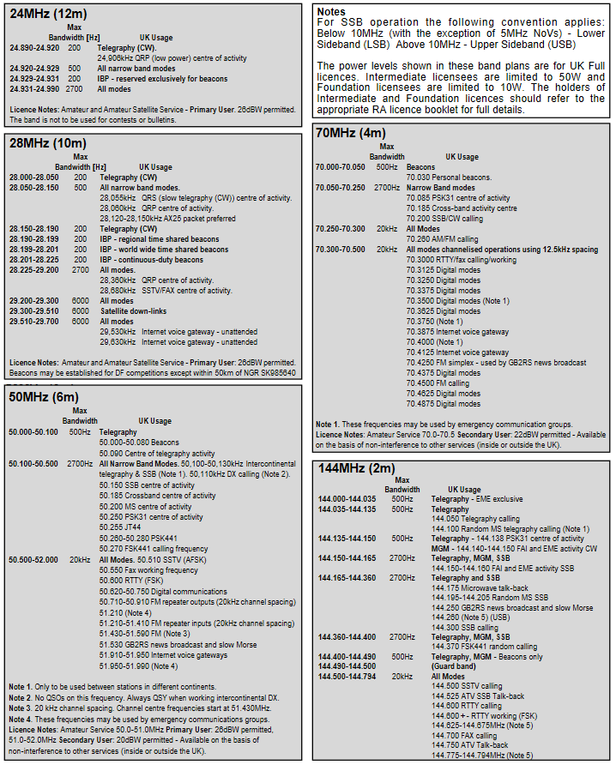

Figure 98:- HAM Radio Bands (24 to 144 MHz)

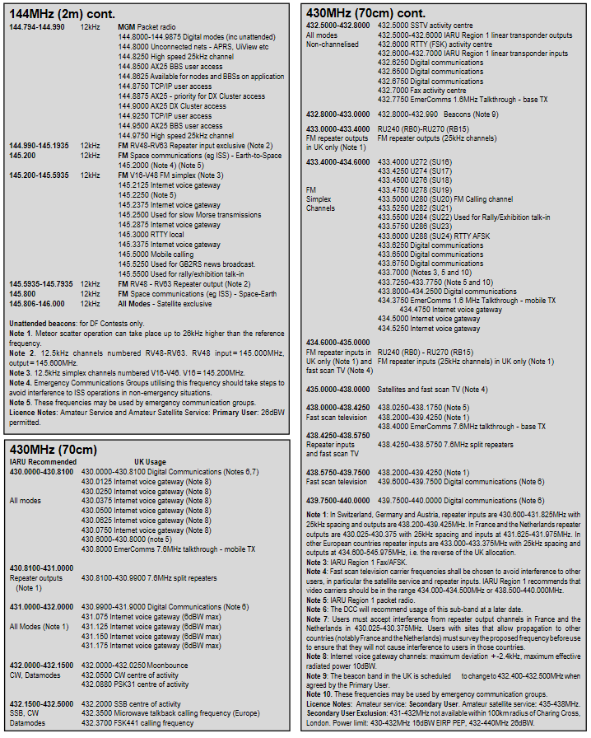

Figure 99:- HAM Radio Bands (144 to 430 MHz)

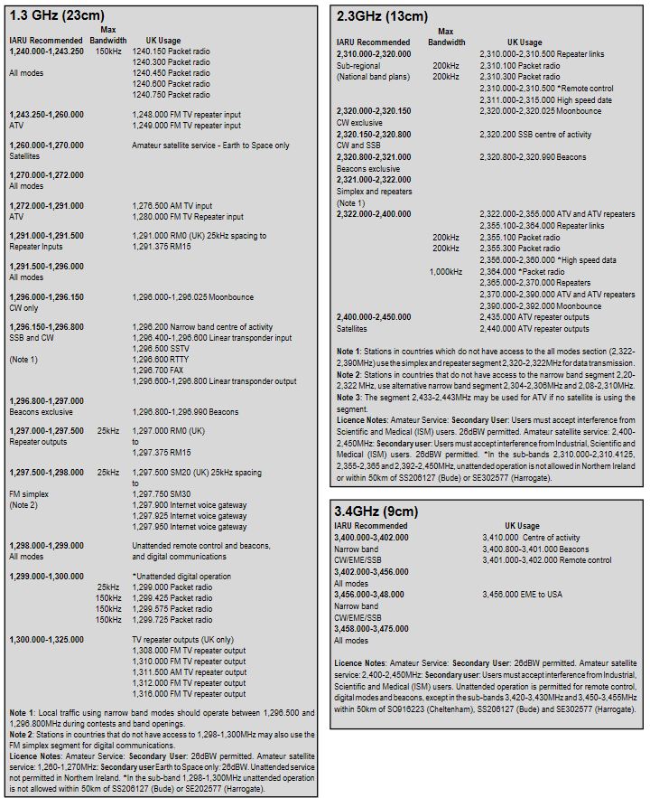

Figure 100:- HAM Radio Bands (1.3 to 3.4 GHz)

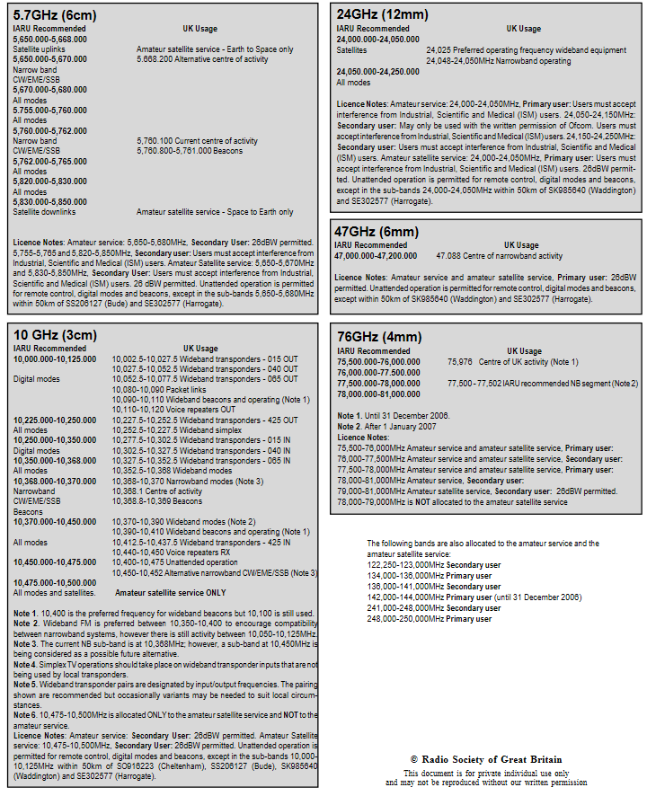

Figure 101:- HAM Radio Bands (5.7 to 74 GHz)

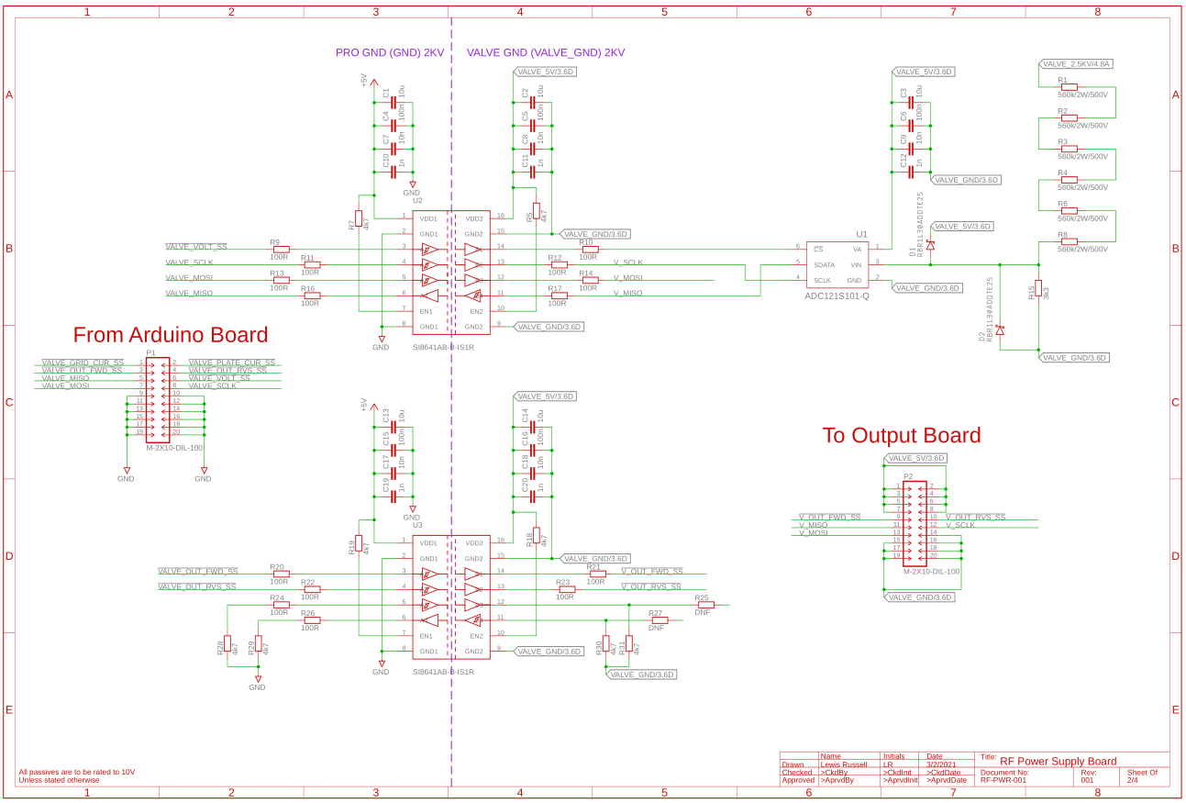

Figure 102:- Isolators and HV ADC

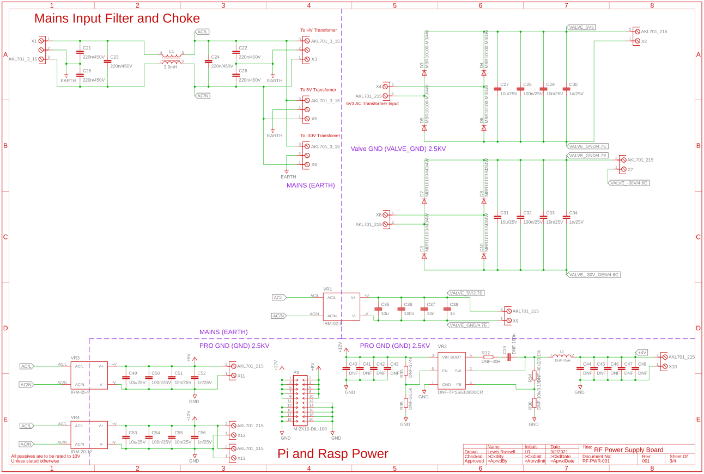

Figure 103:- Mains Input and Voltage Regulation

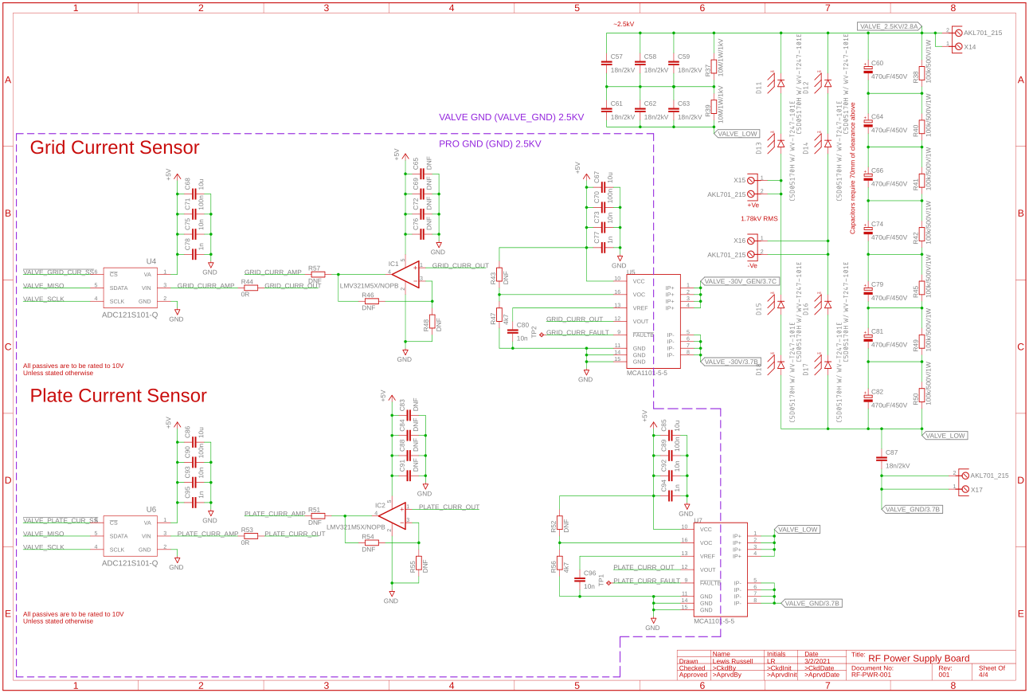

Figure 104:- HV Rectification and Current Sensing

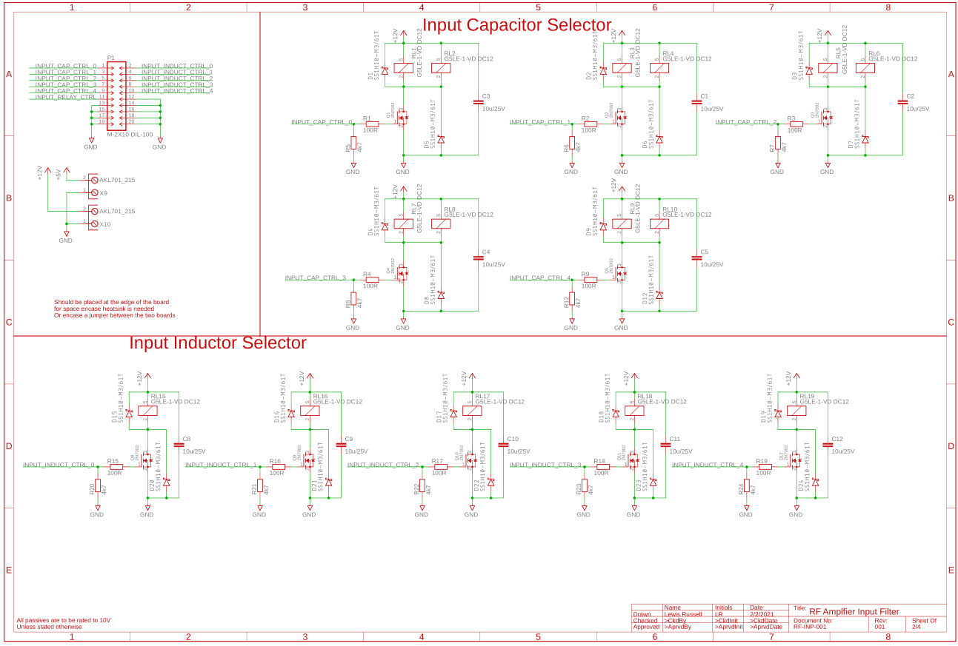

Figure 105:- Input Relay Control

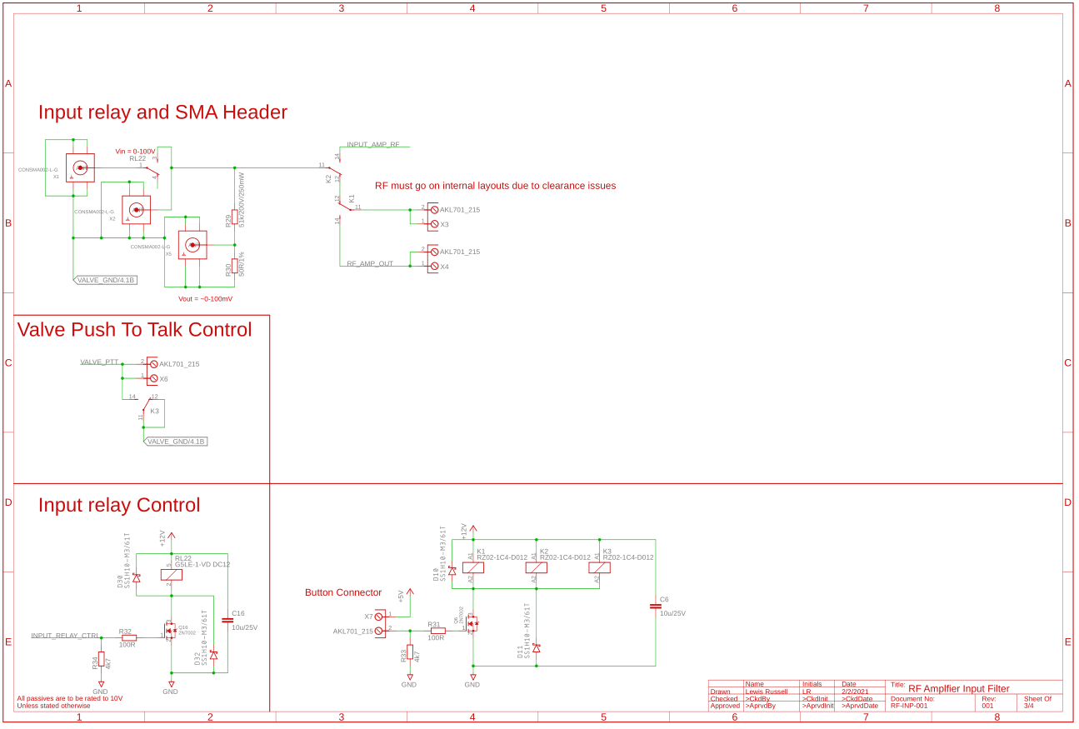

Figure 106:- Input Stage

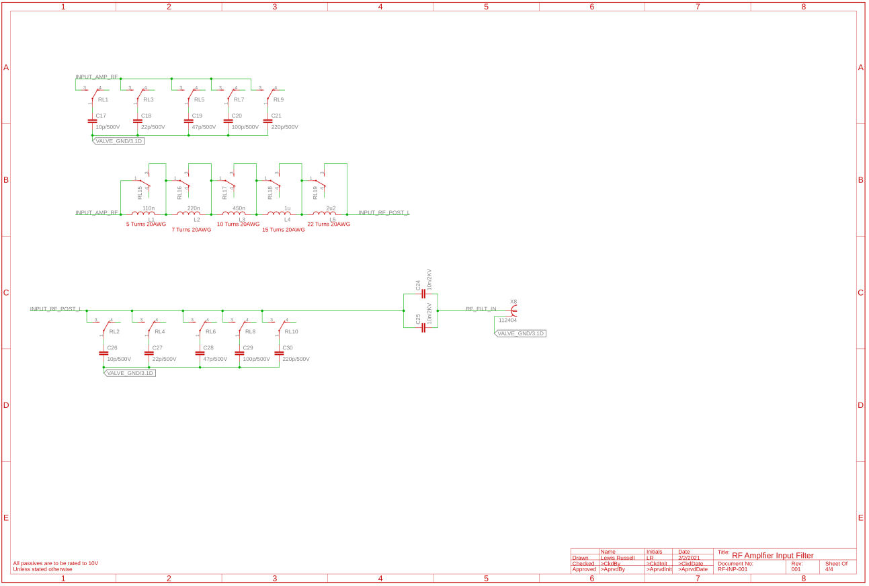

Figure 107:- RF Input Filter

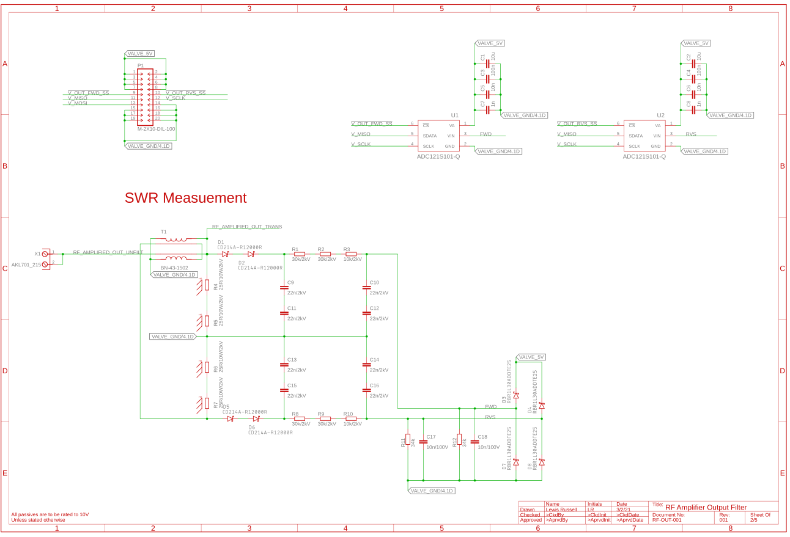

Figure 108:- SWR Measurement

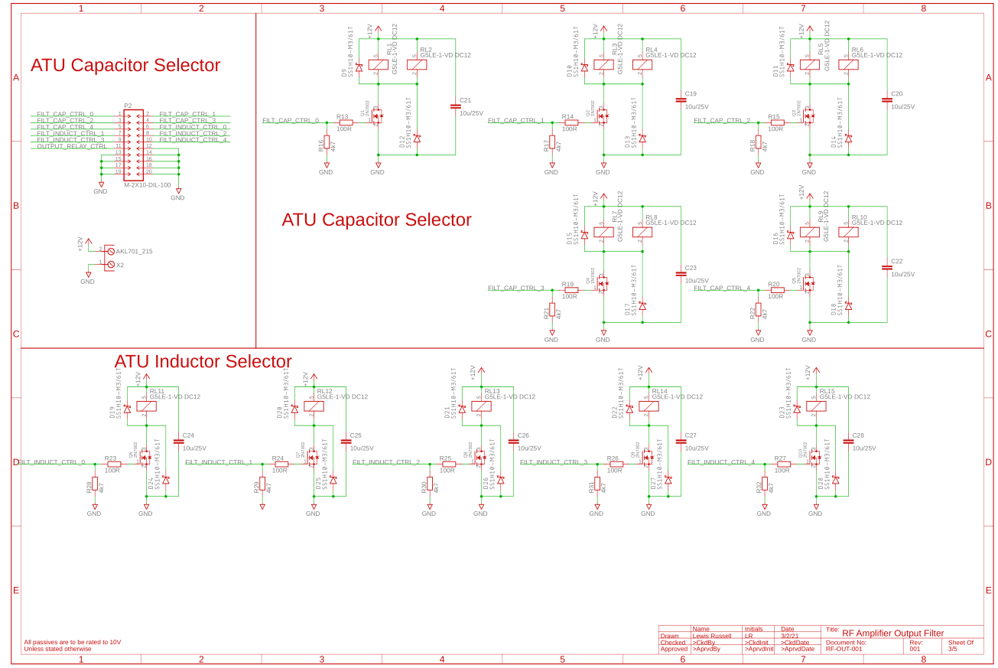

Figure 109:- ATU Relay Control

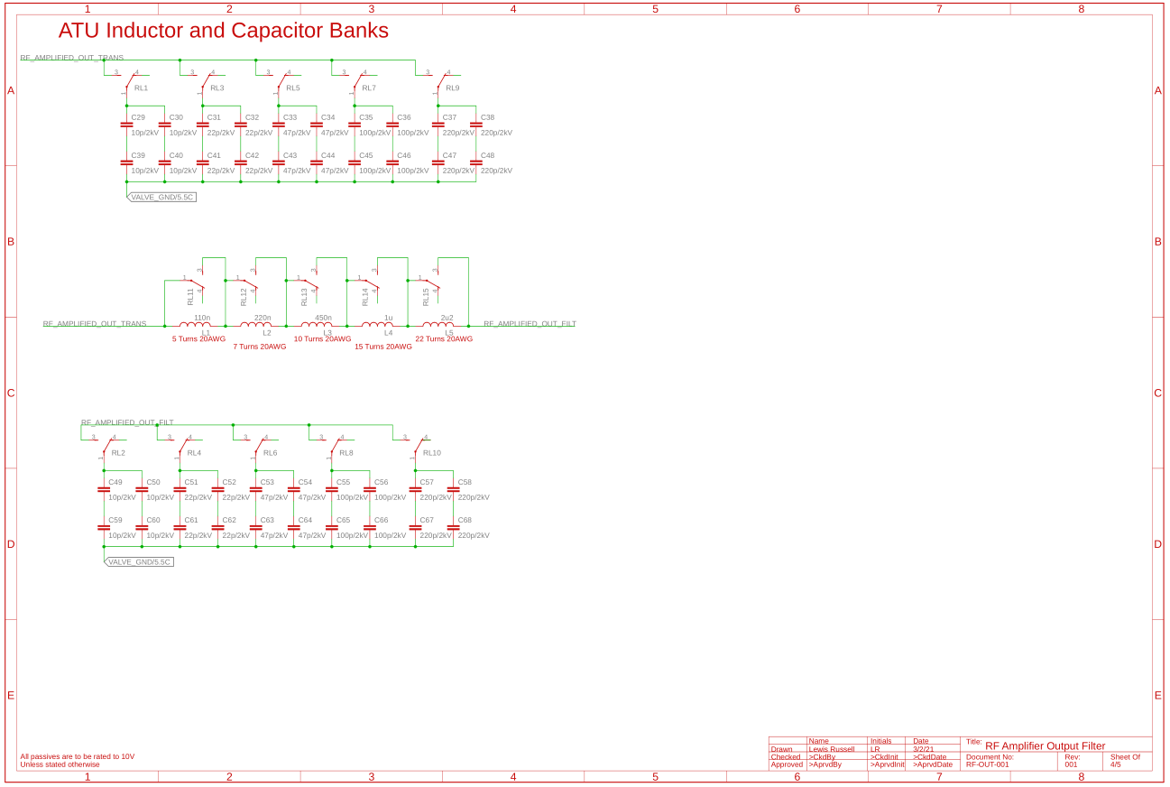

Figure 110:- ATU LC Filter

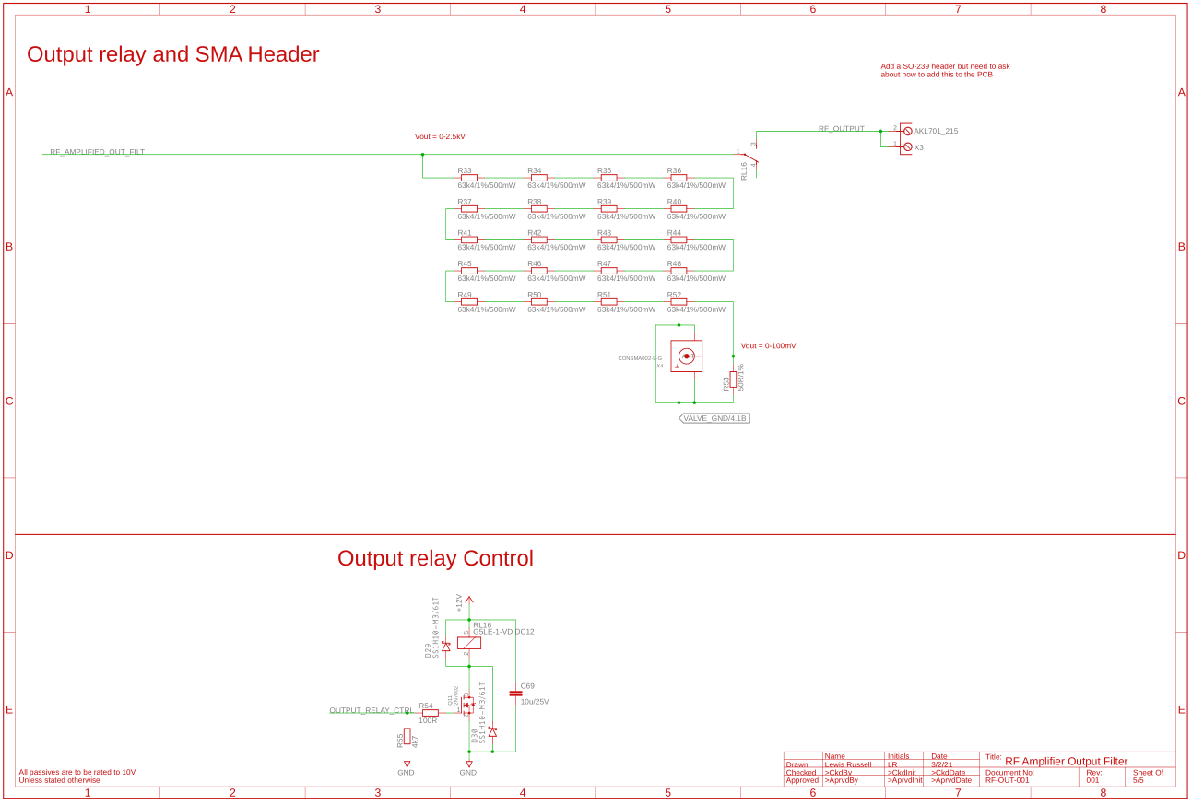

Figure 111:- Output Stage

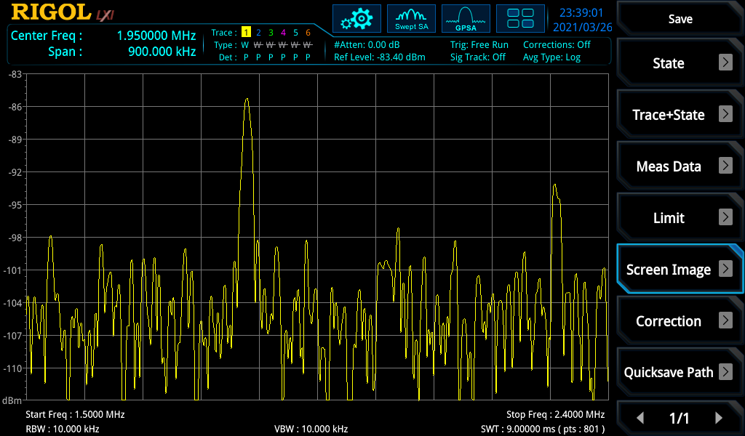

Figure 112:- 1.8410 MHz at 0 m in Hedge

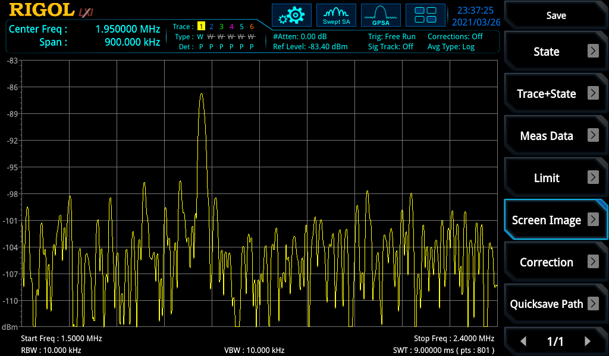

Figure 113:- 1.8410 MHz at 1.8 m in Hedge

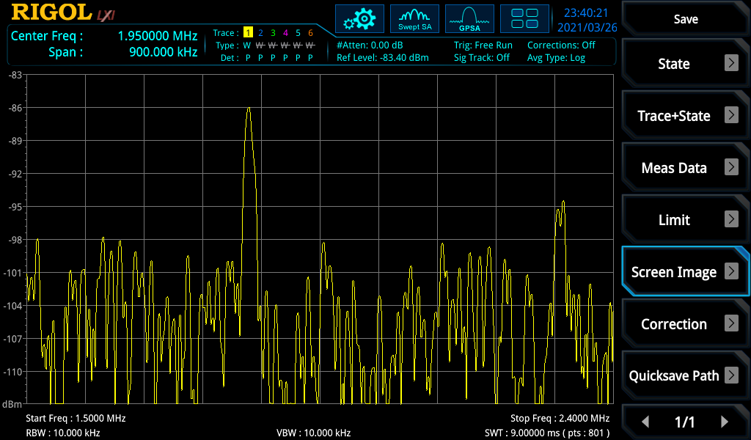

Figure 114:- 1.8410 MHz at 4.1 m in Hedge

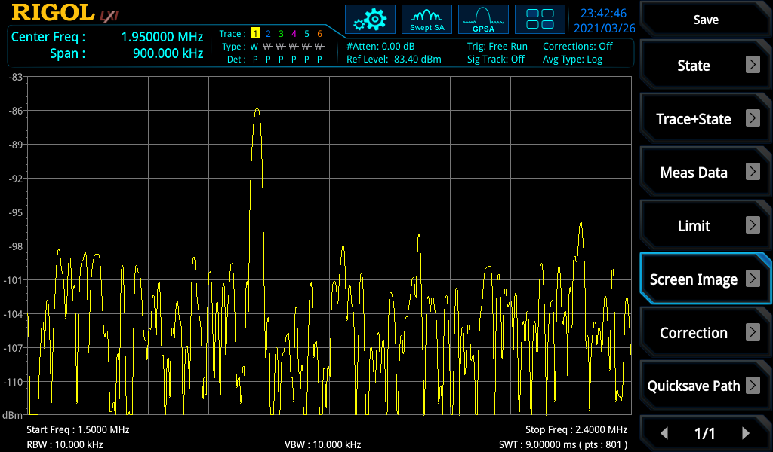

Figure 115:- 1.8410 MHz at 5.9 m in Hedge

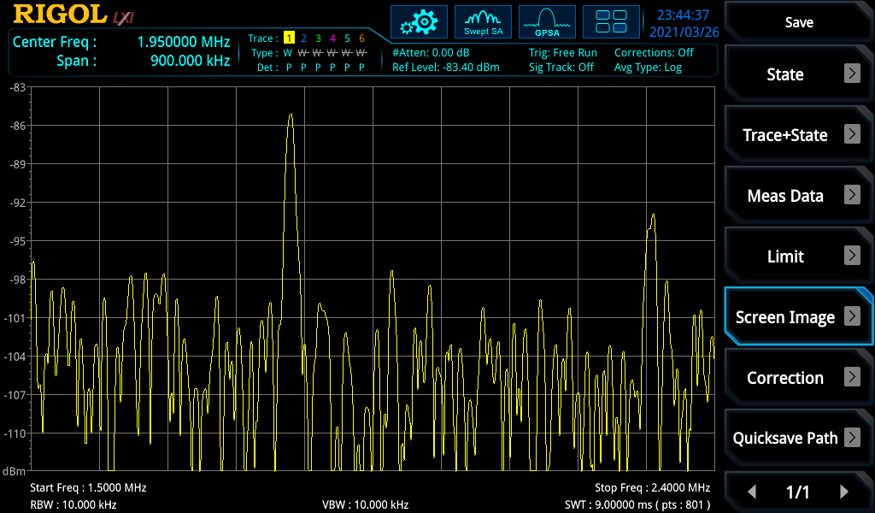

Figure 116:- 1.8410 MHz at 8.1 m in Hedge

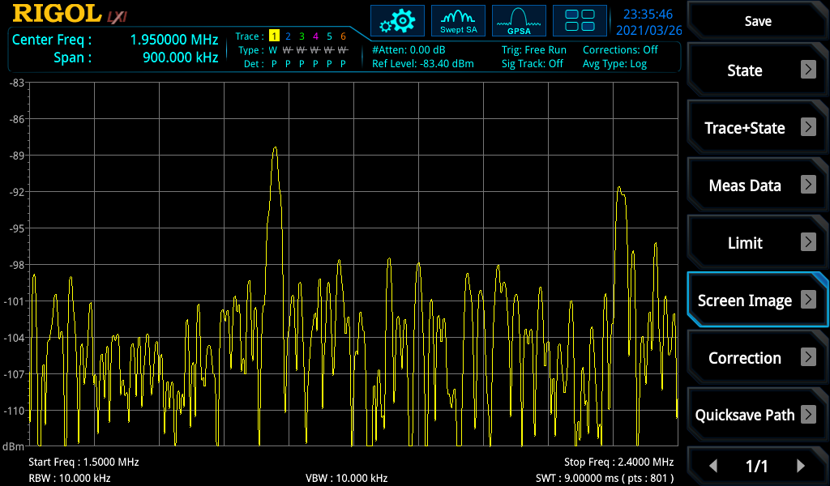

Figure 117:- 1.8410 MHz at 12.1 m in Hedge

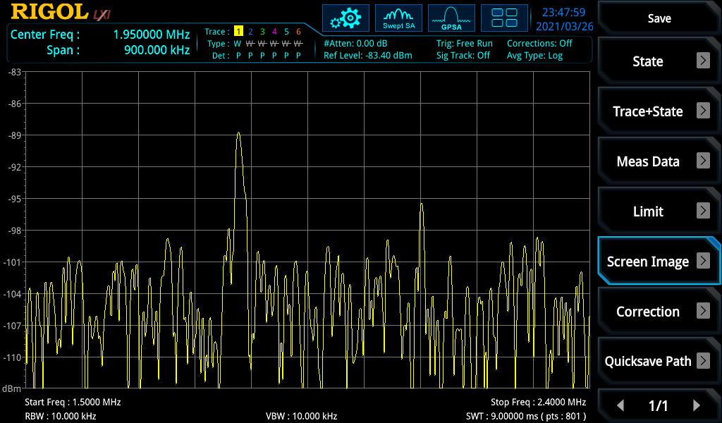

Figure 118:- 1.8410 MHz at 17.2 m in Hedge

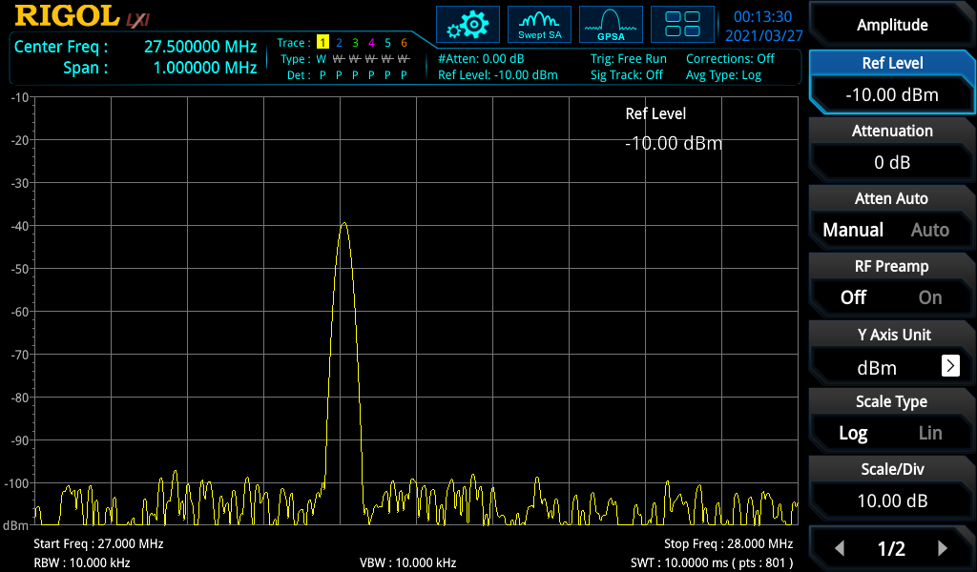

Figure 119:- 27.405 MHz at 0 m in Hedge

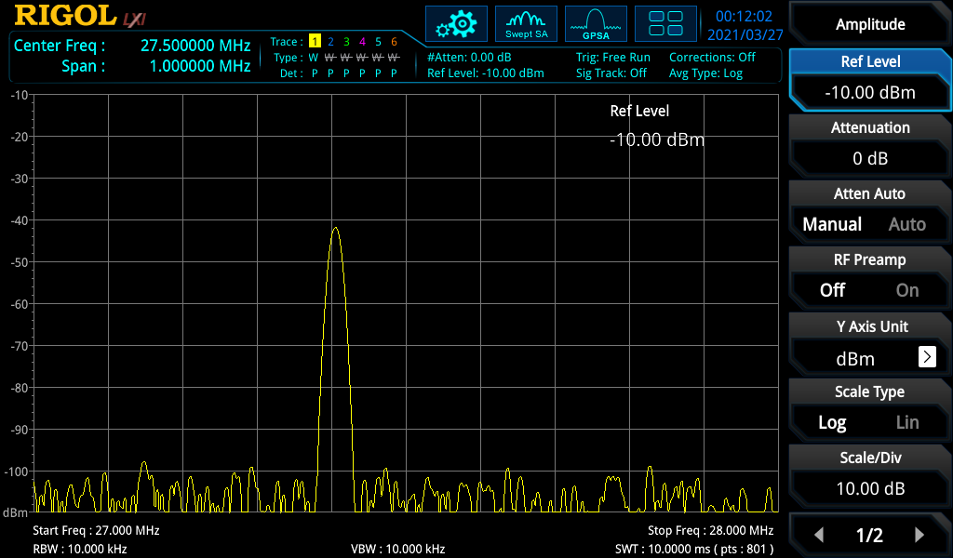

Figure 120:- 27.405 MHz at 2.1 m in Hedge

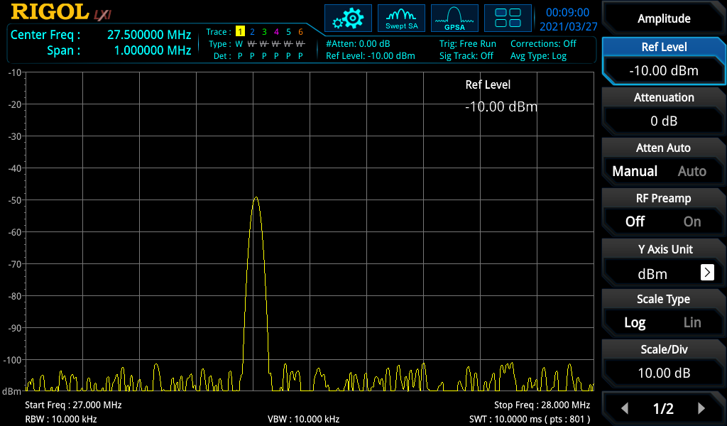

Figure 121:- 27.405 MHz at 4.2 m in Hedge

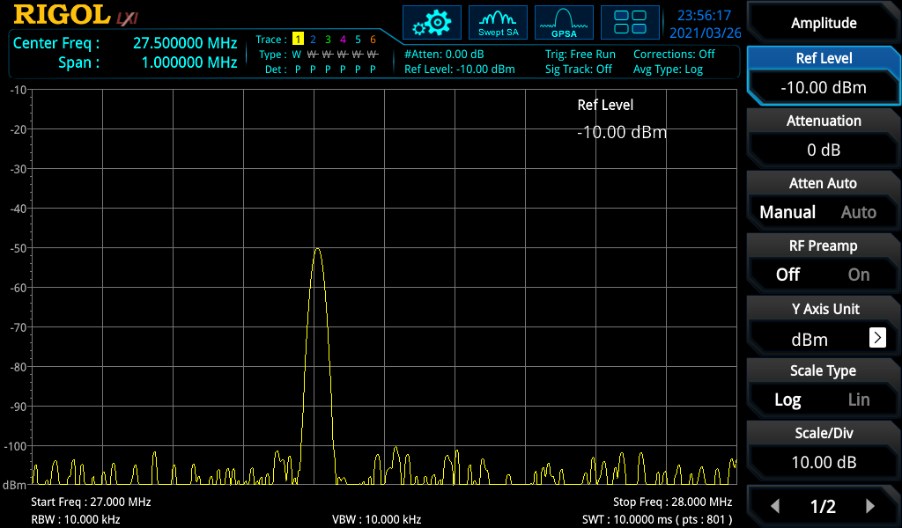

Figure 122:- 27.405 MHz at 7.75 m in Hedge

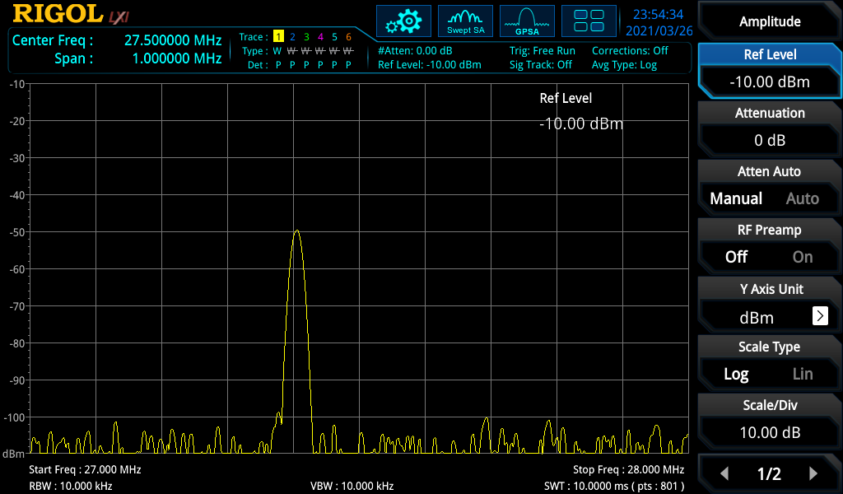

Figure 123:- 27.405 MHz at 9.22 m in Hedge

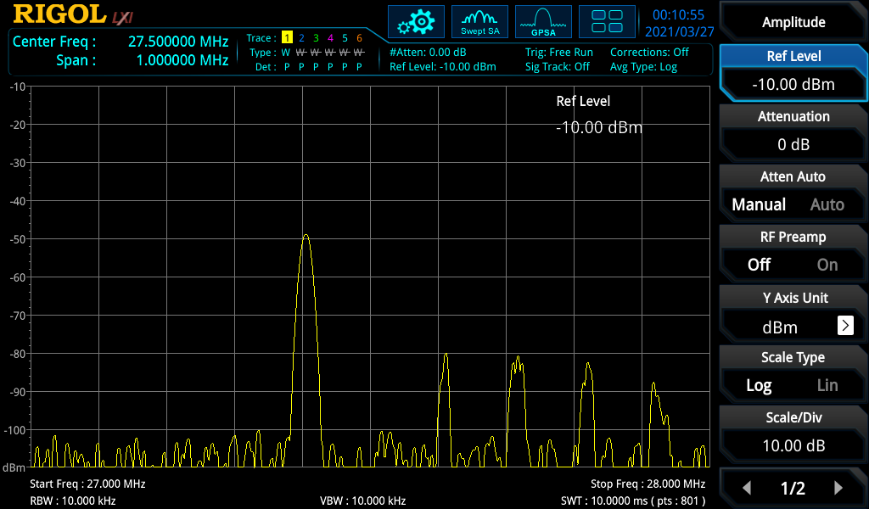

Figure 124:- 27.405 MHz at 10.44 m in Hedge

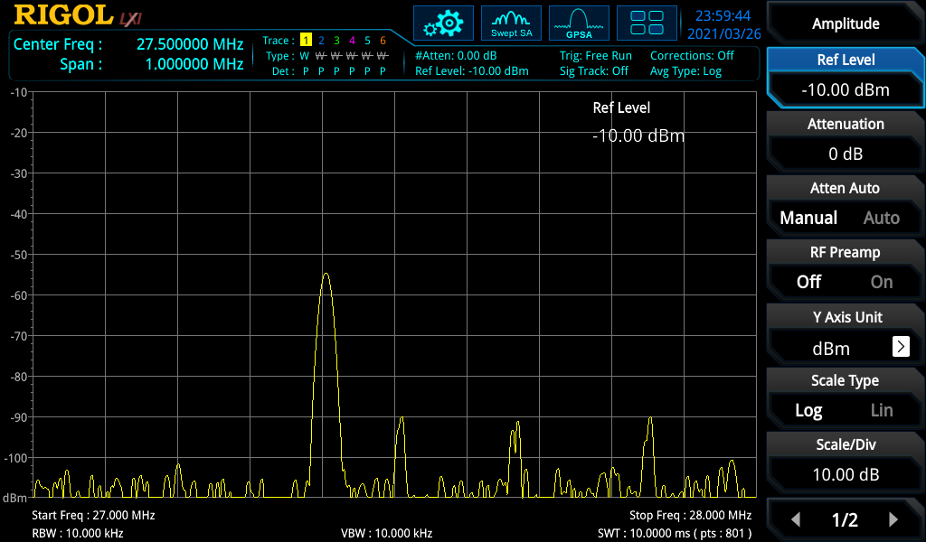

Figure 125:- 27.405 MHz at 13.92 m in Hedge

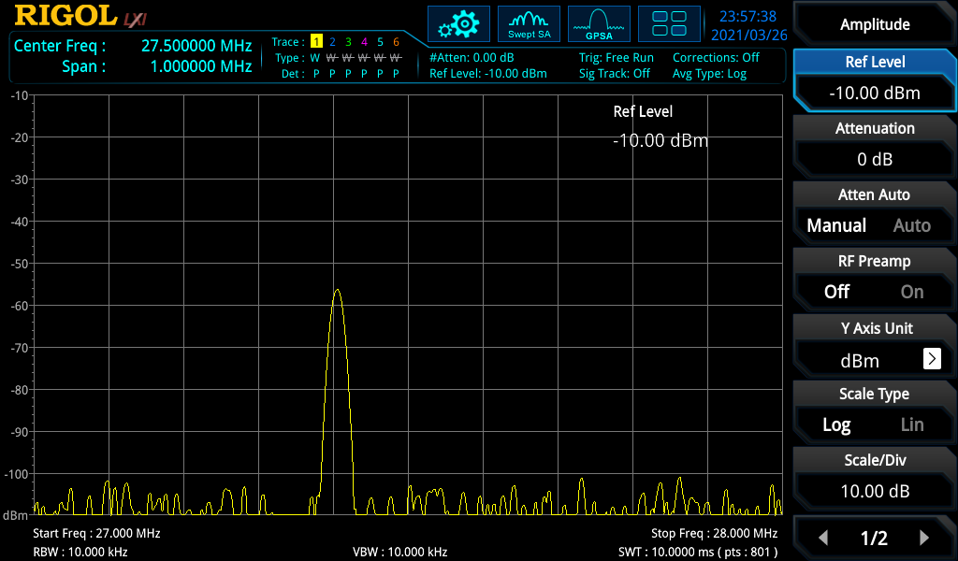

Figure 126:- 27.405 MHz at 17.02 m in Hedge

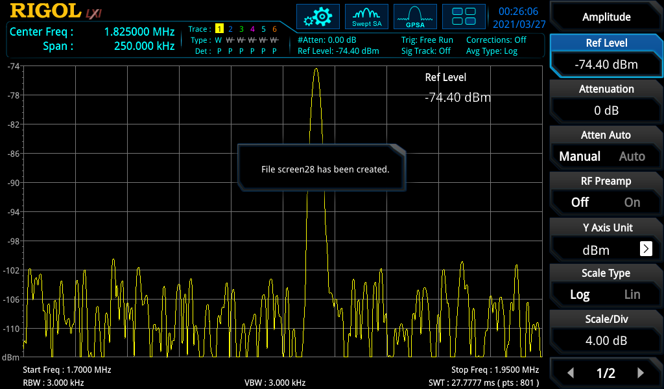

Figure 127:- 1.8410 MHz at 0 m in Hedge

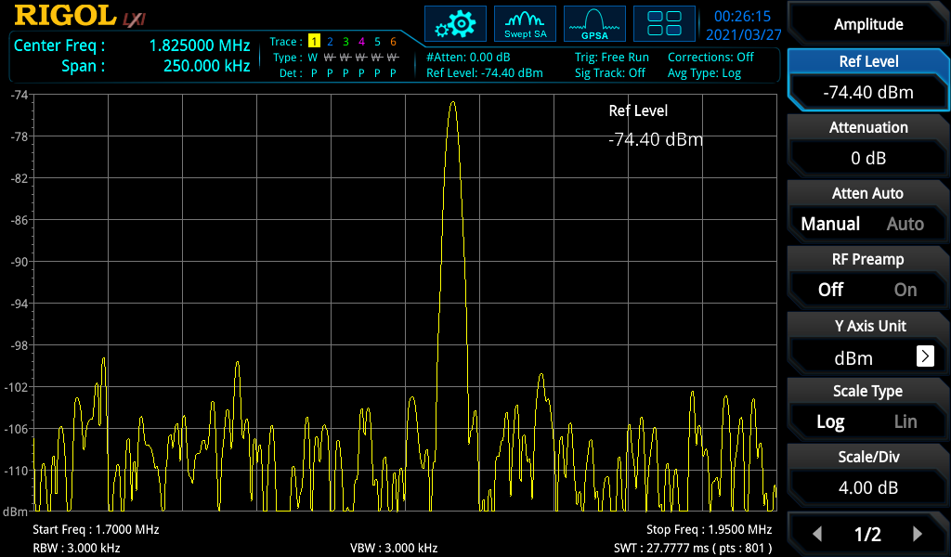

Figure 128:- 1.8410 MHz at 1.1 m in Hedge

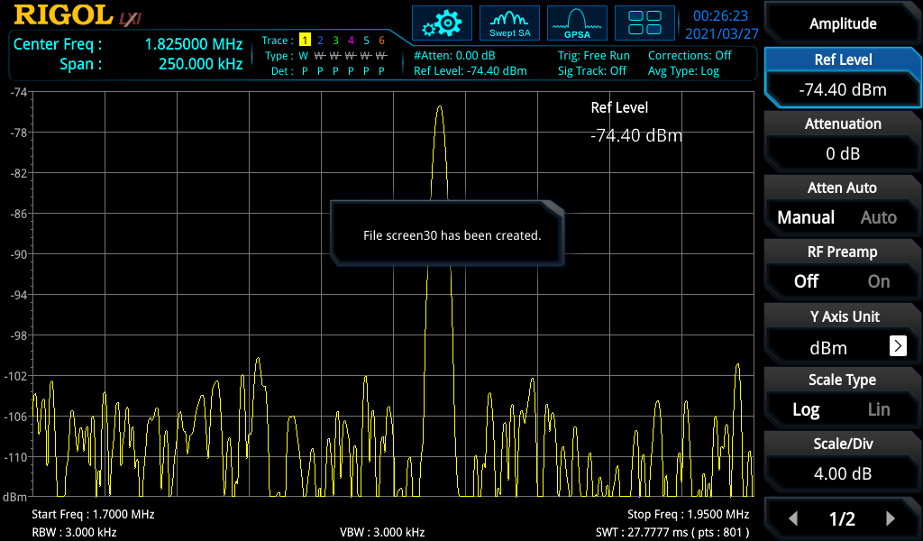

Figure 129:- 1.8410 MHz at 3.35 m in Hedge

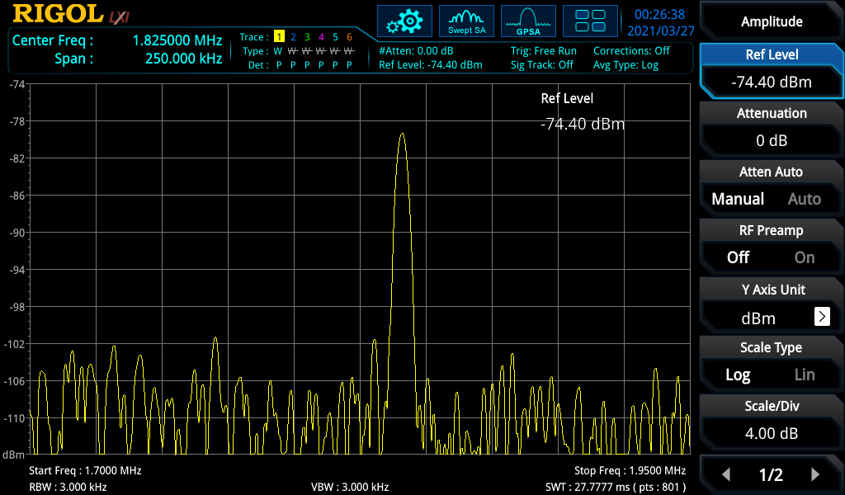

Figure 130:- 1.8410 MHz at 5.1 m in Hedge

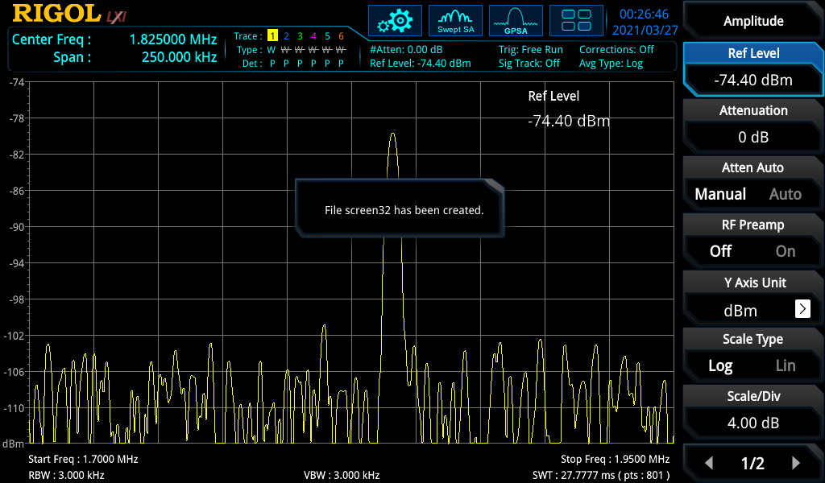

Figure 131:- 1.8410 MHz at 7.2 m in Hedge

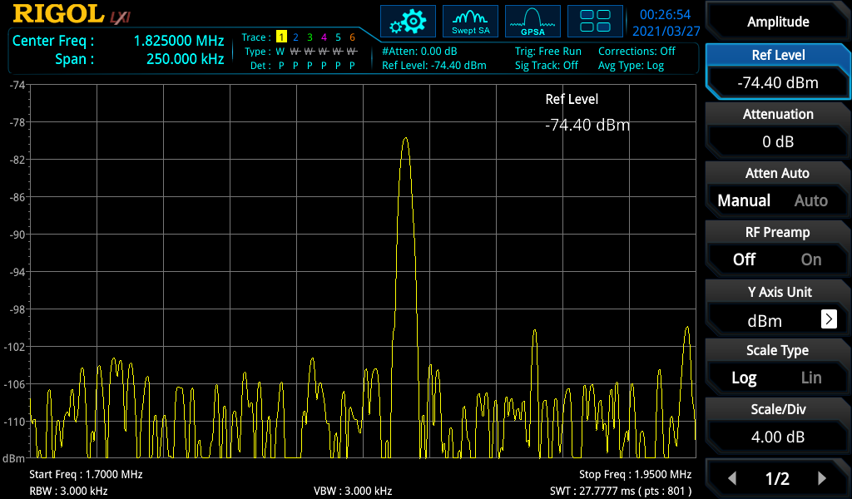

Figure 132:- 1.8410 MHz at 10.5 m in Hedge

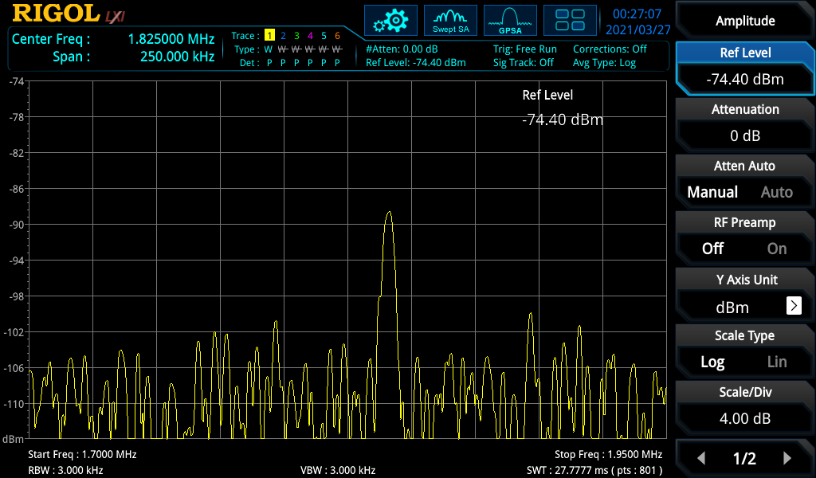

Figure 133:- 1.8410 MHz at 12.4 m in Hedge

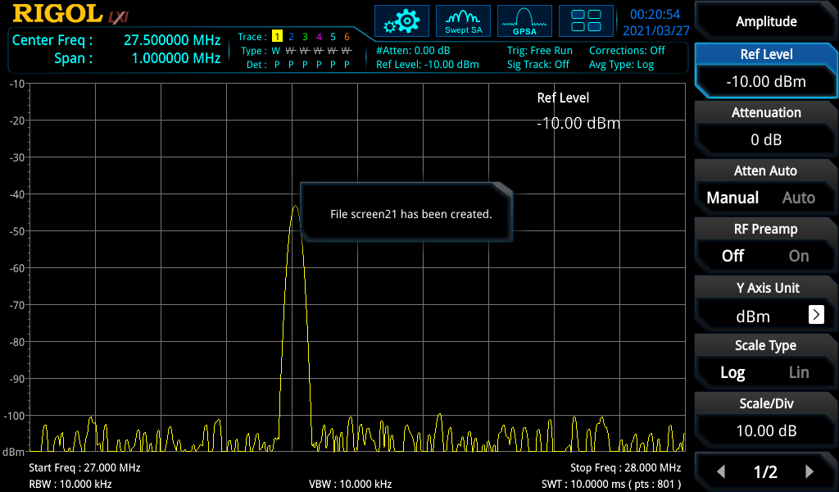

Figure 134:- 27.405 MHz at 0 m in Hedge

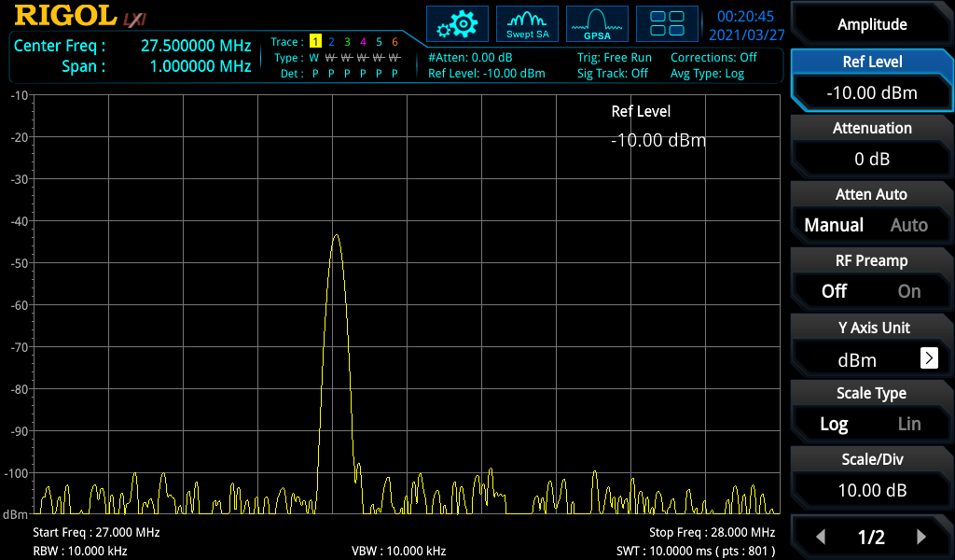

Figure 135:- 27.405 MHz at 1.1 m in Hedge

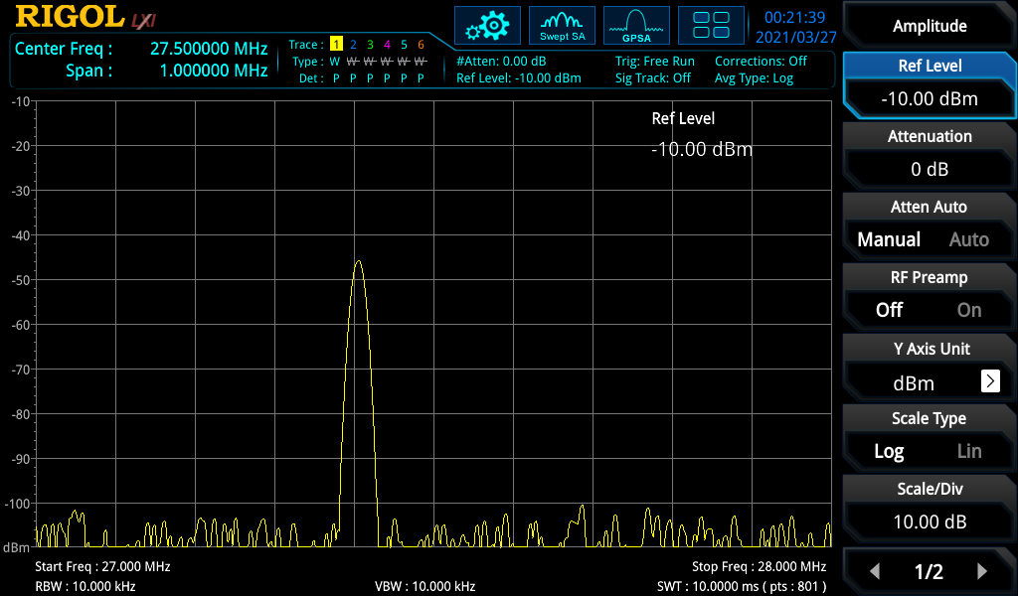

Figure 136:- 27.405 MHz at 3.35 m in Hedge

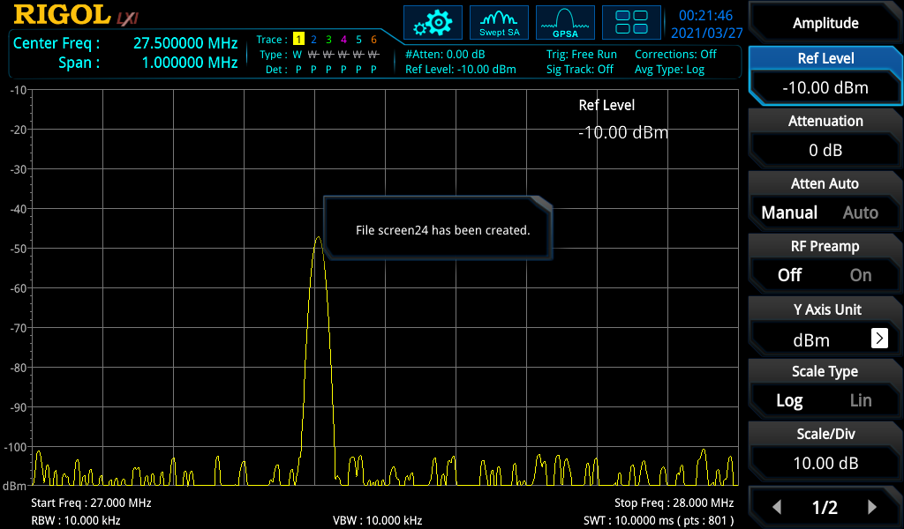

Figure 137:- 27.405 MHz at 5.1 m in Hedge

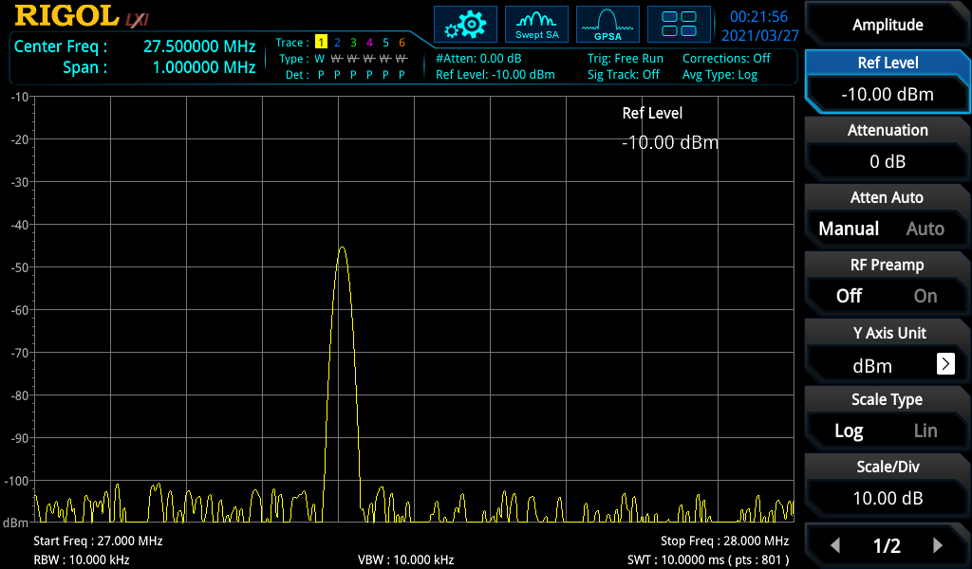

Figure 138:- 27.405 MHz at 7.2m in Hedge

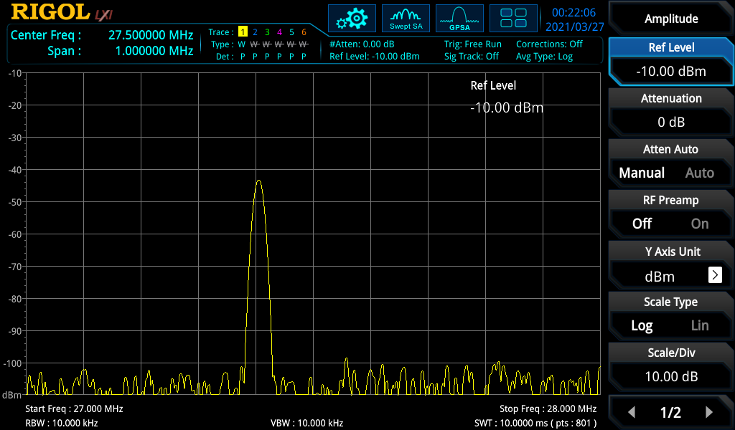

Figure 139:- 27.405 MHz at 10.5 m in Hedge

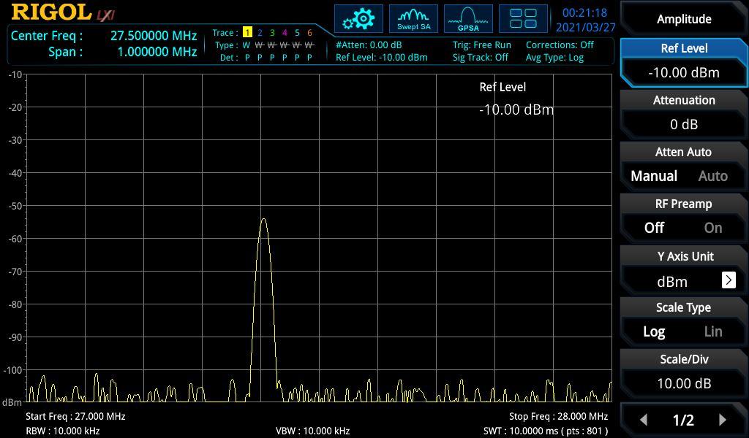

Figure 140:- 27.405 MHz at m 12.4 in Hedge

1. SYDR is normally called a SDR but due to Software Defined Radio sharing the same acronym, and appearing more it has been given priority
2. Price from The DX Shop (accessed 2nd of April 2021)  
   https://thedxshop.com/product/dx1200-solid-state-linear-amplifier/
3. Price from Mouser (accessed 21st March 2021)  
   https://www.mouser.co.uk/ProductDetail/Cynergy3/DAR71210?qs=OlC7AqGiEDkxxAhty01eug%3D%3D
4. Price from Mouser (accessed 21st March 2021) https://www.mouser.co.uk/ProductDetail/Nexperia/2N7002NXAKR?qs=%2Fha2pyFadugrT3yLZ3Uc%2FvE1fARSpfSws4hRL1FD38Y1lsVfk3vKoA%3D%3D
5. Price from Mouser (accessed 21st March 2021)  
   https://www.mouser.co.uk/ProductDetail/Linx-Technologies/CONSMA002-L-G?qs=%2Fha2pyFaduhQhcxMgrQoIha04OXKh0Bp5MeKeNWpLHOAdoo1UAvNfw%3D%3D
6. Price from Mouser (accessed 21st March 2021)  
   https://www.mouser.co.uk/ProductDetail/Wurth-Elektronik/74437529203470?qs=%2Fha2pyFadugkr4QWgN4ssAhdvF8AoWJNITF0EnPIreN%2FRxAezSuGn48AJC9Mp6NL
7. Price from the Tube Amp Doctor (accessed on 21st March 2021)  
   https://www.tubeampdoctor.com/en/shuguang-572b/t160l?number=NN622
8. Price from Mouser (accessed 21st March 2021)  
   https://www.mouser.co.uk/ProductDetail/Cynergy3/DAR71210?qs=OlC7AqGiEDkxxAhty01eug%3D%3D
9. Price from Mouser (accessed 21st March 2021)  
   https://www.mouser.co.uk/ProductDetail/ROHM-Semiconductor/RBR1L30ADDTE25?qs=%2Fha2pyFaduhlaDHQ2NHoAZdh3ZFkjL7j8SUB2CPlvyc%2FZ8Efko8Qdw%3D%3D
10. Price from Mouser (accessed 21st March 2021)  
    https://www.mouser.co.uk/ProductDetail/Bourns/CD214A-R12000R?qs=%2Fha2pyFadugqh10xiW5rwZ1YYhxpo0qN5pR9tFVtxhb%2F8%2FwVS9syhw%3D%3D
11. Price from Ebay (accessed 21st March 2021)  
    https://www.ebay.co.uk/itm/1-2-5-10-x-BN43-1502-Binocular-Ferrite-Core-AMIDON-Twin-Hole-UK-Seller/122747751154?hash=item1c94560af2:g:U60AAOSwXedZ3LEu
12. Price from Mouser (accessed 21st March 2021)   
    https://www.mouser.co.uk/ProductDetail/Silicon-Labs/SI8641AB-B-IS1R?qs=j6MGy4L9yX2B0WjgQzl90w%3D%3D
13. Price from Digi Key (accessed 22nd March 2021)  
    https://www.digikey.co.uk/products/en?keywords=IRM-05-5
14. Price from Digi Key (accessed 22nd March 2021)  
    https://www.digikey.co.uk/product-detail/en/mean-well-usa-inc/IRM-02-5/1866-3009-ND/7704628
15. Price from Digi Key (accessed 22nd March 2021)  
    https://www.digikey.co.uk/products/en?keywords=IRM-20-12
16. Price from Digi Key (accessed 22nd March 2021)

    https://www.digikey.co.uk/products/en?keywords=IRM-20-12
17. Price from Ebay (accessed 22nd March 2021)  
    https://www.ebay.co.uk/itm/Safety-Isolating-Transformer-220-240Vac-6-9-12-30-Vac-100ma-8A-Current/273527216787?var=572931910823